Student Behavior and Discipline Guidance

Determining what incidents of violent and harmful behavior to report in Synergy for the 2017-18 school year
When incidents of violent and harmful behavior by or against students are investigated and appropriate discipline has been prescribed, it’s then determined whether it is to be reported to the Maine Department of Education on the Student Discipline screen in Synergy (see 20-A MRSA §254, sub-§11).
Reportable incidents will be interpreted relative to the SAU’s adoption of its Student Code of Conduct and disciplinary policies (see 20-A MRSA §1001, sub-§15, and sub-§15-A).

Please follow the Department’s guidance to ensure that student behavior and discipline data are accurately reported.

The data will identify student behavior that is disruptive to the peace and usefulness of the school as well as the instructional and environmental supports and school practices that are designed to strengthen relationships, improve the connection to school, promote a sense of accountability, and find opportunities to repair harm that has been caused through misbehavior. The Department will use this data in its efforts related to school improvement under the Every Student Succeeds Act.

Deciding When to Report
An incident is reportable on the Synergy Discipline screen when:
- The incident is:
  - Illicit Drug Related
  - Alcohol Related
  - Weapons Possession
  - Violence with Physical Injury
  - Violence without Physical Injury
  - Other – NOT Drug, Alcohol, Weapons, or Violence Related
- The student is:
  - suspended out of school;
  - supervised during an in-school suspension;
  - placed in an alternative education setting by school personnel;
  - placed in an alternative education setting by a hearing officer;
  - expelled with services; and/or
  - expelled without services
from the regular educational setting for at least a half of a school day,
and/or the student receives a consequence identified as an “additional resolution.”*

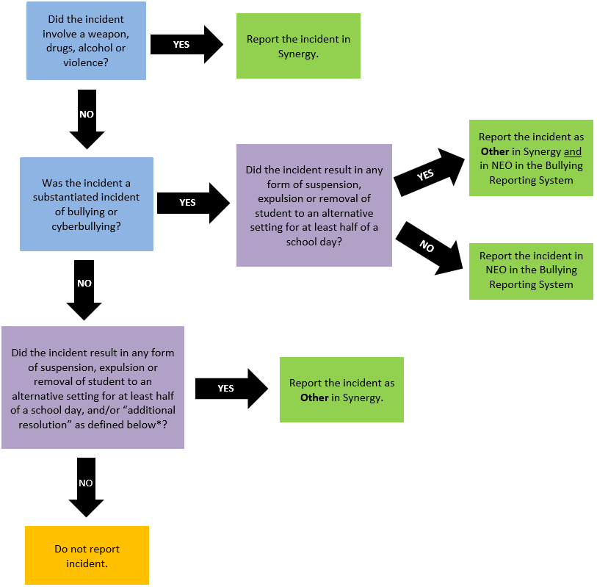

Did the incident involve a weapon, drugs, alcohol, or violence?
If yes, report the incident in Synergy.
If no, was the incident a substantiated incident of bullying or cyberbullying?
If yes, did the incident result in any form of suspension, expulsion or removal of the
student to an alternative setting for at least half of a school day?
If yes, report the incident as OTHER in Synergy and in NEO in the Bullying
Reporting System.
If no, report the incident in NEO in the Bullying Reporting System.
If no, did the incident result in any form of suspension, expulsion or removal of the student to an alternative setting for at least half of a school day, and/or “additional resolution” as defined below?
If yes, report the incident as OTHER in Synergy.
If no, do not report the incident.

Quick-Adding a Discipline Record in Synergy

- In the top right, click 2017-2018 and the Change Focus box appears:

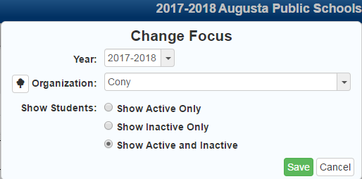

- Select the following in the Change Focus box:
Year: 2017 -2018
Organization: Choose your school (the example picture shows Cony)
Show Students: Show Active and Inactive
Click Save
- Go to the Student Discipline screen:
In the pad tree, click the arrow next to Synergy SIS to expand.
Click the arrow next to Discipline to expand.
Click Student Discipline.

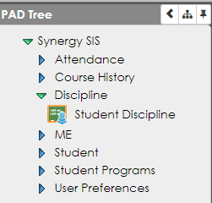

- Locate the student to modify:
Type in the students Last Name and First Name or State ID and click Find.

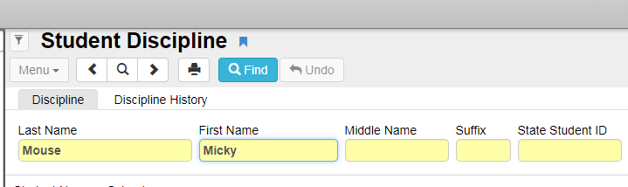

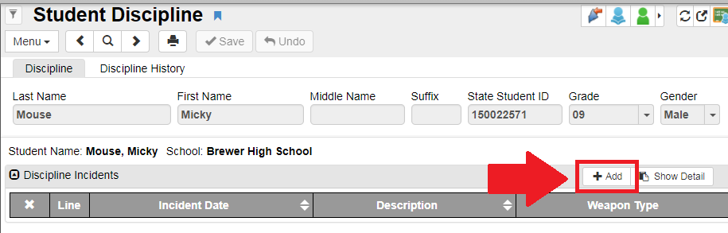
- Click Add. The Student Discipline Detail Add screen will appear.

- Select the Incident Type and Incident Date:
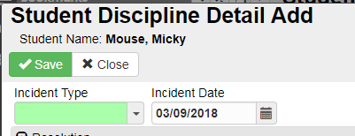

- Click Add and a new row will appear:
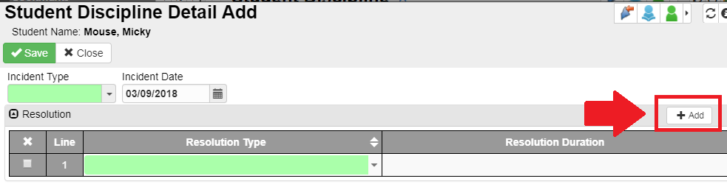

- Select the Resolution and Resolution Duration, if the Resolution results in number of Days. Then click Save:
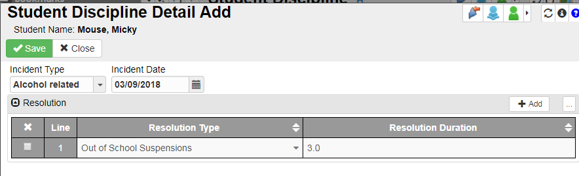

Definition of Discipline Incidents

Incident | Synergy Code | Definition
Illicit drug related | DrugRelated | Drug-related incidents are incidents involving possession or use of substances that include tobacco or illicit drugs (including steroids, all prescription drugs for which the student does not have a prescription and inappropriate use of nonprescription drugs and other substances). Drug-related incidents will include illicit drugs possession on school grounds, being under the influence of illicit drugs on school grounds, tobacco possession or use on school grounds, trafficking or possession for sale of illicit drugs on school grounds.
Alcohol related | AlcoholRelated | Incidents where students possessed or used alcohol on school grounds or were under the influence of alcohol while on school grounds.
Weapons possession | WeaponsPossession | Weapons possession is the possession of the following or similar items: handgun, shotgun or rifle, other type of firearm (e.g. devices designed to expel a projectile, grenade, explosive), knife, other sharp object (e.g. razor blade, ice pick, Chinese star), other object (chain, brass knuckle, billy club, stun gun), or substance used as a weapon (mace, tear gas).
Violent Incident (with Physical Injury) | WithPhysicalInjury | Any physically violent incident with injury where one or more students, school personnel, or other persons on school grounds require professional medical attention.
Violent Incident (without Physical Injury) | WithoutPhysicalInjury | Incidents involving violent behavior or the threat of violent behavior but that did not result in the need for professional medical attention.
Other | Other | Other - NOT related to illicit drug, alcohol, weapons possession, and/or violence is the reason why the student was disciplined.

Definitions of Resolutions

All actions and/or interventions taken to resolve an incident must be reported; not just the final resolution.
Resolution | Synergy Code | Definition
Out of School Suspensions | OutOfSchool | Instances in which a student is temporarily removed from his or her regular school for disciplinary purposes to another setting for at least a half of a school day. This includes both removals in which no IEP services are provided because the removal is 10 days or less, as well as removals in which the child continues to receive services according to his or her IEP.
In School Suspensions | InSchool | Instances in which a student is temporarily removed from his or her regular classroom(s) for disciplinary purposes but remains under the direct supervision of school personnel for at least a half of a school day. Direct supervision means school personnel are physically in the same location as students under their supervision.
Removal to an interim alternative educational setting by School Personnel | REMDW | An appropriate setting determined by the student’s IEP team in which the student is placed for no more than 45 school days. This setting enables the student to continue to receive educational services and participate in the general education curriculum, although in another setting, and to progress toward meeting the goals set out in the IEP. As appropriate, the setting includes a functional behavioral assessment and behavioral intervention services and modifications to address the behavior violation so that it does not reoccur.
Removal to an interim alternative educational setting by a Hearing Officer | REMHO | Instances in which an impartial hearing officer orders the removal of a student with disabilities from his or her current educational placement to an appropriate alternative educational setting for not more than 45 school days based on the hearing officer’s determination that maintaining the student’s current placement is substantially likely to result in injury to the student or others. The IEP team is responsible for determining the interim alternative educational setting.
Expulsion with services | EXPSERV | Action taken by the school board removing a student from his or her regular school for disciplinary purposes for a specific period of time not to exceed the total number of instructional days approved by the school board for the current school year, or for an unspecified period of time with the authorization that the superintendent provides the expelled student with a reentry plan. Educational services ARE provided to the student during the expulsion period. This includes removals resulting from violations of the Gun Free Schools Act that are modified to less than 365 days.
Expulsion without services | EXPWOSERV | Action taken by the school board removing a student from his or her regular school for disciplinary purposes for a specific period of time not to exceed the total number of instructional days approved by the school board for the current school year, or for an unspecified period of time with the authorization that the superintendent provides the expelled student with a reentry plan. Educational services ARE NOT provided to the student during the expulsion period. This includes removals resulting from violations of the Gun Free Schools Act that are modified to less than 365 days.

Resolution Types highlighted in green are for firearms possession incidents only
Expulsion modified to less than one year with educational services under IDEA | EXPMOD | Expulsion modified to less than one year with educational services under IDEA was the methods used to discipline student(s) who are children with disabilities (IDEA) involved in firearms and other outcomes of firearms incidents.
One year expulsion with educational services under IDEA | EXPNOTMOD | One year expulsion with educational services under IDEA was the methods used to discipline student(s) who are children with disabilities (IDEA) involved in firearms and other outcomes of firearms incidents.
One year expulsion and no educational services | EXPNOTMODNOALT | One year expulsion and no educational services is the method used to discipline the student(s) who are not children with disabilities (IDEA) involved in firearms and other outcomes of firearms incidents.
Expulsion modified to less than one year with educational services | EXPMODALT | Expulsion modified to less than one year with educational services is the method used to discipline the student(s) who are not children with disabilities (IDEA) involved in firearms and other outcomes of firearms incidents.
Expulsion modified to less than one year without educational services | EXPMODNOALT | Expulsion modified to less than one year without educational services is the method used to discipline the student(s) who are not children with disabilities (IDEA) involved in firearms and other outcomes of firearms incidents.
One year expulsion and educational services | EXPALT | One year expulsion and educational services is the method used to discipline the student(s) who are not children with disabilities (IDEA) involved in firearms and other outcomes of firearms incidents.

Additional Resolutions
Community service | 03076 | Community service is a consequence of an incident for the student(s) involved in an incident as perpetrator(s).
Juvenile justice referral | 03088 | Juvenile justice referral is a consequence of an incident for the student(s) involved in an incident as perpetrator(s).
Law enforcement referral | 03089 | Law enforcement referral is a consequence of an incident for the student(s) involved in an incident as perpetrator(s).
Restitution | 03094 | Restitution is a consequence of an incident for the student(s) involved in an incident as perpetrator(s).
Substance abuse counseling mandated | 03097 | Substance abuse counseling mandated is a consequence of an incident for the student(s) involved in an incident as perpetrator(s).
Substance abuse treatment mandated | 03098 | Substance abuse treatment mandated is a consequence of an incident for the student(s) involved in an incident as perpetrator(s).
Conflict resolution or anger management services mandated | 03080 | Conflict resolution or anger management services mandated is a consequence of an incident for the student(s) involved in an incident as perpetrator(s)
Counseling mandated | 03082 | Counseling mandated is a consequence of an incident for the student(s) involved in an incident as perpetrator(s).

Contact for Questions
Should you have questions on what to report, when to report or how to categorize a behavior incident, please contact Sarah Ricker, Student Assistance Coordinator at the Maine Department of Education, 624-6685 or email sarah.ricker@maine.gov.
Should you have any issues accessing Synergy State Edition or the Behavior Management tab within Synergy State Edition, please contact the MEDMS Helpdesk at 624-6896 or email at MEDMS.helpdesk@maine.gov.

