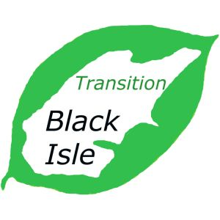
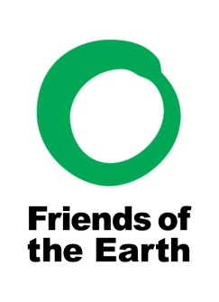

North Kessock Community Market
Saturday 30th January 2016
10am - 12 noon
North Kessock Village Hall

Come and support your local producers
Fresh Vegetable / Fish / Beef / Cheese / Bread / Jam / Chutney / Chocolates / Cakes / Cards / Fresh Eggs / Plants / Homemade Candles / Cushions / Paintings / Jewellery and much more

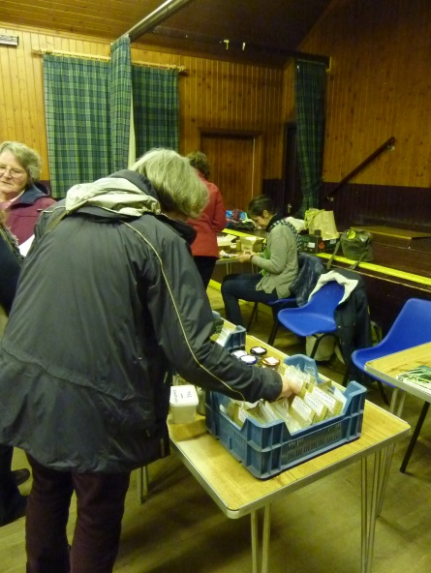
And Seed swap at the TBI table.
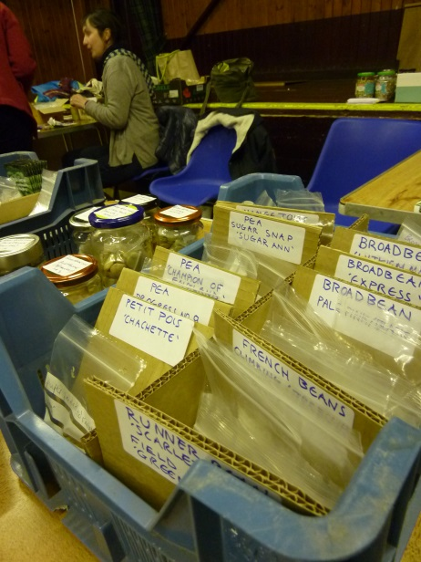
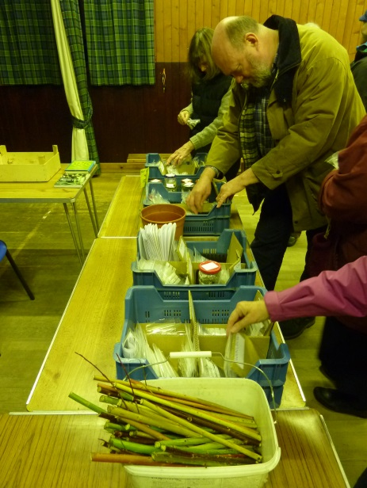
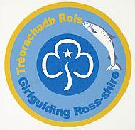
Teas and Home Baking by Girl Guiding Ross-shire
To book a table or for info about the Market:-
Email Sylvie Main at kessockmarket@transitionblackisle.org,
Mob: 07926 044064
or go to www.transitionblackisle.org.uk or www.foe-invernessandross.org.uk

