**Greenplate Effect – It doesn’t happen!**

Now, why am I not surprised?

Yet again, when I test what should be one of the rock solid corner stone foundations of the radiation greenhouse effect, the so-called “Greenplate Effect” it just doesn’t happen. No matter how many times I test it, it refuses to show its lovely green-red hot face.

For those of you whom don’t know, there are a large number, of governmental and scientific advisors all of whom have convinced themselves using “wrong maths” that the “Green-plate Effect” is real and that they can show it is real because their maths says so. Maths can be used to show Thanos, the nemesis of the Avengers is real and then digitise said maths to place him on a screen. He isn’t real. Maths can be used to show that most normal families have 2.4 children, they don’t, no-one does. Maths can be used to show it perfectly possible to exist a long and healthy life with -3 hearts, it isn’t negatives numbers such as this don’t exist in reality, it is just made up nonsense.

Their math’s, bears absolutely no relation to reality, and therefore any models they construct using it, are totally false. As Nikola Tesla once said.

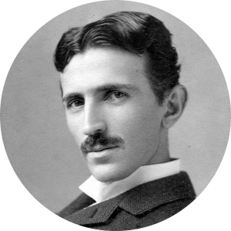

***“Today’s scientists have substituted mathematics for experiments, and they wander off through equation after equation, and eventually build a structure which has no relation to reality.”***

It’s almost like Nikola saw the future of climate clownatolgy and wrote a paragraph for it in preparation.

The green-plate effect I elaborated upon in my book. [https://www.waterstones.com/book/black-dragon/geraint-hughes//9781949267006](https://www.waterstones.com/book/black-dragon/geraint-hughes/9781949267006).

However, I didn’t call it the green-plate effect, I called it “London is calling 911” because if you do the averaging maths, which the alarmists pretend is real, then what happens is this.

With a plate in space on its own, using average approximation approach you get a temperature of 331.5k. So that you get 1367 in and 1367 out, with 683.5 out on each side.

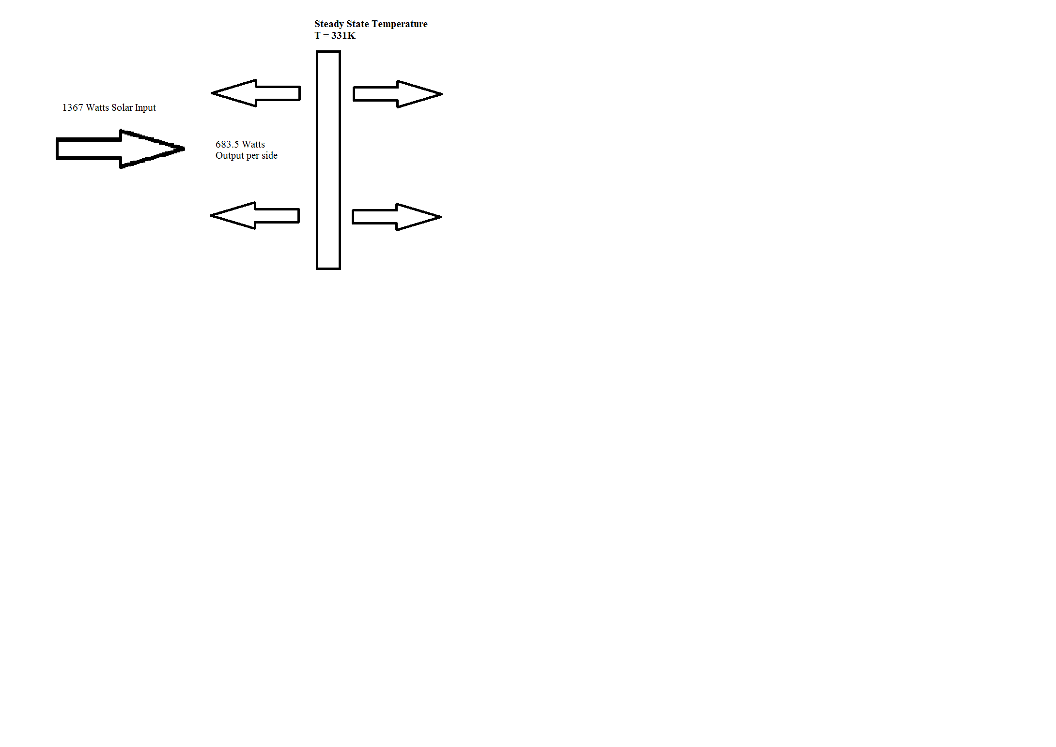

So therefore on this basis, if you added another plate behind the first plate and continued to pretend that this fake reality was correct you get the following.

911 Plates

In other words, the output from the 1st plate, increases from 683.5 to 911 watts per side, to get a hotter front plate and a warm 2nd plate giving a total 1367 in and out.

This ***fake effect*** is what the pretenders call the green-plate effect. Because it mathematically shows that the temperature of the first plate has risen in steady state temperature by just over 20K. (I.e. Back-radiant forcing). Surely maths can’t be wrong, right? No way man, maths rules!!!!!!

When I wrote my book I didn’t have any test rigs constructed and I worked on the assumption that the maths as above was right and then, I showed how its effects were completely nullified and rendered irrelevant by Conduction and Convection and how 3D radiance renders such models completely ineffective at inducing heat gain on the surface, ***EVEN IF YOU ASSUME THEY ARE RIGHT!***

A nullification effect which I have duplicated and demonstrated in my twin vacuum comparison experiment & other similar experiments. <https://www.thepostil.com/evidence-co2-is-not-a-greenhouse-gas/>

However, there is not a nullification of a back radiant effect, because back radiance, has no heating effect and so there is nothing to nullify.

Now, that I am in possession of my taller tower chamber, a chamber I only procured because you-tube trolls kept telling me “There wasn’t a big enough column of Air for back radiance to occur.” I noticed that I have just enough space to perform some rudimentary plate to plate tests, with no need for gases. Believers in the green-plate effect even go on to say, if you add a third plate the 1st one gets hotter still & if you add a fourth its hotter again & so on and so forth. They are so ***SNOOTY*** about this, they think they are right. They should be snooting at their own arrogance.

So this is what I have done and these are the results that I have discovered.

**Experiment Details**

I have performed three sets of experiments. I have compared a heated plate and the maximum steady state temperature it attains, when fully exposed at room temperature. This is just one plate on its own, supported above a constant heat source with mild steel angle supports.

Main Components, 40 watt spiral vintage bulb, 130mm aluminium diameter disc, powder coated black, 1mm thick. 200mm long metal steel supports, digital thermometer. With the two plate setup a second disc or equal size is used and plastic spacers to separate the discs.

**Components Picture**

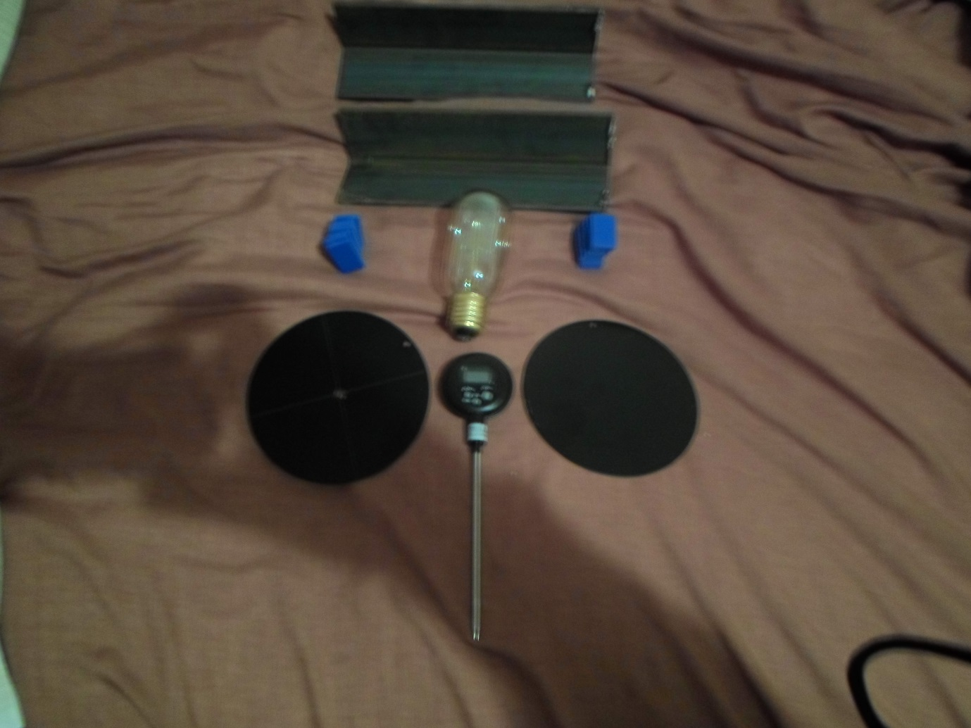

There is no contact between the bulb and the metal supports.

**Bulb & Supports Pic**

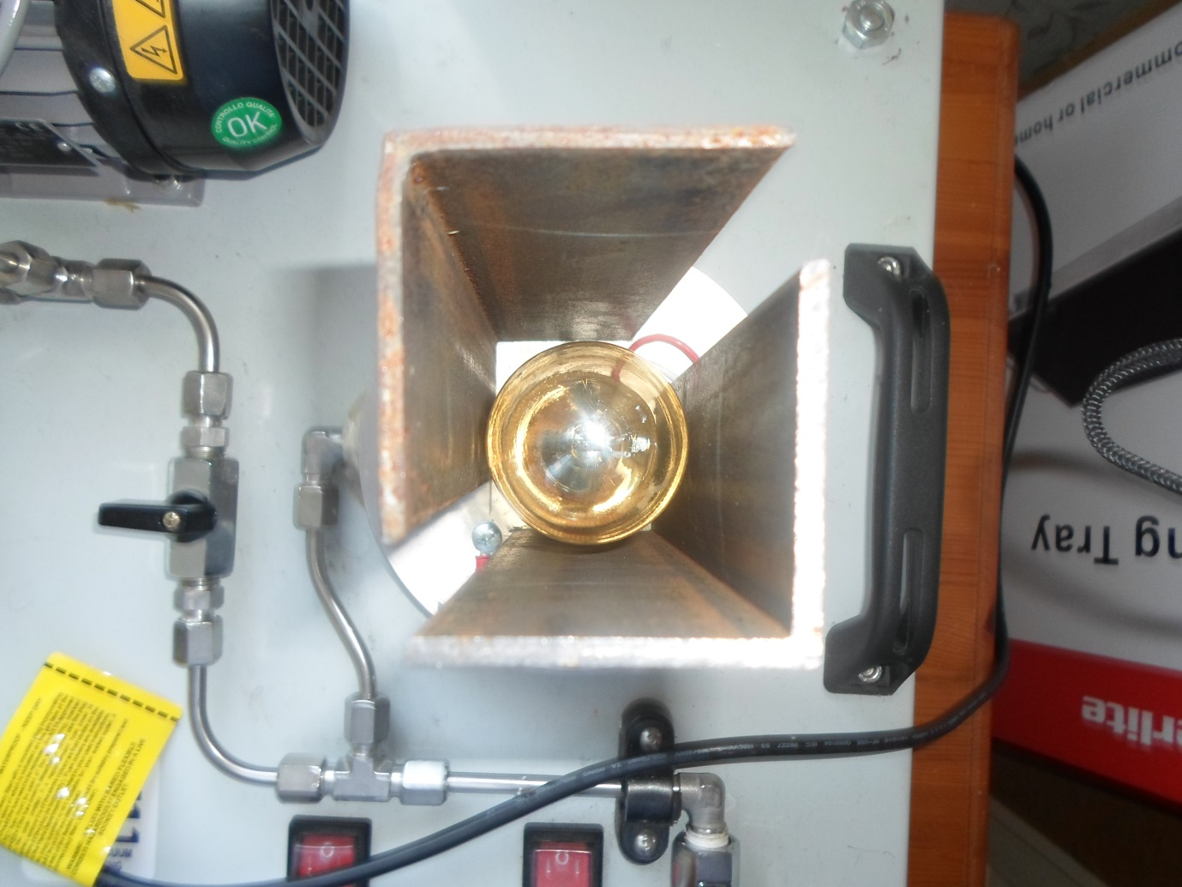

Therefore energy can only get to the plate via direct radiance from the bulb going up and anything conducted to the plate which is radiated from the bulb to the angle supports. There is no direct conductive transfer. In the vacuum chamber, under vacuum, there is no convective gains or losses within the chamber either.

I have conducted a second experiment where the same rig, was placed inside the Vacuum Chamber and the chamber evacuated & then a final test where instead of there being 1 plate, a 2nd plate was placed above the 1st, in order to see what back radiant heating effects took place.

I can confirm NONE, were experienced. The results are below.

20 minutes of cooling was also recorded between heating tests, just for interest and comparison.

**Experiment 1 – Plate Exposed to air**

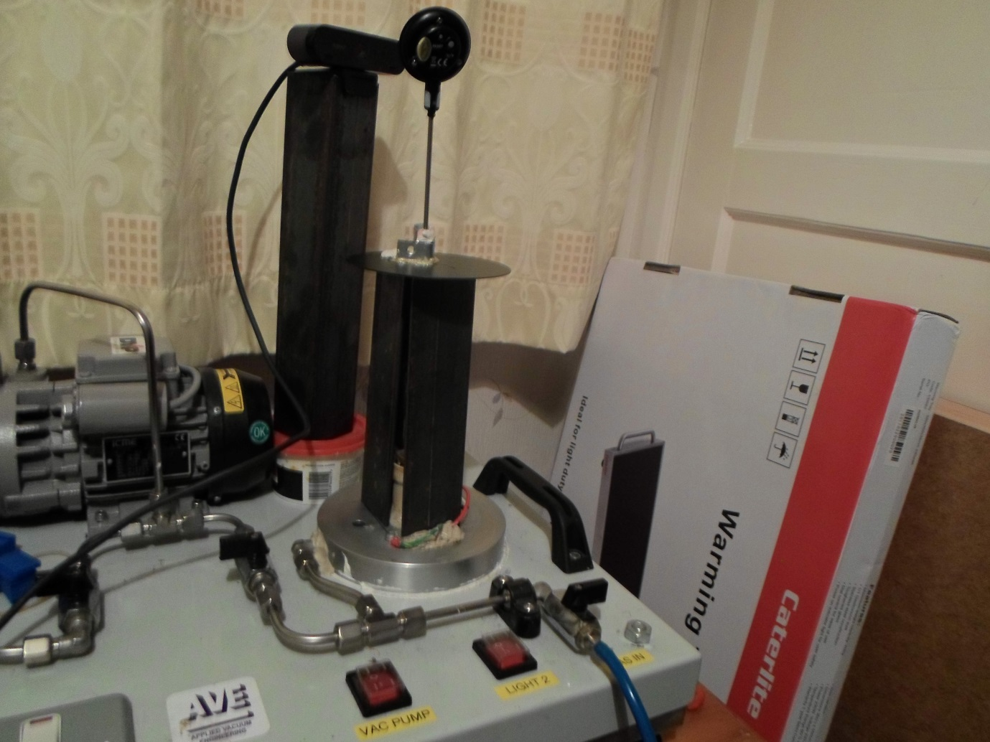

When fully exposed to room temperature the following results occurred. The thermometer is kept in place by two small angle brackets in the centre and some putty.

|  |  |  |  |  |  |  |
| --- | --- | --- | --- | --- | --- | --- |
| **Experiment 1 - Single Plate Exposed to room air, no chamber.** | | | | | |  |
| **Test No** | **Start Temp** | **Max Temp** | **Increase** | **Cooling** | **Reduction** | **Notes** |
| 1 | 26.1 | 47.6 | 21.5 | 30 | **-17.6** | Cold Start. 60 mins heating, 20 min cooling. |
| 2 | 29.3 | 46.5 | 17.2 | 29.7 | **-16.8** | 60 mins heating, 20 min cooling. |
| 3 | 24 | 46.1 | 22.1 | 29.6 | **-16.5** | 60 mins heating, 20 min cooling. |
| 4 | 29.4 | 47.4 | 18 | 31 | **-16.4** | 60 mins heating, 20 min cooling. |
| 5 | 30.7 | 46.7 | 16 | 29.9 | **-16.8** | 60 mins heating, 20 min cooling. |
| **Min** | | **46.1** | **16** | **29.6** | **-16.4** |  |
| **Mean** | | **46.86** | **18.96** | **30.04** | **-16.82** |  |
| **Max** | | **47.6** | **22.1** | **31** | **-17.6** |  |
| **Range** | | **1.5** | **6.1** | **1.4** | **-1.2** |  |

There are tiny breaks in between each test, as I also recorded these results on camera, save & name the data and then set up a new file for recording. I may at some point download them all on you-tube.

A full breakdown of temperature tables will be downloaded onto my website. <https://theblackdragonsite.wordpress.com/>

Each test was 1hour of heating with 20 minutes of cooling in-between.

Here we see that the peak maximum temperature was 47.6 with a range of just 1.5 degrees throughout the 5 tests. Over 20 minutes on average 16.82 degrees of cooling was experienced. With my arrangement the steel frame, gives a large amount of thermal mass and in the results, it shows with the temperature rise being slowest during the early stages.

This arrangement is just for comparison and allows for convective cooling all around.

**Experiment 2 Single Plate in Vacuum Chamber**

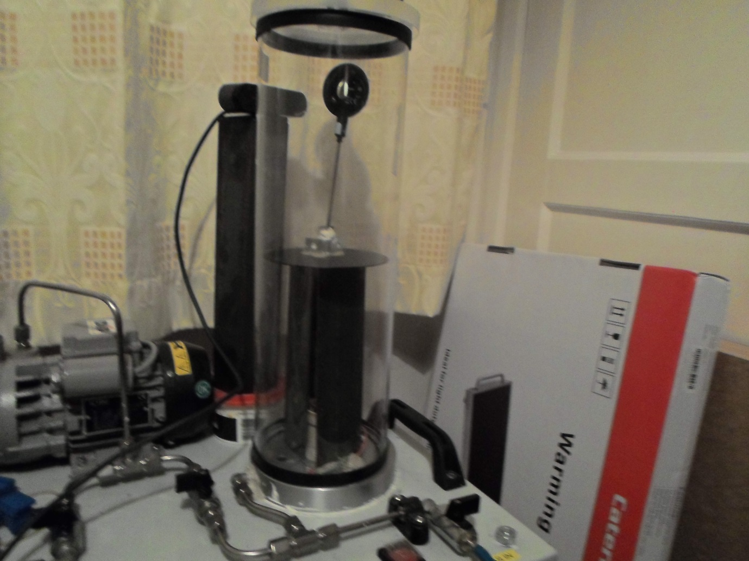

There is no contact between the metal plate and the vacuum chamber.

|  |  |  |  |  |  |  |
| --- | --- | --- | --- | --- | --- | --- |
| **Experiment No 2 - Single Plate in Vacuum in Chamber** | | | | | |  |
| **Test No** | **Start Temp** | **Max Temp** | **Increase** | **Cooling** | **Reduction** | **Notes** |
| 1 | 22.3 | 70.9 | 48.6 | n / a | **n / a** | Cold Start. 2 Hour heating, 20 min cd. Video corrupted on cooldown. |
| 2 | 29.1 | 70.9 | 41.8 | 49 | **-20.9** | 2 hour heating, 20 min cd. |
| 3 | 47.4 | 68.5 | 21.1 | 48 | **-20.9** | 60 min heating, 20 min cd. |
| 4 | 46.9 | 70.8 | 23.9 | 49.9 | **-20.1** | 60 min heating, 20 min cd. |
| 5 | 48.1 | 69.6 | 21.5 | 48.5 | **-21.3** | 60 min heating, 20 min cd. |
| **Min** | | **68.5** | **21.1** | **48** | **-20.1** |  |
| **Mean** | | **70.14** | **31.38** | **39.08** | **-16.64** |  |
| **Max** | | **70.9** | **48.6** | **49.9** | **-21.3** |  |
| **Range** | | **2.4** | **27.5** | **1.9** | **-1.2** | Larger range on increase, due to reheats needing only 1 hour to reach max. |

The first test didn’t quite work correctly as the video corrupted on the first cool-down and I tried to do it again, but ended up leaving the unit to cool too long when trying to fix it. So on the 2nd test the heating period was 2 hours long, similar to the 1st. To be honest I wasn’t expecting such software fails. No idea why & it didn’t re-occur.

Here we can see that there is a peak maximum temperature of the plate of 70.9 with a range of just 2.4 degrees between the tests. I am not quite sure what cause’s the differences, as nothing changed. I am presuming that it must be as a result of electrical current fluctuations on the bulb and perhaps changes in air currents in the room which might affect the base, which is metal and connected to the plate via the metal stand, causing conductive loss fluctuations.

In future I will devise a new method of support with the aim of reducing such contact. Maybe I will use wood, or hangars instead.

Again, there are small breaks in between as video switch overs occur.

We can see the difference that removing convective cooling has on the plate. The temperature is some 30 degrees higher.

**Experiment 3 Twin Plate in Vacuum Chamber**

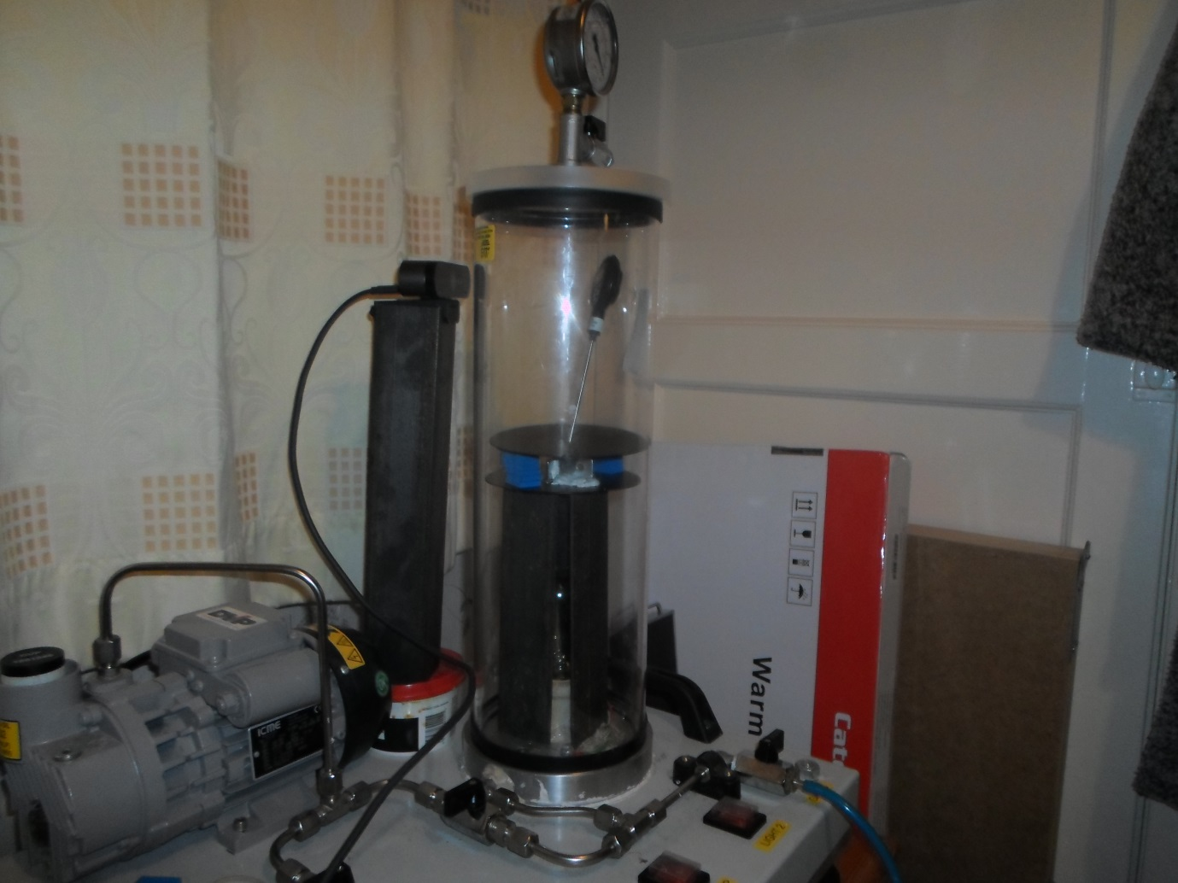

Again no contact between the plates and the vacuum chamber.

The only contact between the plates are the plastic spacers. The thermometer goes through a hole in the top plate.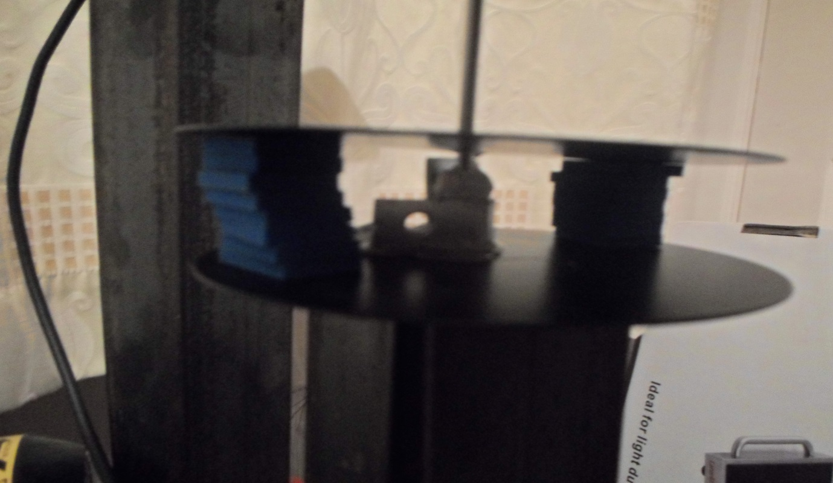

|  |  |  |  |  |  |  |
| --- | --- | --- | --- | --- | --- | --- |
| **Experiment No 3 - Twin Plate in Vacuum in Chamber** | | | | | |  |
| **Test No** | **Start Temp** | **Max Temp** | **Increase** | **Cooling** | **Reduction** | **Notes** |
| 1 | 22 | 68.5 | 46.5 | 50 | **-19.7** | 2 hour heat 20 min cd |
| 2 | 44.1 | 67.1 | 23 | 48.7 | **-18.5** | 1 hour heating 20 min cd |
| 3 | 35.1 | 67.1 | 32 | 48.9 | **-18.4** | 1 hour heating 20 min cd |
| 4 | 44.7 | 68.3 | 23.6 | 49.4 | **-18.9** | 1 hour heating 20 min cd |
| 5 | 20.4 | 69.9 | 48.6 | 48.6 | **-20.7** | 2 hour heat 20 min cd |
| **Min** | | **67.1** | **23** | **48.6** | **-18.4** |  |
| **Mean** | | **68.18** | **34.74** | **49.12** | **-19.24** |  |
| **Max** | | **69.9** | **48.6** | **50** | **-20.7** |  |
| **Range** | | **2.8** | **25.6** | **1.4** | **-2.3** |  |

I had dinner in between test 4 & 5 so I did a 2 hour heat.

All in all the results were quite similar with the 1 plate test. For information on test 5 it took 7.5 minutes to go from 68 degrees to 69 and it never got to 70. Thermal mass is added to the system due to an extra plate and some heat transfer from the 1st plate to the 2nd plate via the plastic spacers is causing lower peak steady state temperatures. That’s it.

I have to say, I was terribly disappointed, I was expecting the tipping point to be reached, 100 deg C plus temperatures as the amazing, ground-breaking complete smashing up of the 2nd Law of thermodynamics revealed itself to me in all its “green-plate glory.” Unfortunately, for all the twaddle talking alarmists out there, I can now show you all up & it’s only going to get better. Your talk is twaddle & your blabber is all “blah, blah, blah.”

On this experiment the maximum temperatures peaked on the lower end of the range of experiment two. This is because there is a small, loss from the first plate to the second plate, via conduction where the 1st plate supports the 2nd plate via the plastic spacers. These plastic spacers have far lower conductivity than the metal plates, but still, they act as small thermal bridges, enough to cause the peak temperatures to drop slightly. There isn’t any nullification occurring, there just isn’t any heat rise due to back irradiance, that is a false science.

It is also noticeable in the rates of warming to get to the steady state temperature, were slower and on average it took longer.

Yes this set up isn’t perfect, but I can improve upon it, make the necessary tweaks and run further tests no problems at all. Your magic won’t show itself, because it isn’t real. None of you can “SHOW ME NOW” your back radiant CO2 inducing warming. All the alarmists are fakers, their religion it is not real and it sure is not science.

Real science explains nature, real science aligns observations with theory. My explanations match the observations. My reasoning matches reality. Radiation greenhouse effect does no such thing, it fails to appear, under every circumstance, however tested, it just does not happen. **IT IS A LIE, A BIG LIE!**

Oh and yes, if I put an IR detector on the 1st plate, it would indeed detect IR coming from the 2nd plate, but SO WHAT. It meant nothing, there was no temperature rise at all. The 2nd plate is cooler than the 1st, so there is no mechanism at play which would enable higher peak temperatures. You can’t warm objects to higher temperatures using their own heat. There was no reduction in the rate of cooling, resulting in a faster rate of warming or higher peak temperatures, NONE. Some thermal mass was added and that was it.

The radiation greenhouse effect, IN ITS ENTIRETY, is all nothing but lies. The fake science of the phoney chicken little fanatics, is nothing more than the parading of parlour tricks, half-baked useless graphical data with no basis in reality & utterly pointless maths with no use in practical engineering & all designed with no purpose other than to con. They are exactly like the spiritualists that claim they can speak to your recently dead Auntie and Uncle, or detect water with broken sticks, or use magnetic wrist band beads to increase your strength. It’s all just a tissue of lies.

Oh and yes, you can stop hurricanes, but only if you buy this great new overpriced electric motorbike and pay your over the top carbon taxes. “Coughs loudly.”

If you went to a doctor with a broken arm and he showed you a graph telling you that drinking honey tea with lemon will cure it, no need for a sling or plaster, or an x-ray, threw a book at you called “the consensus of honey & lemon tea for fixing broken bones” and then told you drink it and you will be fine. Would you say, “Hey thanks doc, you been a great help”, or would you report him. Well that’s what every single climate alarmist is doing to you, they are fobbing you off with lies. Every single green politician, what every single UN IPCC pontificator. Every climate change committee, every Carbon Reduction emissions advisor. Fobbing you off, every last one.

Radiation Greenhouse effect, global warming, climate crisis & climate emergency has no foundations, none, it is all built on sand.

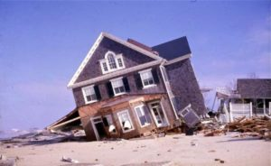

So tell your family, tell your friends, tell who ever happens to be in power in your area and demand ACTION. All those committing Climate Crisis Fraud, need to be held to account, sacked, fined & jailed, made to account for the crimes that they commit upon society.

How many people didn’t get the right medicinal treatment, because money was wasted on some stupid Carbon Saving scheme instead of Medicine? The real cost of CCF is unknown, it’s about time people examined it and laid the facts bare to the public. The public has a right to know and a right to be angry & so they should be. The largest scam in all of the history of human kind, is happening right now and it is being perpetrated upon us all, that includes YOU!

