School Psychology Review: https://www.tandfonline.com/uspr
NASP Members Full Access: https://apps.nasponline.org/resources-and-publications/periodicals/spr-launch.aspx

School Psychology Review contributes contemporary research preventing school violence and promoting school safety
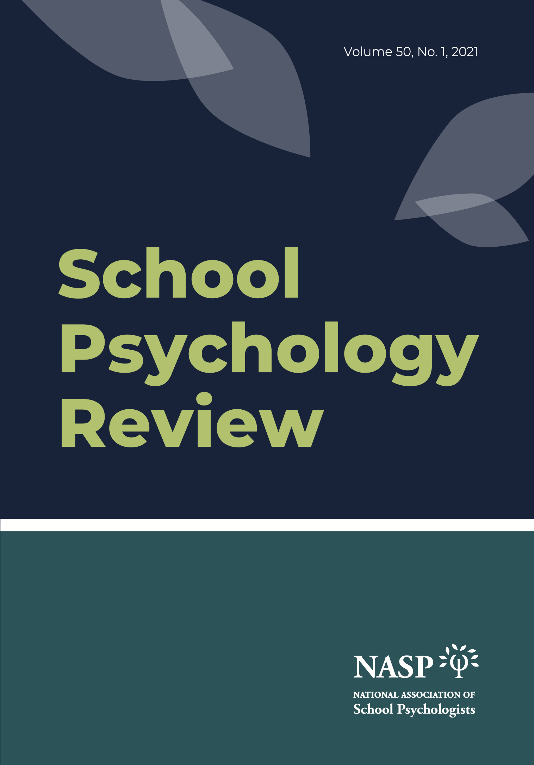

SPR Leadership Team members:

Editor | Shane R. Jimerson | University of California, Santa Barbara
Senior Editor | Jamilia J. Blake | Texas A&M University
Senior Editor | Gary L. Canivez | Eastern Illinois University
Senior Editor | Dorothy L. Espelage | University of North Carolina
Senior Editor | Jorge E. Gonzalez | University of Houston
Senior Editor | Amanda L. Sullivan | University of Minnesota
Senior Editor | Frank C. Worrell | University of California, Berkeley
Associate Editor | Prerna Arora | Teachers College, Columbia University
Associate Editor | Scott L. Graves | The Ohio State University
Associate Editor | Francis L. Huang | University of Missouri
Associate Editor | Stacy-Ann A. January | University of South Florida
Associate Editor | Tyler L. Renshaw | Utah State University
Associate Editor | Samuel Y. Song | University of Nevada, Las Vegas
Associate Editor | Cixin Wang | University of Maryland

In our ongoing efforts to bring science to practice, this document includes a listing of recent School Psychology Review articles that help to prevent school violence and promote school safety.

School Psychology Review (SPR) is a peer-reviewed journal published quarterly by NASP. The primary purpose of SPR is to provide a means for communicating scholarly advances in research, training, and practice related to psychology and education, and specifically to school psychology. Of particular interest are articles presenting original, data-based research that can contribute to the development of innovative intervention and prevention strategies and the evaluation of these approaches. SPR presents important conceptual developments and empirical findings from a wide range of disciplines (e.g., educational, child clinical, pediatric, community, and family psychology, as well as education and special education) and communicates advances from within school psychology to the broader educational and psychological communities.

School safety is necessary for students in schools to learn and experience a positive developmental trajectory. Problems of school violence have sequelae that are not always considered by educational and political leaders such that key issues may be conflated, minimized, distorted, or overstated, often hindering systematic progress. Efforts to promote school safety vary tremendously, with widespread efforts to “harden” schools focusing primarily on security approaches, often at the expense of focusing attention and resources to critical foci investigated in school safety research. Areas in need of further research include fostering a positive school climate, using authoritative approaches that balance structure and support, and creating multidisciplinary collaborative structures, such as threat assessment teams that follow a well-structured approach to analyzing and responding to signals of emerging problems. This special topic collection further advances the field of school safety research, employing a transdisciplinary approach that is distinct from interdisciplinary and cross-disciplinary approaches in that it is a more complex synthesis, going beyond discipline-specific views.

The purpose of this special topic focus is to examine multiple dimensions of school safety research, unpack empirically-based answers to key research questions, and enable a broad array of educational stakeholders to identify links to their own areas of school safety concerns. Recognizing transdisciplinary and interdisciplinary scholarship in this area, this collection features manuscripts from scholars across diverse disciplines and addressing a wide range of science informing and advancing our understanding related to preventing school violence and promoting school safety, including research that;

- expands contemporary understanding of school violence and school safety.
- advances understanding of factors related to diversity and equity that influence school violence and school safety.
- informs contemporary understanding of how school discipline and school organization impacts school violence and school safety.
- informs understanding of gun access related to school and community violence.
- informs understanding of threat assessment, school climate, positive behavioral supports, restorative justice, and other strategies to promote school safety.

This document may be valuable to inform school psychology practitioners, graduate students, and faculty about preventing school violence and promoting school safety.

Graduate educators may consider adding several of these articles to provide contemporary scholarship relevant to preventing school violence and promoting school safety.
School Psychology Review
Contributes Contemporary Research
Preventing School Violence and Promoting School Safety

Featuring Guest Editors: Matthew Mayer and Amanda Nickerson

Overview

Preventing School Violence and Promoting School Safety: Contemporary Scholarship Advancing Science, Practice, and Policy
Mayer, M. J., Nickerson, A. B., & Jimerson, S. R. (2021). Preventing school violence and promoting school safety: Contemporary scholarship advancing science, practice, and policy. School Psychology Review, 50, DOI: 10.1080/2372966X.2021.1949933

Conceptual Foundations

History and Future of School Safety Research
Cornell, D. G., Mayer, M. J., & Sulkowski, M. L. (2021). History and future of school safety research. School Psychology Review, 50, ppp-ppp. DOI: 10.1080/2372966X.2020.1857212

Safe Places to Learn: Advances in School Safety Research and Practice
Nickerson, A. B., Randa, R., Jimerson, S. R., & Guerra, N. G. (2021). Safe places to learn: Advances in school safety research and practice. School Psychology Review, 50, ppp-ppp. DOI: 10.1080/2372966X.2021.1871948

A Call for the Conceptual Integration of Opportunity Structures within School Safety Research
Astor, R. A., Noguera, P., Fergus, E., Gadsden, V., & Benbenishty, R. (2021). A call for the conceptual integration of opportunity structures within school safety research. School Psychology Review, 50, ppp-ppp. DOI: 10.1080/2372966X.2020.1854621

School Securitization and Its Alternatives: The Social, Political, and Contextual Drivers of School Safety Policy and Practice
Madfis, E., Hirschfield, P., & Addington, L. A. (2021). School securitization and its alternatives: The social, political, and contextual drivers of school safety policy and practice. School Psychology Review, 50, ppp-ppp. DOI: 10.1080/2372966X.2020.1855063

Good Intentions are Not Enough: Centering Equity in School Discipline Reform
Gregory, A., Osher, D., Bear, G. G., Jagers, R. J., & Sprague, J. R. (2021). Good intentions are not enough: Centering equity in school discipline reform. School Psychology Review, 50, ppp-ppp. DOI: 10.1080/2372966X.2020.1861911

Addressing School Safety through Comprehensive School Climate Approaches
Bradshaw, C. P., Cohen, J., Espelage, D. L., & Nation, M. (2021). Addressing school safety through comprehensive school climate approaches. School Psychology Review, 50, ppp-ppp. DOI: 10.1080/2372966X.2021.1926321

Guns, School Shooters and School Safety: What We Know and Directions for Change
Flannery, D. J., Fox, J. A., Wallace, L., Mulvey, E., & Modzeleski, W. (2021). Guns, school shooters, and school safety: What we know and directions for change. School Psychology Review, 50, ppp-ppp. DOI: 10.1080/2372966X.2020.1846458

Centering Race and Ethnicity in School Safety

Centering Race to Move Towards an Intersectional Ecological Framework for Defining School Safety for Black students
Elianny, E. (2021). Centering race to move towards an intersectional ecological framework for defining school safety for Black students. School Psychology Review, 50, ppp-ppp. DOI: 10.1080/2372966X.2021.1930580

Unequally Safe: Association Between Bullying and Perceived School Safety and the Moderating Effects of Race/Ethnicity, Gender, and Grade Levels
Yang, C., Lin, X., & Stomski, M. (2021). Unequally safe: Association between bullying and perceived school safety and the moderating effects of race/ethnicity, gender, and grade level. School Psychology Review, 50, ppp-ppp. DOI: 10.1080/2372966X.2020.1860427

Associations Between Community-level Racial Biases, Office Discipline Referrals, and Out-of-School Suspensions
Girvan, E. J., McIntosh, K. & Santiago-Rosario, M. R. (2021). Associations between community-level racial biases, office discipline referrals, and out-of-school suspensions. School Psychology Review, 50, ppp-ppp. DOI: 10.1080/2372966X.2020.1838232

An Intersectional Examination of the Effects of Race/Ethnicity and Immigrant Status on School Victimization in Predominantly Hispanic/Latino High Schools
Yang, C., Manchanda, S., Lin, X. & Teng, Z. (2021). An intersectional examination of the effects of race/ethnicity and immigrant status on school victimization in predominantly Hispanic/Latinx high schools. School Psychology Review, 50, ppp-ppp. DOI: 10.1080/2372966X.2020.1840262

School Connectedness and Bystander Intervention: The Moderating Role of Perceived Exclusion and Privilege among African American Students
Knox, J., Gibson, S., Gönültaş, S., & Mulvey, K. L. (2021). School connectedness and bystander intervention: The moderating role of perceived exclusion and privilege among African American students. School Psychology Review, 50, ppp-ppp. DOI: 10.1080/2372966X.2020.1846459

School Resource Officers’ Training and Roles

School Resource Officers’ Roles Differ in the Prediction of Nonviolent and Serious Violent Incident Events
Stevens, T., Barnard-Brak, L., & Jackson, J. (2021). School Resource Officers’ Roles Differ in the Prediction of Nonviolent and Serious Violent Incident Events. School Psychology Review, 50, ppp-ppp. DOI: https://doi.org/10.1080/2372966X.2021.1886837

Trauma Informed Care in Schools: Perspectives from School Resource Officers & School Security Personnel During Professional Development Training
Forber-Pratt, A. J., El Sheikh, A. J., Robinson, L. E., Espelage, D. L., Ingram, K. M., Valido, A., & Torgal, C. (2021). Trauma-informed care in schools: Perspectives from school resource officers and school security professionals during professional development training. School Psychology Review, 50, ppp-ppp. DOI: 10.1080/2372966X.2020.1832863

The Influence of School Resource Officer Presence on Teacher Perceptions of School Safety and Security
Wood, B. J. & Hampton, E. (2021). The influence of school resource officer presence on teacher perceptions of school safety and security. School Psychology Review, 50, ppp-ppp. DOI: 10.1080/2372966X.2020.1844547

Discipline and School Climate

Mind the Gap: A Systematic Review of Research on Restorative Practices in Schools
Zakszeski, B. & Rutherford, L. (2021). Mind the gap: A systematic review of research on restorative practices in schools. School Psychology Review, 50, ppp-ppp. DOI: 10.1080/2372966X.2020.1852056

Teacher Support for Zero Tolerance is Associated with Higher Suspension Rates and Lower Feelings of Safety
Huang, F. L., & Cornell, D. G. (2021). Teacher support for zero tolerance is associated with higher suspension rates and lower feelings of safety. School Psychology Review, 50(2), ppp-ppp. DOI: 10.1080/2372966X.2020.1832865

Teacher Perceptions Matter: Psychometric Properties the Georgia School Personnel Survey of School Climate
Saint, J., Rice, K. G., Varjas, K., & Meters, J. (2021). Teacher perceptions matter: Psychometric properties of the Georgia School Personnel Survey of School Climate. School Psychology Review, 50, ppp-ppp. doi: 10.1080/2372966X.2021.1958645

Bullying and Peer Victimization

Patterns and Pathways of Peer Victimization across the Transition to Middle School
Splett, J., Monachino, C., Shen, Z., Cornett, S., Halliday, C., & Weist, M. (2021). Patterns and Pathways of Peer Victimization across the Transition to Middle School. School Psychology Review, 50, ppp-ppp. doi: 10.1080/2372966X.2021.1904792

Perceptions of Emotional and Physical Safety Among Boarding Students and Associations with School Bullying
Fredrick, S. S., McClemont, A. J., Jenkins, L. N., & Kern, M. (2021). Perceptions of emotional and physical safety among boarding students and associations with school bullying. School Psychology Review, 50, ppp-ppp. DOI: 10.1080/2372966X.2021.1873705

Scaling and Disseminating Brief Bullying Prevention Programming: Strengths, Challenges, & Considerations
Leff, S. S., Waasdorp, T. E., Paskewich, B. S., & Winston, F. K. (2021). Scaling and disseminating brief bullying prevention programming: Strengths, challenges, and considerations. School Psychology Review, 50, ppp-ppp. DOI: 10.1080/2372966X.2020.1851612

