School Psychology Review: https://www.tandfonline.com/uspr
NASP Members Full Access: https://apps.nasponline.org/resources-and-publications/periodicals/spr-launch.aspx

School Psychology Review provides contemporary research regarding promoting youth mental health at school
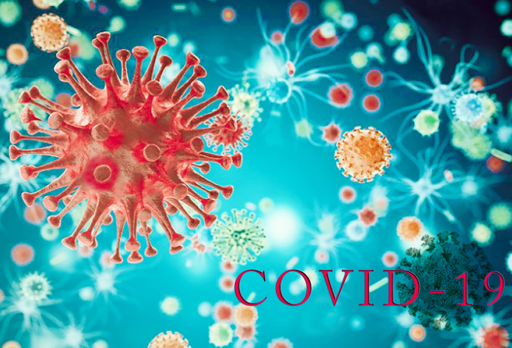
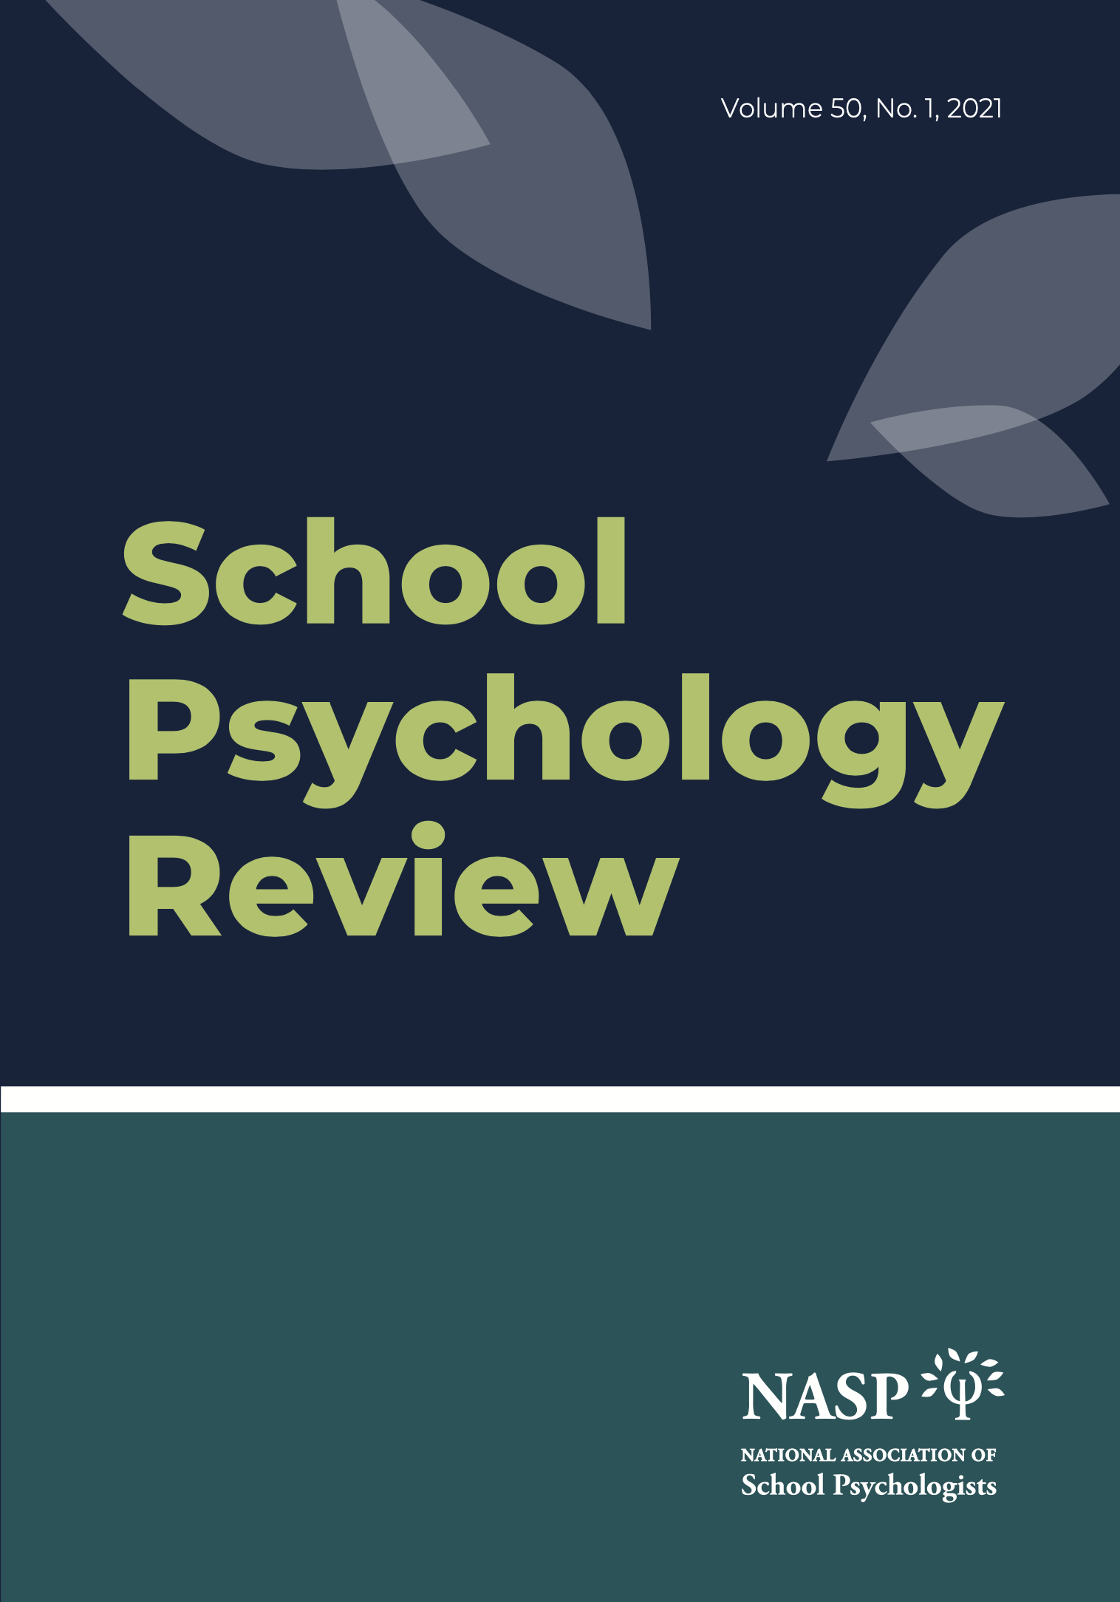

SPR Leadership Team members:

Editor | Shane R. Jimerson | University of California, Santa Barbara
Senior Editor | Jamilia J. Blake | Texas A&M University
Senior Editor | Gary L. Canivez | Eastern Illinois University
Senior Editor | Dorothy L. Espelage | University of North Carolina
Senior Editor | Jorge E. Gonzalez | University of Houston
Senior Editor | Amanda L. Sullivan | University of Minnesota
Senior Editor | Frank C. Worrell | University of California, Berkeley
Associate Editor | Prerna Arora | Teachers College, Columbia University
Associate Editor | Scott L. Graves | The Ohio State University
Associate Editor | Francis L. Huang | University of Missouri
Associate Editor | Stacy-Ann A. January | University of South Florida
Associate Editor | Tyler L. Renshaw | Utah State University
Associate Editor | Samuel Y. Song | University of Nevada, Las Vegas
Associate Editor | Cixin Wang | University of Maryland

In our ongoing efforts to bring science to practice, this document includes a listing of recent School Psychology Review articles that address the COVID-19 pandemic and school psychology.

School Psychology Review (SPR) is a peer-reviewed journal published quarterly by NASP. The primary purpose of SPR is to provide a means for communicating scholarly advances in research, training, and practice related to psychology and education, and specifically to school psychology. Of particular interest are articles presenting original, data-based research that can contribute to the development of innovative intervention and prevention strategies and the evaluation of these approaches. SPR presents important conceptual developments and empirical findings from a wide range of disciplines (e.g., educational, child clinical, pediatric, community, and family psychology, as well as education and special education) and communicates advances from within school psychology to the broader educational and psychological communities.

The 2020 Coronavirus Pandemic is recognized as a severe global health crisis. Coined as a “once- in-a-century pandemic” (Gates, 2020), societies and populations around the world are faced by massive, unprecedented challenges, disrupting essential aspects of public, economic, and private life. School psychology practice has had to adapt to the pandemic acutely and the question remains whether these changes will (and should be) permanent changes in school psychology as a field. The articles in this special topic collection include submissions from nationally and internationally prominent scholars and practitioner-scholars, which focus on understanding the roles of school psychologists and educators in short-term and long-term responses towards COVID, and further bridge the research-to-practice gap by including empirical papers on theory, research, practice, and policy.

The COVID-19 pandemic has had an unprecedented impact on children, families, and schools in the U.S. While most schools in the U.S. were closed at some point during the pandemic and students participated in home-based online learning during this pandemic, students have experienced many challenges including disruption in academic learning, social isolation, economic recession, and greater screen time. Schools offer not only education services, but also many other services to students (such as food/nutrition, healthcare, co-curricular activities, and mental health services). The research reveals that the pandemic has negatively impacted youth mental health and social, emotional, psychological and educational well-being (Golberstein, Wen, & Miller, 2020). The impact may be even greater for students with disabilities, and students from culturally linguistically diverse families that are more severely influenced by COVID-19. This research informs school psychologists and education professionals to address the educational and psychological impacts of the pandemic in the schools they serve (e.g., with students, parents, teachers, school systems).
Articles address a range of topics, including: 1) social, emotional, psychological and educational, effects of the pandemic for children, families, and educators: 2) modifications to assessment, intervention, and other forms of service delivery supported with empirical data, and 3) adaptations to support training and education in school psychology.

This document may be valuable to inform school psychology practitioners, graduate students, and faculty about COVID-19 and school psychology.

Graduate educators may consider adding several of these articles to provide contemporary scholarship relevant to COVID-19 and school psychology.

School Psychology Review
Features Contemporary Research Regarding
Promoting Youth Mental Health at School

A Public Health Approach to Reducing the Societal Prevalence and Burden of Youth Mental Health Problems: Introduction to the Special Issue
Herman, K. C., Reinke, W. M., Thompson, A. M., Hawley, K. M., Wallis, K., Stormont, M. & Peters, C. (2021). A public health approach to reducing the societal prevalence and burden of youth mental health problems: Introduction to the special issue. School Psychology Review, 50(1), 8-16, DOI: https://doi.org/10.1080/2372966X.2020.1827682

Investigating the Longitudinal Association Between Fidelity to a Large-Scale Comprehensive School Mental Health Prevention and Intervention Model and Student Outcomes
Reinke, W. M., Herman, K. C., Thompson, A., Copeland, C., McCall, C. S., Holmes, S., & Owens, S. A. (2021). Investigating the longitudinal association between fidelity to a large-scale comprehensive school mental health prevention and intervention model and student outcomes. School Psychology Review, 50(1), 17–29. https://doi.org/10.1080/2372966X.2020.1870869

Impact of the Family Access Center of Excellence (FACE) on Behavioral and Educational Outcomes—A Quasi-Experimental Study
Thompson, A. M., Herman, K. C., Reinke, W. M., Hawley, K., Peters, C., Ehret, A., Hobbs, A., & Elmore, R. (2021). Impact of the family access center of excellence (face) on behavioral and educational outcomes—A quasi-experimental study. School Psychology Review, 50(1), 30–35. https://doi.org/10.1080/2372966X.2020.1841545

Evaluation of a Social Media Campaign on Youth Mental Health Stigma and Help-Seeking
Thompson, A., Hollis, S., Herman, K. C., Reinke, W. M., Hawley, K., & Magee S. (2021). Evaluation of a social media campaign on youth mental health stigma and help-seeking. School Psychology Review, 50(1), 36–41. https://doi.org/10.1080/2372966X.2020.1838873

Designing Interventions for Implementation in Schools: A Multimethod Investigation of Fidelity of a Self-Monitoring Intervention
Holmes, S. R., Thompson, A. M., Herman, K. C., & Reinke, W. M. (2021). Designing interventions for implementation in schools: A multimethod investigation of fidelity of a self-monitoring intervention. School Psychology Review, 50(1), 42-51. https://doi.org/10.1080/2372966X.2020.1870868

Randomized Trial of Show Me FIRST: A Brief School-Based Intervention for Internalizing Concerns
Cho, E., Strawhun, J., Owens, S. A., Tugendrajch, S. K., & Hawley, K. M. (2021). Randomized trial of show me FIRST: A brief school-based intervention for internalizing concerns. School Psychology Review, 50(1), 52–61. https://doi.org/10.1080/2372966X.2020.1836944

Motivational Interviewing With At-Risk Students (MARS) Mentoring: Addressing the Unique Mental Health Needs of Students in Alternative School Placements
Henry, L., Reinke, W. M., Herman, K. C., Thompson, A. M., & Lewis, C. G. (2021). Motivational interviewing with at-risk students (MARS) mentoring: Addressing the unique mental health needs of students in alternative school placements. School Psychology Review, 50(1), 62–74. https://doi.org/10.1080/2372966X.2020.1827679

Sustained Effects of a School-Based Psychiatry Program
Cho, E., Marriott, B. R., Herman, K. C., Schutz, C. L., & Young-Walker, L. (2021). Sustained effects of a school-based psychiatry program. School Psychology Review, 50(1), 75–80. https://doi.org/10.1080/2372966X.2020.1811063

Results From a Statewide School-Based Mental Health Program: Effects on School Climate
DiGirolamo, A. M., Desai, D., Farmer, D., McLaren, S., Whitmore, A., McKay, D., Fitzgerald, L., Pearson, S., & McGiboney, G. (2021). Results from a statewide school-based mental health program: Effects on school climate. School Psychology Review, 50(1), 81–98. https://doi.org/10.1080/2372966X.2020.1837607

Scaling Up Behavioral Health Promotion Efforts in Maryland: The Economic Benefit of Positive Behavioral Interventions and Supports
Bradshaw, C. P., Lindstrom Johnson, S., Zhu, Y., & Pas, E. T. (2021). Scaling up behavioral health promotion efforts in Maryland: The economic benefit of positive behavioral interventions and supports. School Psychology Review, 50(1), 99-109. https://doi.org/10.1080/2372966X.2020.1823797

Building Policy Support for School Mental Health in South Carolina
Blackburn Franke, K., Paton, M., & Weist, M. (2021). Building policy support for school mental health in South Carolina. School Psychology Review, 50(1), 110–121. https://doi.org/10.1080/2372966X.2020.1819756

Reducing the Societal Prevalence and Burden of Youth Mental Health Problems: Lessons Learned and Next Steps
Herman, K. C., Reinke, W. M., Thompson, A. M., Hawley, K. M., & Stormont, M. (2021). Reducing the societal prevalence and burden of youth mental health problems: Lessons learned and next steps. School Psychology Review, 50(1), 122–130. https://doi.org/10.1080/2372966X.2020.1827683

