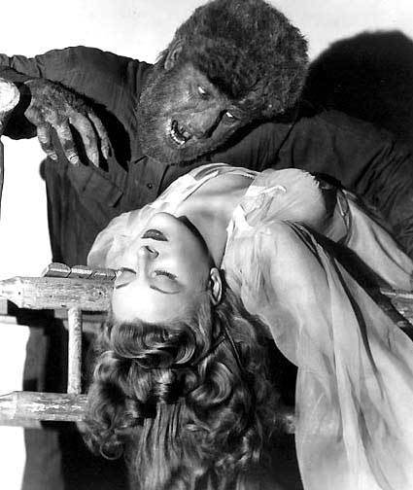

*Films representing the best in  
Sci-Fi, Fantasy and Horror*

**This is a fundraiser for Organic Fit Kids— which teaches children, parents, teachers and school board administrators about healthy eating, exercise, and wellness. Find out more by going to OrganicFitKids.com.**

**Barry’s  
Science Fiction, Fantasy & Horror  
Short Film Festival Tour**

**The Premiere of some of the  
most exciting Independent films  
from around the world.**

**Thursday, October 23rd, 2014  
Flix Brewhouse, 2200 Interstate 35  
Frontage Rd, Round Rock, TX 78681**

Show Times: 7:00 pm and 10:00 pm  
Tickets Available online at Flixbrewhouse.com

**Tickets are $15.00.   
For Tickets and information, call (512) 244-3549**  
copyright © 2014 ALL RIGHTS RESERVED