Project : StratML

1. Here is the result list.
Description of some files is not coming here.

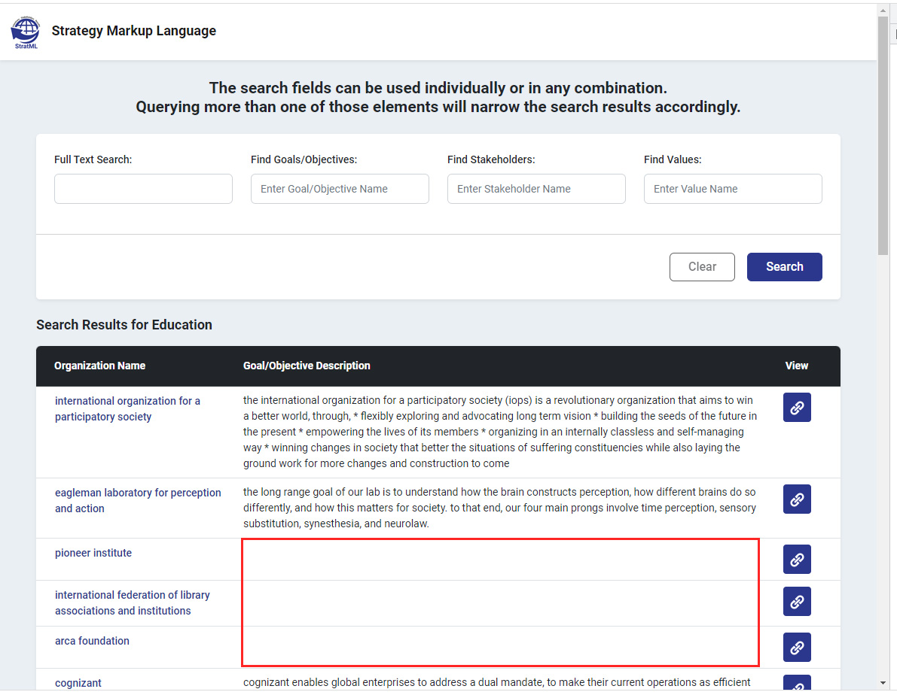

2. We have taken the first tag description from the xml file.
Some files don't have these titles.

3. If we saw the xml files then the description tag may be some other tag also.
So which description tag to pick



