NNLM All of Us CEC Community Award

Social Media Toolkit for Partners

Thank you for promoting our new Community Awards! We invite you to reshare/post the following from the NNLM All of Us Community Engagement Network Facebook and Twitter pages when possible.

Social Media Pages
Facebook: @NNLMCEN (https://www.facebook.com/NNLMCEN)
Twitter: @nnlmAoU (https://twitter.com/nnlmAoU)

Hashtag Ideas
#LibraryFunding #PublicLibraries #FundingOpportunity

Important Links
- RFP Webpage: bit.ly/CECAwards
- Award Interest Form: bit.ly/CECAwardInterest
- Technical Assistance Registration: cecawardwebinar.eventbrite.com

Images for Use/Distribution [ensuring ADA compliant]:
PNG files of images should be attached to the email with this document. Please contact Sharon-han@uiowa.edu if you are interested in other images.
Image Name | Preview | Alt-Text
Award Type - general | 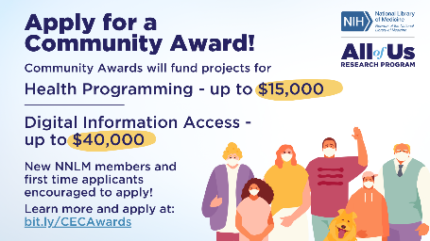 | Graphic with light blue background. Cartoon graphic of people and one dog, all wearing masks, in the lower right-hand corner. Text says “Apply for a Community Award! Community Awards will fund projects for Health Programming up to $15,000 and Digital Information Access up to $40,000. New NNLM members and first-time applicants encouraged to apply! Learn more and apply at bit.ly/CECAwards.”
Community Awards – Library Square | 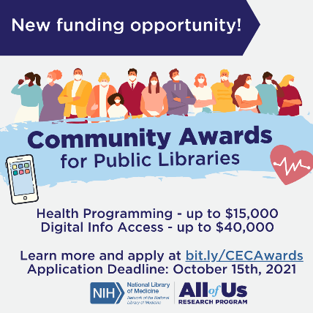 | Square graphic with light gray background. Navy bar on top reads “new funding opportunity!” Cartoon image of people wearing masks standing in a row with blue brushstroke over them. Text reads “Community Awards for Public Libraries” with icon of heart on right, icon of cell phone on left. Text below says “Health programming up to $15,000. Digital Info Access up to $40,000. Learn more and apply at bit.ly/CECAwards. Application Deadline: October 15th, 2021.”

Twitter Posts
Language (check for <280 char) | Image
@nnlmAoU is offering $15,000 awards for health programs and $40,000 awards for digital information access projects. Great funding opportunity for public libraries and community orgs! Apps due 10/15. To learn more: bit.ly/CECAwards | Award type - General
DYK: your free NNLM membership makes your library eligible for funding like Community Awards from @nnlmAoU? Apps due 10/15. Learn more and apply today: bit.ly/CECAwards | Award type - General
Is your library looking to improve health programs and digital info access in your community? Apply for a Community Award! Apps due 10/15. To learn more: bit.ly/CECAwards | Community Awards – Library Square

Facebook/LinkedIn/Email
Language | Image
The NNLM All of Us Community Engagement Center invites public libraries and community-based organizations to apply to fund projects for health programming (up to $15,000 each) and digital information access (up to $40,000 each). This is a great opportunity to support online events, community outreach, loanable technology, and more!  Applications due October 15, 2021.  More information about the award and application process can be found at: https://bit.ly/CECAwards | Award type - general

Questions/Suggestions?
Contact Sharon Han, CEC Engagement Specialist, at sharon-han@uiowa.edu.

