The Willamette Valley Legislative Fellowship is a competitive 11-week fellowship hosted by House Speaker Dan Rayfield during the lead up to the 2022 General Election. During the fellowship, students work on campaigns for legislative elections across the state, develop policy for the upcoming 2023 legislative session, and participate in a unique guest-speaker series with policy and campaign experts.
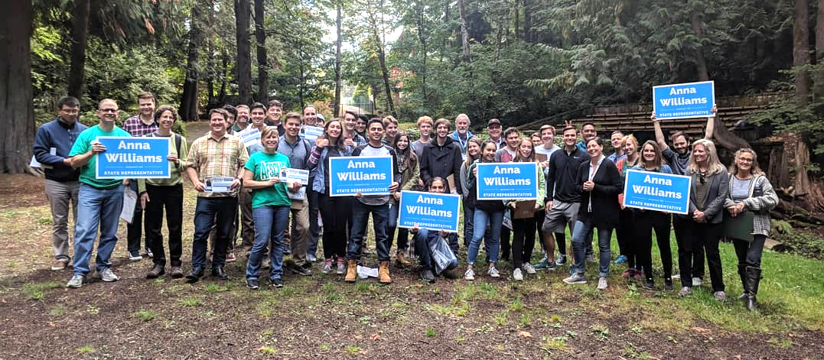
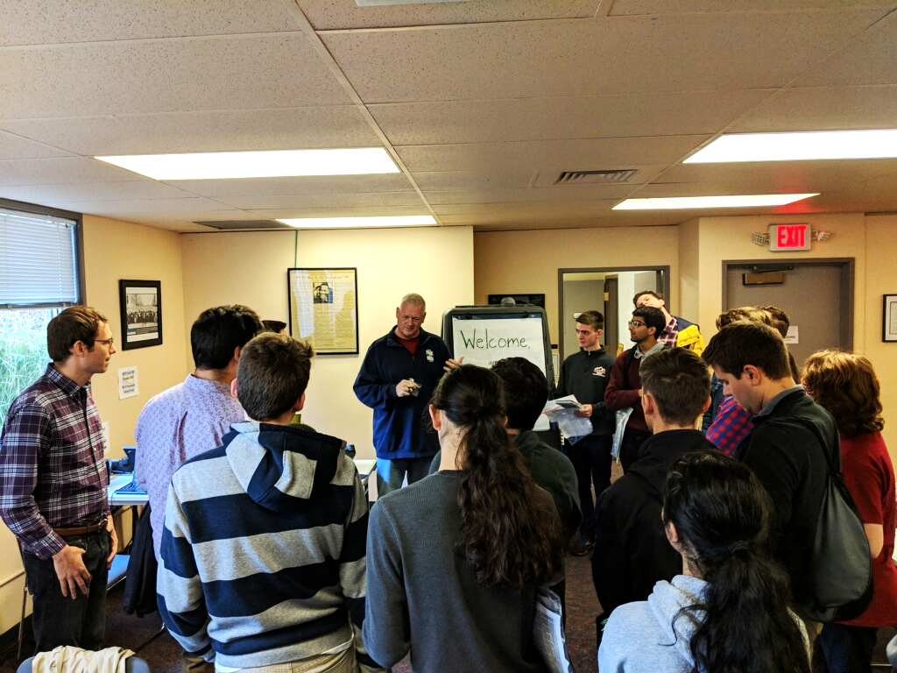

Fellowship Structure:
- The Legislative Fellowship takes place over an 11-week period from August 21st, 2022, to November 8th, 2022, and consists of three core aspects.
  - Policy Development: Fellows work with peers in a policy group based on their areas of interest to develop a policy concept. The strongest proposal(s) are drafted by Speaker Rayfield’s office for consideration during the 2023 Legislative Session.
  - Campaign Events: Fellows will receive training to use skills developed to staff campaign events held throughout the state. During the events, fellows network with staff, current representatives, and candidates seeking legislative office, while developing practical campaign experience. Transportation and food are provided for weekend events.
  - Workshops/Guest-Speaker Series: Fellows learn from guest speakers in various fields of expertise and develop skills that will be implemented in practical settings during the program. Workshops take place every Thursday evening throughout the 11-week program.

Guest Speaker Workshops: (Note: Fellowship will still meet on Thursdays with no guest speaker)
- Workshop 1 – 9/1
  - Developing & Drafting Good Policy
- Workshop 2 – 9/8:
  - Implementing Field Work Strategy
- Workshop 3 – 9/22:
  - Voter Database Tutorial & Targeting

- Workshop 4 – 9/29:
  - Campaign & Candidate Management
- Workshop 5 – 10/6:
  - Building a Successful Fundraising Plan
- Workshop 6 – 10/20:
  - Crafting Effective Messaging

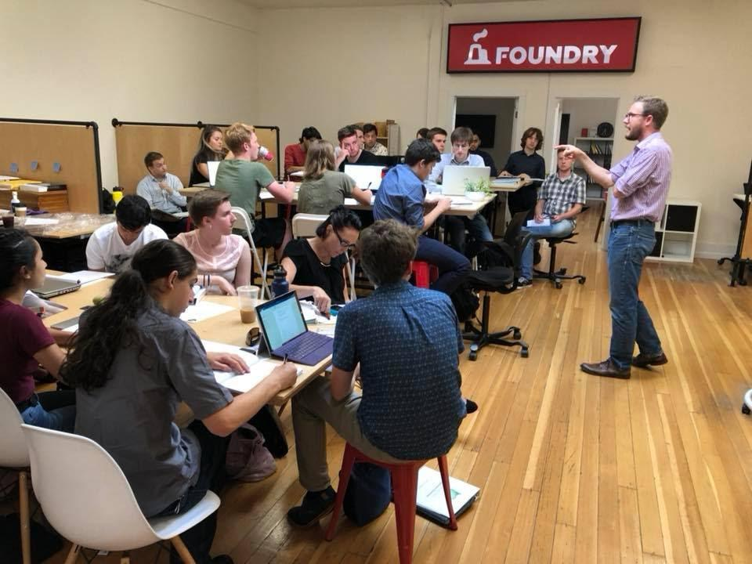
Compensation:
- A $500 stipend will be provided to participants who complete all fellowship requirements.
- Some students may be eligible for college credit with their respective schools.

Requirements:
- Time commitment:
  - Guest Speaker Workshops: Every Thursday evening, beginning August 25th and ending on Election Night.
  - Group Policy Work: Each Thursday during workshops fellows will work with their peers to develop a policy concept. Fellows will also need to work with their group outside of scheduled workshops to formulate policy, connect with stakeholders, and produce messaging.
  - Weekend Campaign Events: Fellows will be responsible for attending nine weekend events.
- Interest in pursuing a college degree.
- Preferred Experience:
  - Political interest
  - Written and oral communication skills
  - Ability to work well with others in a collaborative process
  - Ability to complete work independently

Selection Process:
- The application process will open May 2nd, 2022 and close June 3rd, 2022.
- To apply, complete the following steps:
- Complete the online application at http://www.danrayfield.com/Fellowship
- Submit a resume, cover letter indicating why you are applying for the fellowship, and a headshot to Jack Lehman at jack@danrayfield.com.
- Qualified applicants will be contacted for an interview within a week of their application submission.

Questions?
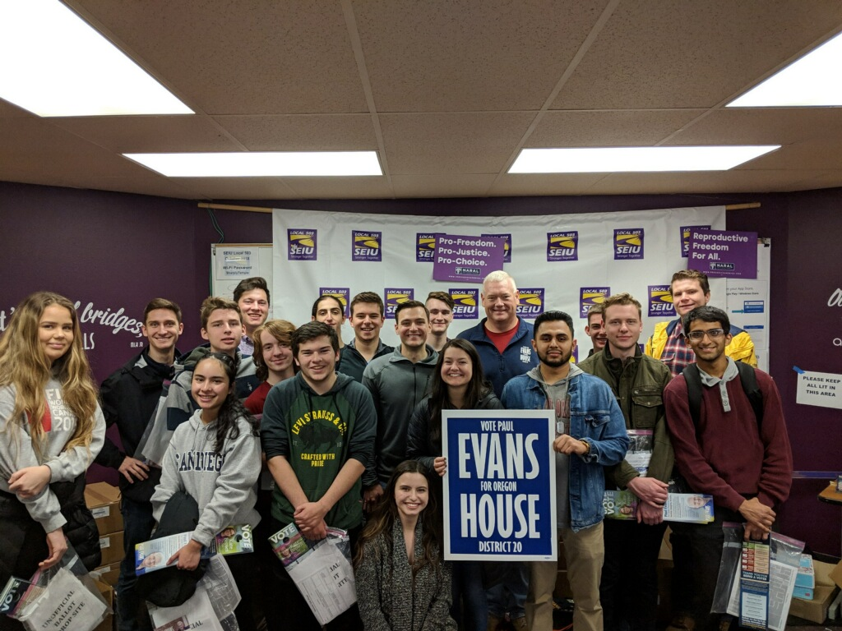
Please contact Jack Lehman at 541-609-0036 or jack@danrayfield.com with any questions!

