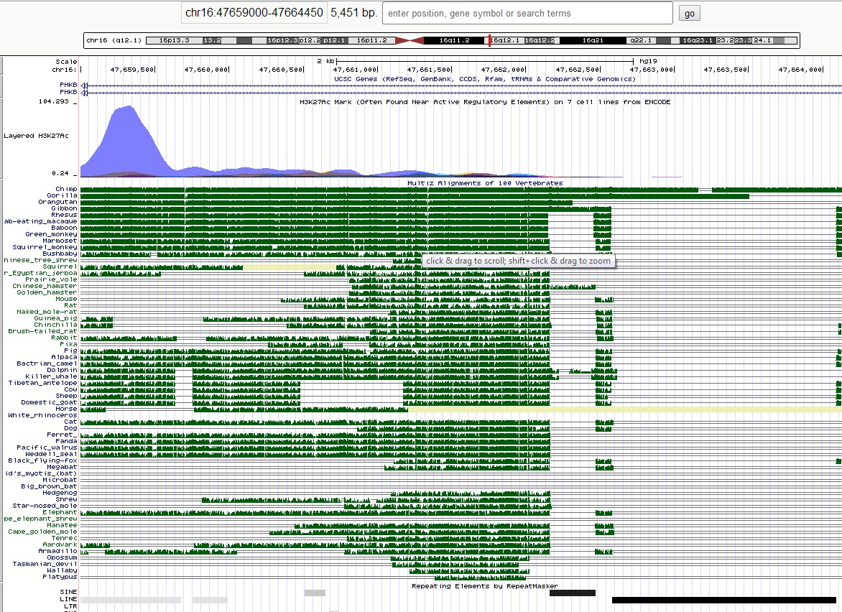

Fig 1. Conservation of lncRNA

Fig.2. Phylogenetic tree constructed based on the above sequence conservation

