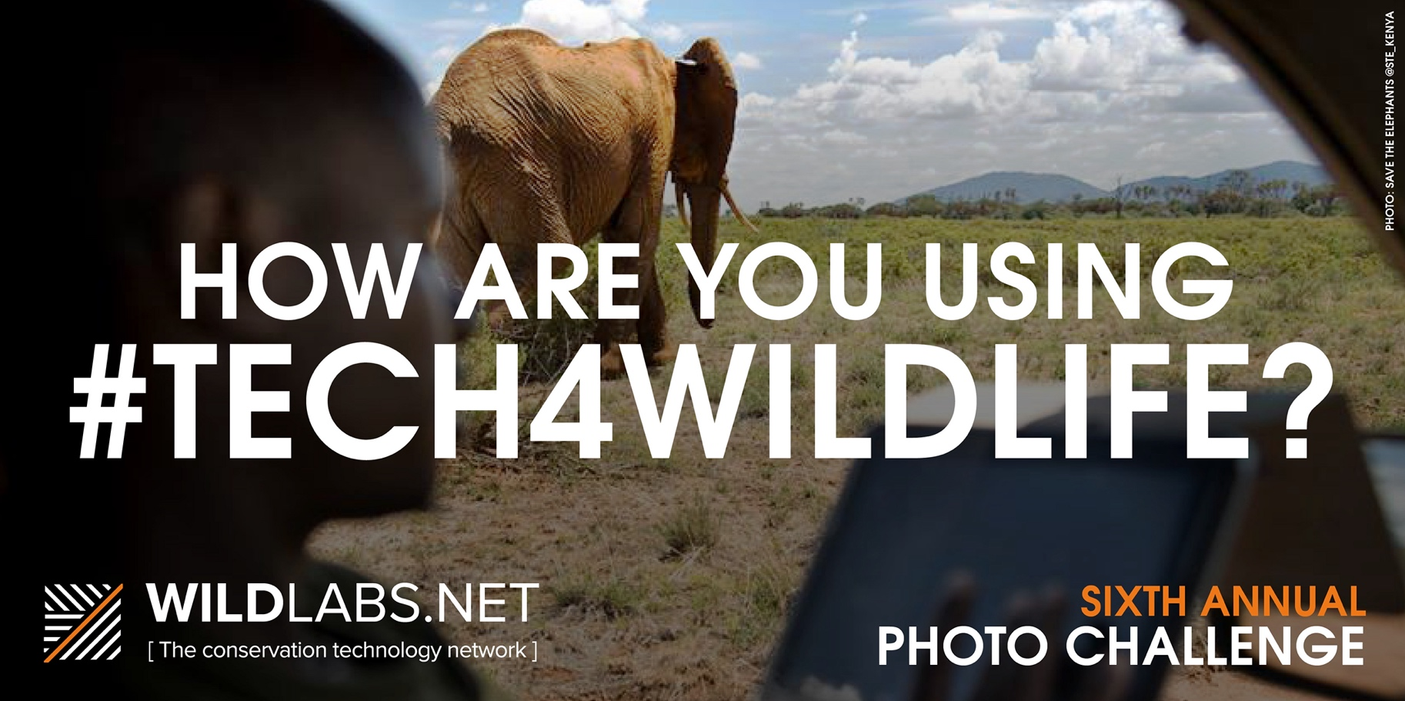

On Wednesday 24th February, we will launch our Sixth Annual #Tech4Wildlife Photo Challenge.
We’re asking for your help to get the word out – see end of document for suggested posts.
Every year, we celebrate World Wildlife Day on March 3 by asking users of conservation tech to share photos on Twitter of how they use tech in the field and the lab, using the #Tech4Wildlife hashtag. This is your chance to show off your best photos and share the diverse, innovative ways you are using tech for wildlife conservation.
Last year, we saw orca biologging tags collecting movement data and HD video footage in Norway, a collaborative camera trap project that studied predator/prey relationships by using auditory cues, non-invasive monitoring techniques to identify individual big cats by footprints, machine learning to study bat populations, ROVS and drones surveying for ghost gear underwater in Myanmar and the Indian Ocean, camera collars to capture behavioral data, and much more! So we want to know: how are you using #Tech4Wildlife?
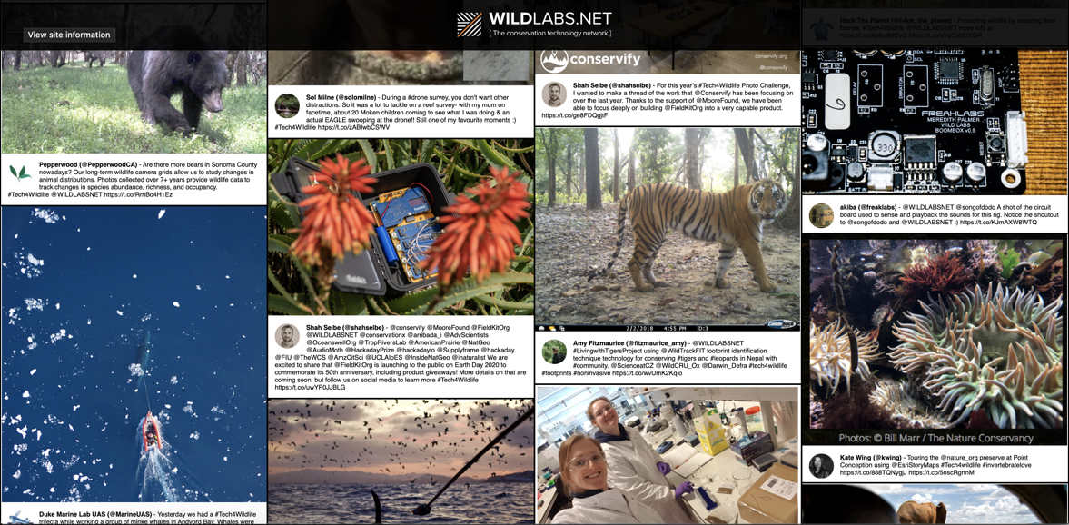
The #tech4wildlife feed is a valuable visual resource mapping the breath of technology projects in conservation

By participating, you’ll join hundreds of other users of conservation tech and draw attention to all the ways in which tech can be used to support wildlife conservation. In six years, we've seen over 6,000 tweets around the hashtag, with more than 1000 photos and videos posted by our community showing how they're using tech in the wild. Images from our #Tech4Wildlife Photo Challenge have reached more than 1.5 million people, establishing our #tech4wildlife hashtag as the go-to place for conservation tech on twitter and raising awareness for all the vital conservation work happening within our community on every continent around the globe.

This has been a huge year for the #tech4wildlife community online. In spite of worldwide lockdowns, cancelled field seasons, and other disruptions to conservation tech work, this community has continued to grow. We want to make this year’s #Tech4Wildlife Photo Challenge bigger than ever, to celebrate all our community and welcome everyone into the world of conservation tech!
We’d love to see what you’re working on, which is why we’ve reached out specially to invite you to join in this year’s challenge. To join, all you need to do is:
- Take a photo of how you are using tech to help wildlife (or find an old favourite photo from past field seasons!)
- Share it on Twitter: tell us a bit about your work and the tech featured
- Remember to use the hashtag #Tech4Wildlife and tag us at @WILDLABSNET
We will feature all the images shared in our #Tech4Wildlife image feed on WILDLABS.NET, and on our Twitter feed throughout the week of the Photo Challenge! We’re also planning thematic days where we highlight projects shared in past years. You may want to join in on one of these themes if you have photos and projects that fit!
  - Thursday: Remember Fieldwork?
  - Friday: Remote Monitoring
  - Saturday: #Tech4wildlife Close to Home
  - Sunday: Collaboration
  - Monday: Fieldwork Fails
  - Tuesday: Big Ideas
  - Wednesday: Countdown, Our Top 10 for 2021
On March 3, we'll celebrate World Wildlife Day and highlight the very best images shared in the 2021 #Tech4Wildlife Photo Challenge. Make sure you share your photos before March 3rd to be considered for the #Tech4Wildlife honours list.
Find out more: www.wildlabs.net/tech4wildlife

FOR SHARING: Images and Suggested Posts
In this social media kit, we have included images and suggested posts for you to share the message about our annual photo challenge. The challenge is not limited to World Wildlife Day, so any social media posts about the challenge can go up in the days leading up to March 3rd. We’re aware that your social media calendars are likely to be quite busy on the day, so we will appreciate any time you can slot a post about the challenge in.
We will also be posting about the challenge from @WILDLABSNET, so please keep an eye out for opportunities to retweet relevant posts.
An easy retweet is our launch tweet on Wednesday. This will be pinned to the top of @WILDLABSNET profile on twitter here: https://twitter.com/wildlabsnet
IMAGES FOR SOCIAL MEDIA SHARING
Everything you need is here:
https://drive.google.com/drive/folders/14BPrFpNi27f3i4WlR6IKxH0Uqo-PmfBD?usp=sharing

If you’re interested in sharing the challenge from your accounts (we’d love if you would!), feel free to use any of the following resources.
- #tech4wildlife GIF:
  - https://gph.is/g/4AkNM6O
  - https://media.giphy.com/media/R1cbJ8CG4HEwVu0eyC/giphy.gif
- Images sized for Twitter:
  - https://drive.google.com/drive/folders/14BPrFpNi27f3i4WlR6IKxH0Uqo-PmfBD?usp=sharing
- Themes:
  - Thursday: Remember Fieldwork?
  - Friday: Remote Monitoring
  - Saturday: #Tech4wildlife Close to Home
  - Sunday: Collaboration
  - Monday: Fieldwork Fails
  - Tuesday: Big Ideas
  - Wednesday: Countdown, Our Top 10 for 2021
SUGGESTED SOCIAL MEDIA POSTS
Twitter
- Are you using tech for wildlife conservation? Join the @WILDLABS #Tech4wildlife Photo Challenge: snap a pic and tell us how you’re using #Tech4Wildlife this #worldwildlifeday https://wildlabs.net/tech4wildlife
- See how scientists are engineering technology for wildlife with @WILDLABSNET #tech4wildlife photo challenge https://wildlabs.net/tech4wildlife
- A pictures says a thousand words: share how you’re using #tech4wildlife with the @WILDLABSNET photo challenge: https://wildlabs.net/tech4wildlife
- Technology is helping protect wildlife on #worldwildlifeday. See how with the #Tech4wildlife Photo Challenge on @WILDLABSNET https://wildlabs.net/tech4wildlife
Facebook or Instagram
- Orca biologging tags collecting movement data and HD video footage in Norway, a collaborative camera trap project that studied predator/prey relationships by using auditory cues, non-invasive monitoring techniques to identify individual big cats by footprints, machine learning to study bat populations, and sensor kits deployed around the world. Last year, hundreds of field users shared how technology is helping wildlife conservation with the WILDLABS #Tech4Wildlife Photo Challenge on Twitter. So we want to know, how are you using #Tech4Wildlife? https://wildlabs.net/tech4wildlife
- Do you use technology for conservation? WILDLABS is celebrating World Wildlife Day with their annual #Tech4Wildlife photo challenge! To join in: snap a photo of how you use tech for wildlife conservation and share with the hashtag #Tech4Wildlife. Help show the variety of ways technology works for conservation. Find out more: https://wildlabs.net/tech4wildlife
- With World Wildlife Day approaching, we’re showcasing the strides that have been made in the development of conservation technology with the annual #Tech4Wildlife photo challenge. Join the conversation on Twitter and share an image of how you use #tech4wildlife. Find out more: https://wildlabs.net/tech4wildlife

