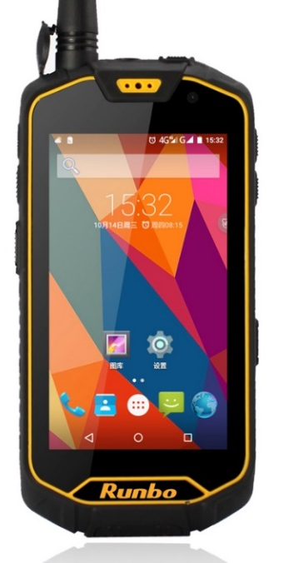
MAFC Scouts Guidelines for Using CyberTracker for Data Collection
Edited & reprinted with funding from;
Produced with funding
from;

Pre-Patrol Preparation

As a Patrol Leader, understand the need for patrols (why) and what to know when planning protection activities (what)?

- What are the threats?
- Where are the threats and which is the most threatened area?
- What are the resources available for protection activities?
- Where have the patrols covered already?
- Are the threats increasing or decreasing over time?
- Are we achieving our aim of protection?
- Are the patrols effective?
- To know this - we need information which comes from data recorded during patrols.

Understand the type of data required.
- Accurate
- Standardized
- Crime scene evidence
- Directly comparable across time and space
- Collected following systematic protocols

Understand what the data model in CyberTracker captures:
- Patrol set up
- Human sign/threats
- Carcass observations
- Wildlife observations

Note:
- Standard detail needs to be collected about each observation.
- Each observation needs to be geo-referenced with a date/time.
- Photos are to be taken where required or necessary.

Patrol Preparation

Patrol process in CyberTracker
- Patrol preparation
  - Check that phone are charged
  - Switch the phone on and ensure GPS is enabled
  - Wait for phone GPS to get a position – icon “”will disappear
  - Do not embark on patrol before phone gets GPS position
  - Carry backup GPS or phone.
  - Upload necessary coordinates to GPS handsets for GOTO function use (e.g. coordinates for poaching incident).

- Patrol start
- Always start with patrol start page
- Setup Patrol details:
- Patrol type
- Team
- Station
- Mandate
- Objective (if any)
- Comments (if any)
- Members
  - Always start patrol by marking a “Patrol Start” under Position, as the first observation.
- Patrol pause/resume
  - Use to record rests/breaks in patrol.

- Patrol end
  - Take point (End Patrol) to close every patrol
  - Exit CyberTracker: use code 1234
  - Be ready for the next patrol.
  - Recharge phone using battery pack or link to computer USB.
  - Ensure battery packs are always fully charged

On Patrol with CyberTracker

  - Keep the smartphone on during the patrol and not in hip pocket. Shirt pocket ok.
  - If there are changes to patrol - e.g. change transport type, patrol leader, patrol division, patrol mandate – DO END the patrol and then start a new patrol.
  - Adding a new observation versus add to previous observation. Ask patrol leads. E.g., if the item the same crime scene – use “add to previous observation”; if different crime scene, then it is a new observation.
  - Do NOT/NEVER use SKIP GPS in field (gives the waypoint 0.00 – 0.00).
  - Always acquire start and end patrol waypoints.

Frequently Asked Questions.

What should I do if SMART phone stops working?

  - Collect data using backup smartphone or GPS
and datasheets. Note down when the smart phone stopped working.
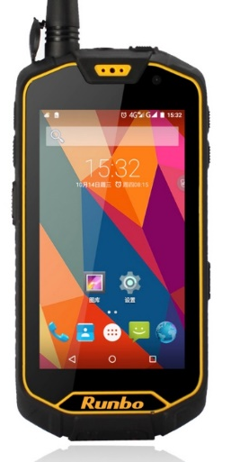

What should I do if Phone hangs?

  - DO NOT turn device off.
    - Click the home key (circled red at bottom of phone - see right) and then click on CyberTracker app icon

    - If that fails, Go to Settings/Apps/ CyberTracker and then:
  - Click ‘Force Stop’
  - Click ‘OK’
  - Click on CyberTracker icon to return to patrol data entry.

Caring for your Smart Phone

  - Keep your phone always Fully Charged. Smartphones work best and last longer when kept fully charged.
  - Avoid using a phone continuously until it completely runs out of power. Whenever you can, charge it. This should be especially so when you return from any patrol.

  - Ensure all phone ports are tightly sealed. An open port or any that is not tightly sealed allows in dust and water, making it fail to work.

  - Designate a safe place to keep and store your phone when not in use. It is a good practice to choose one spot where it always goes (near a charger) so that you can find it with ease.

  - Keep your phone dry and away from dust. It is a rugged smartphone and water proof, but hey, these properties often fail! Avoid placing it near water or carrying it near open water (such as a pond, the river, or toilets).

  - If there is something you do not understand on the phone, then do not do it. Leave it to the data manager.

Steps for SMART Data Entry from GPS

  - Entering Patrol Data From GPS (Note: This is the same process for entering Transect Survey Data)

In case you collect data using the GPS instead of the smartphone, the following is the procedure for downloading the data to a computer

  - Convert GPS waypoints into format that MapSource can read
    - Connect GPS to computer
    - Open dnrgps (Shortcut is on Taskbar)
    - Click on 'GPS'
    - Select 'Download All'
    - Select Waypoints to download and press 'OK'
    - Go to 'File'
    - Select 'Save To' and Choose 'File…'
    - Browse to Folder where file will be saved (C:\Users\USER\Desktop\M & R Data\FIELD DATA. All M&R Desktops should use this directory path)
    - Type file name. (Include outpost, GPS number and Date)
    - In 'Save as type' select 'GPS Exchange Format'
    - Select 'Save'
    - In next window tick 'Waypoints' and select 'OK'
    - Select 'OK' again. Close dnrgps.

- Convert dnrgps file created into format readable to smart using MapSource
  - Open MapSource (Shortcut is on Taskbar)
  - Go to 'File'
  - Click on Open
  - Browse to the file saved in C:\Users\USER\Desktop\M & R Data\FIELD DATA using DNR GPS
  - Select File and Click on 'Open'
  - Click on 'File'
  - Click on 'Save As…'
  - Browse to ‘MapSource Files', C:\Users\USER\Desktop\M & R Data\FIELD DATA and Open it by double clicking it.
  - Type file name. (Include outpost, GPS number and Date)
  - In 'Save as type' select 'GPS eXchange Format (*.gpx)'
  - Click on Save.
  - Close MapSource

- Open Saved Waypoints in SMART to create Patrols
  - Open SMART
  - Click on 'open new Patrol wizard'
  - Fill in the Patrol details and select the date range of all the data on the GPS and forms. click 'Finish' at the end
  - Click on 'Import Waypoints…'
  - Select 'GPX File' and click on 'Next'
  - Click on 'Add' button and browse to file saved in C:\Users\USER\Desktop\M & R Data\FIELD DATA\MapSource Files
  - Select File and Click on 'Open'
  - Click 'Import All (and assign to correct day)' option
  - Click on 'Finish'
  - Click on 'OK'
      - Setting up a patrol track in SMART

  - Option 1: Creating patrol tracks in SMART using downloaded GPS data
    - In SMART, Click on 'Set Track…'
    - Click on 'Generate from Waypoints'
    - Click 'Next'
    - Select 'Generate tracks from waypoints from all days'
    - Click on 'Finish'
    - Click on 'Ok'
    - Start entering the observation data from the data sheets

- Option 2: Converting patrol tracks and entering them into SMART (Only if Option 1 fails)
  - Converting Tracks in MapSource into format readable in SMART
    - Connect GPS to computer
    - Open MapSource (Shortcut is on Taskbar)
    - Click on 'Transfer'
    - Click on 'Receive From Device…'
    - Click on 'Tracks' (a tick mark appears)
    - Click on 'Receive'
    - Click on 'OK'
    - Click on 'File'
    - Click on 'Save As…'
    - Browse to ‘MapSource Files' save in C:\Users\USER\Desktop\M & R Data\FIELD DATA\MapSource Files and Open it by double clicking on it
    - Type file name (Start with 'Track - outpost, GPS number and Date’)
    - In 'Save as type' select 'GPS eXchange Format (*.gpx)'
    - Click on Save.
    - Close MapSource

- Open Saved Track in SMART to create Patrol track
  - In SMART, Click on 'Set Track…'
  - Select 'GPX File' and click on 'Next>'
  - Click on the 'Add' button and browse to track file saved in C:\Users\USER\Desktop\M & R Data\FIELD DATA\MapSource Files
  - Select File and Click on 'Open'
  - Click 'Import Only tracks for "date"
  - Click on 'Finish'
  - Click on 'OK'
  - Repeat this process for all the other days patrolled.
  - Start entering the observation data from the data sheets

