Inhalt
2 Classes 1
2.1 1PpsPlusTod_Pac 1
2.2 ClockSpec 2
2.3 NeSync_Pac 2
2.4 PhysicalLayerFrequencySync_Pac 3
2.5 PtpDomainConstraint_Pac 4
2.6 PtpSync_Pac 5
2.7 Ptp_Pac 7
2.8 SsmExternalClock_Pac 9
2.9 SsmInBand_Pac 10
2.10 SyncCdSpec 11
2.11 SyncLpSpec 12
2.12 SyncProtectionSpec 13
3 Data Types 14
3.1 ExternalTimePortDataset 14
3.2 IeeeEui64 16
3.3 PtpDefaultDataset 16
3.4 PtpMacEncapsulation 17
3.5 PtpSourceDataset 18
3.6 PtpTransparentClockDefaultDataset 21
3.7 PtpUdpEncapsulation 21
4 Enumeration Types 22
4.1 BitsType 22
4.2 ClockQualityLevel 22
4.3 IpProtocolType 22
4.4 PacketFreqSyncProfiles 23
4.5 PacketFreqSyncProfilesEnabler 23
4.6 PtpClockStep 23
4.7 PtpDeviceType 23
4.8 PtpPortState 23
4.9 PtpProfiles 24
4.10 RunMode 24
4.11 SsmModeType 24
4.12 SwitchType 24
4.13 TimeSyncProfiles 24
4.14 TimeSyncProfilesEnabler 25
5 Primitive Types 25

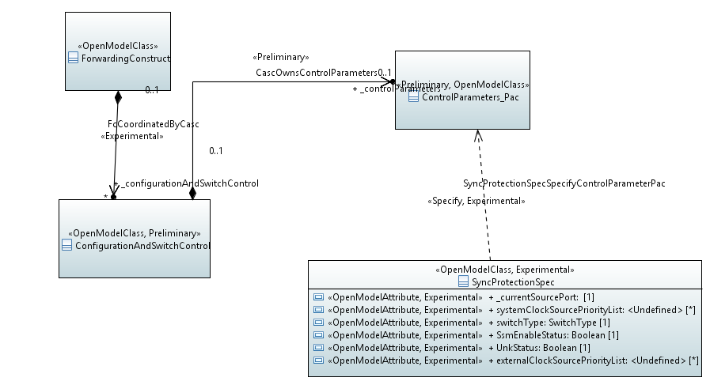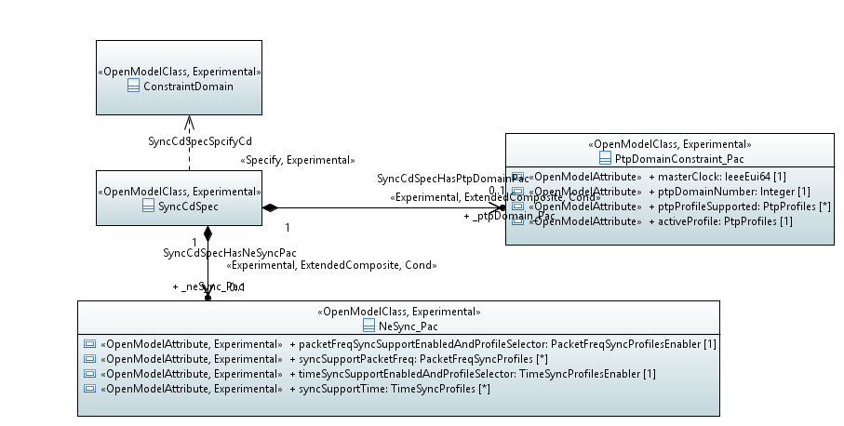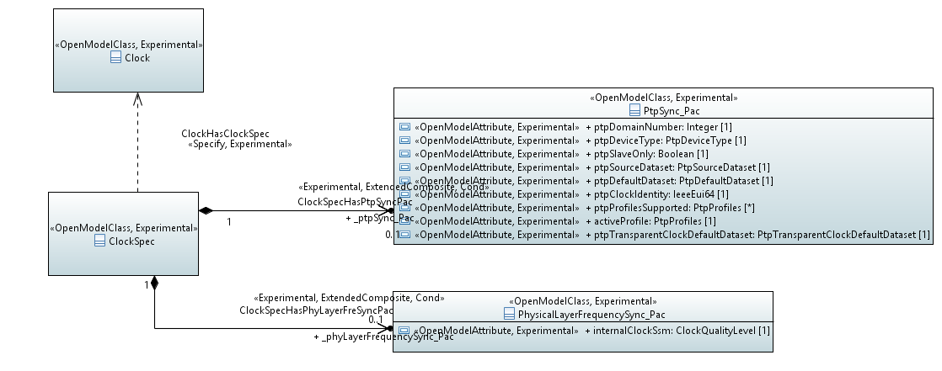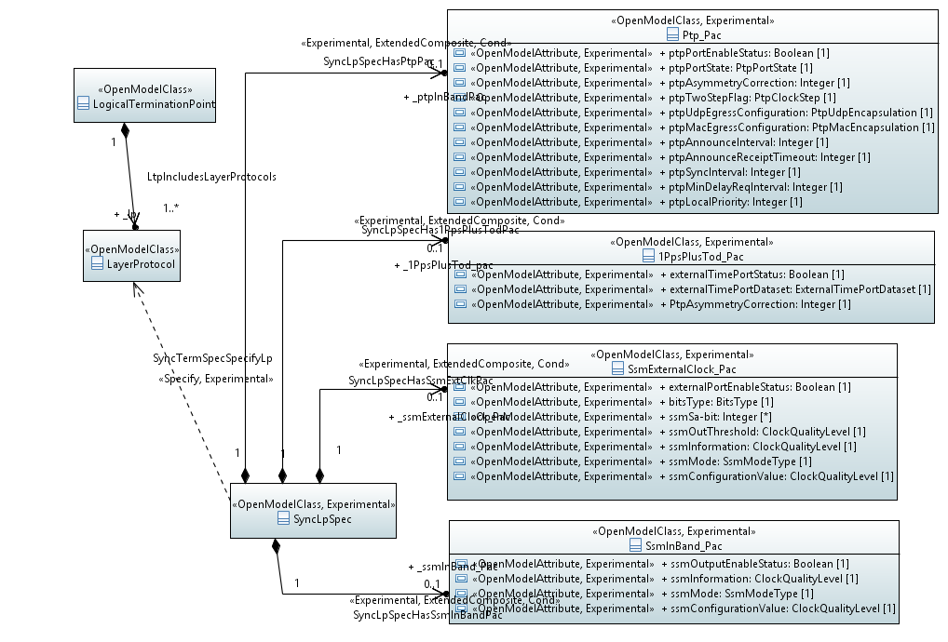

Classes

1PpsPlusTod_Pac

Applied stereotypes:
- Experimental
- OpenModelClass
- support: MANDATORY

Attributes for 1PpsPlusTod_Pac
Table 1: Attributes for 1PpsPlusTod_Pac
Attribute Name | Type | Multiplicity | Access | Stereotypes | Description
externalTimePortStatus | Boolean  ./. | 1 | RW | OpenModelAttribute  • partOfObjectKey: 0  • isInvariant: false  • valueRange: no range constraint  • unit: no unit defined  • support: MANDATORY  Experimental | Indicate whether this external time port is used as an input or output port.
externalTimePortDataset | ExternalTimePortDataset  ./. | 1 | RW | OpenModelAttribute  • partOfObjectKey: 0  • isInvariant: false  • valueRange: no range constraint  • unit: no unit defined  • support: MANDATORY  Experimental | The status dataset of this port
PtpAsymmetryCorrection | Integer  ./. | 1 | RW | OpenModelAttribute  • partOfObjectKey: 0  • isInvariant: false  • valueRange: no range constraint  • unit: no unit defined  • support: MANDATORY  Experimental | The delay compensation value of this external port.

ClockSpec

Applied stereotypes:
- Experimental
- OpenModelClass
- support: MANDATORY

Attributes for ClockSpec
Table 1: Attributes for ClockSpec
Attribute Name | Type | Multiplicity | Access | Stereotypes | Description
_ptpSync_Pac | PtpSync_Pac  ./. | 0..1 | RW | OpenModelAttribute  • partOfObjectKey: 0  • isInvariant: false  • valueRange: no range constraint  • unit: no unit defined  • support: MANDATORY  Experimental | See referenced class
_phyLayerFrequencySync_Pac | PhysicalLayerFrequencySync_Pac  ./. | 0..1 | RW | OpenModelAttribute  • partOfObjectKey: 0  • isInvariant: false  • valueRange: no range constraint  • unit: no unit defined  • support: MANDATORY  Experimental | See referenced class

NeSync_Pac
Sync spec for sync capability and status of NE.

Applied stereotypes:
- Experimental
- OpenModelClass
- support: MANDATORY

Attributes for NeSync_Pac
Table 1: Attributes for NeSync_Pac
Attribute Name | Type | Multiplicity | Access | Stereotypes | Description
packetFreqSyncSupportEnabledAndProfileSelector | PacketFreqSyncProfilesEnabler  ./. | 1 | R | OpenModelAttribute  • partOfObjectKey: 0  • isInvariant: false  • valueRange: no range constraint  • unit: no unit defined  • support: MANDATORY  Experimental | Allows which packet frequency sync functions to be enabled
syncSupportPacketFreq | PacketFreqSyncProfiles  ./. | 0..* | R | OpenModelAttribute  • partOfObjectKey: 0  • isInvariant: false  • valueRange: no range constraint  • unit: no unit defined  • support: MANDATORY  Experimental | Indicate whether the NE has the capability to support packet frequency synchronization. and which frequency profile to support.
timeSyncSupportEnabledAndProfileSelector | TimeSyncProfilesEnabler  ./. | 1 | R | OpenModelAttribute  • partOfObjectKey: 0  • isInvariant: false  • valueRange: no range constraint  • unit: no unit defined  • support: MANDATORY  Experimental | Allows which time sync profiles to be enabled
syncSupportTime | TimeSyncProfiles  ./. | 0..* | R | OpenModelAttribute  • partOfObjectKey: 0  • isInvariant: false  • valueRange: no range constraint  • unit: no unit defined  • support: MANDATORY  Experimental | Indicate whether the NE has the capability to support time synchronization and which time profile to support.
syncSupportPhysicalFreq | Boolean  ./. | 1 | RW | OpenModelAttribute  • partOfObjectKey: 0  • isInvariant: false  • valueRange: no range constraint  • unit: no unit defined  • support: MANDATORY  Experimental

PhysicalLayerFrequencySync_Pac
Conditional package for Frequency Sync Clock

Applied stereotypes:
- Experimental
- OpenModelClass
- support: MANDATORY

Attributes for PhysicalLayerFrequencySync_Pac
Table 1: Attributes for PhysicalLayerFrequencySync_Pac
Attribute Name | Type | Multiplicity | Access | Stereotypes | Description
internalClockSsm | ClockQualityLevel  ./. | 1 | R | OpenModelAttribute  • partOfObjectKey: 0  • isInvariant: false  • valueRange: no range constraint  • unit: no unit defined  • support: MANDATORY  Experimental | The quality level of internal clock of the NE.

PtpDomainConstraint_Pac

Applied stereotypes:
- Experimental
- OpenModelClass
- support: MANDATORY

Attributes for PtpDomainConstraint_Pac
Table 1: Attributes for PtpDomainConstraint_Pac
Attribute Name | Type | Multiplicity | Access | Stereotypes | Description
masterClock | IeeeEui64  ./. | 1 | RW | OpenModelAttribute  • partOfObjectKey: 0  • isInvariant: false  • valueRange: no range constraint  • unit: no unit defined  • support: MANDATORY | The ID of the grandmaster clock in the PTP domain.
ptpDomainNumber | Integer  ./. | 1 | RW | OpenModelAttribute  • partOfObjectKey: 0  • isInvariant: false  • valueRange: no range constraint  • unit: no unit defined  • support: MANDATORY | The PTP Domain Number
ptpProfileSupported | PtpProfiles  ./. | 0..* | RW | OpenModelAttribute  • partOfObjectKey: 0  • isInvariant: false  • valueRange: no range constraint  • unit: no unit defined  • support: MANDATORY | The PTP profile the PTP domain supports.
activeProfile | PtpProfiles  ./. | 1 | RW | OpenModelAttribute  • partOfObjectKey: 0  • isInvariant: false  • valueRange: no range constraint  • unit: no unit defined  • support: MANDATORY | The current active PTP profile in the supported PTP profile list.

PtpSync_Pac
Conditional package for Time Sync Clock

Applied stereotypes:
- Experimental
- OpenModelClass
- support: MANDATORY

Attributes for PtpSync_Pac
Table 1: Attributes for PtpSync_Pac
Attribute Name | Type | Multiplicity | Access | Stereotypes | Description
ptpDomainNumber | Integer  ./. | 1 | RW | OpenModelAttribute  • partOfObjectKey: 0  • isInvariant: false  • valueRange: no range constraint  • unit: no unit defined  • support: MANDATORY  Experimental | The PTP domain number of the NE.
ptpDeviceType | PtpDeviceType  ./. | 1 | R | OpenModelAttribute  • partOfObjectKey: 0  • isInvariant: false  • valueRange: no range constraint  • unit: no unit defined  • support: MANDATORY  Experimental | Three PTP device types are included: boundary clock (BC), transparent clock (TC), and ordinary clock (OC).
ptpSlaveOnly | Boolean  ./. | 1 | R | OpenModelAttribute  • partOfObjectKey: 0  • isInvariant: false  • valueRange: no range constraint  • unit: no unit defined  • support: MANDATORY  Experimental | Indicate whether the NE can only be used as PTP slave or not.
ptpSourceDataset | PtpSourceDataset  ./. | 1 | R | OpenModelAttribute  • partOfObjectKey: 0  • isInvariant: false  • valueRange: no range constraint  • unit: no unit defined  • support: MANDATORY  Experimental | The PTP status dataset of current tracing source:.
ptpDefaultDataset | PtpDefaultDataset  ./. | 1 | RW | OpenModelAttribute  • partOfObjectKey: 0  • isInvariant: false  • valueRange: no range constraint  • unit: no unit defined  • support: MANDATORY  Experimental | The PTP status dataset of internal clock of the NE
ptpClockIdentity | IeeeEui64  ./. | 1 | RW | OpenModelAttribute  • partOfObjectKey: 0  • isInvariant: false  • valueRange: no range constraint  • unit: no unit defined  • support: MANDATORY  Experimental | Identifier of the "physical" clock
ptpProfilesSupported | PtpProfiles  ./. | 0..* | R | OpenModelAttribute  • partOfObjectKey: 0  • isInvariant: false  • valueRange: no range constraint  • unit: no unit defined  • support: MANDATORY  Experimental | The PTP profiles that the clock supports
activeProfile | PtpProfiles  ./. | 1 | RW | OpenModelAttribute  • partOfObjectKey: 0  • isInvariant: false  • valueRange: no range constraint  • unit: no unit defined  • support: MANDATORY  Experimental | The profile currently in use: Must be in the list of supported profiles
ptpTransparentClockDefaultDataset | PtpTransparentClockDefaultDataset  ./. | 1 | RW | OpenModelAttribute  • partOfObjectKey: 0  • isInvariant: false  • valueRange: no range constraint  • unit: no unit defined  • support: MANDATORY  Experimental

Ptp_Pac

Applied stereotypes:
- Experimental
- OpenModelClass
- support: MANDATORY

Attributes for Ptp_Pac
Table 1: Attributes for Ptp_Pac
Attribute Name | Type | Multiplicity | Access | Stereotypes | Description
ptpPortEnableStatus | Boolean  ./. | 1 | RW | OpenModelAttribute  • partOfObjectKey: 0  • isInvariant: false  • valueRange: no range constraint  • unit: no unit defined  • support: MANDATORY  Experimental | Indicate whether to enable this PTP port or not.
ptpPortState | PtpPortState  ./. | 1 | RW | OpenModelAttribute  • partOfObjectKey: 0  • isInvariant: false  • valueRange: no range constraint  • unit: no unit defined  • support: MANDATORY  Experimental | The current PTP state of the PTP port, such as master, slave, passive, initializing, listening, premaster, uncalibrated, and faulty.
ptpAsymmetryCorrection | Integer  ./. | 1 | RW | OpenModelAttribute  • partOfObjectKey: 0  • isInvariant: false  • valueRange: no range constraint  • unit: no unit defined  • support: MANDATORY  Experimental | The asymmetry correction value of this PTP port.
ptpTwoStepFlag | PtpClockStep  ./. | 1 | RW | OpenModelAttribute  • partOfObjectKey: 0  • isInvariant: false  • valueRange: no range constraint  • unit: no unit defined  • support: MANDATORY  Experimental | Indicate whether one-step or two-step mechanism is adopted.
ptpUdpEgressConfiguration | PtpUdpEncapsulation  ./. | 1 | RW | OpenModelAttribute  • partOfObjectKey: 0  • isInvariant: false  • valueRange: no range constraint  • unit: no unit defined  • support: MANDATORY  Experimental | The configuration of PTP UDP encapsulation, including destination IP address and IPv4/IPv6 protocol.
ptpMacEgressConfiguration | PtpMacEncapsulation  ./. | 1 | RW | OpenModelAttribute  • partOfObjectKey: 0  • isInvariant: false  • valueRange: no range constraint  • unit: no unit defined  • support: MANDATORY  Experimental | The configuration of PTP MAC encapsulation, including destination MAC address and VLAN configuration.
ptpAnnounceInterval | Integer  ./. | 1 | RW | OpenModelAttribute  • partOfObjectKey: 0  • isInvariant: false  • valueRange: no range constraint  • unit: no unit defined  • support: MANDATORY  Experimental | The sending interval of PTP announce message.
ptpAnnounceReceiptTimeout | Integer  ./. | 1 | RW | OpenModelAttribute  • partOfObjectKey: 0  • isInvariant: false  • valueRange: no range constraint  • unit: no unit defined  • support: MANDATORY  Experimental | It is used for fault detection of PTP announce messages.
ptpSyncInterval | Integer  ./. | 1 | RW | OpenModelAttribute  • partOfObjectKey: 0  • isInvariant: false  • valueRange: no range constraint  • unit: no unit defined  • support: MANDATORY  Experimental | The sending interval of PTP Sync message.
ptpMinDelayReqInterval | Integer  ./. | 1 | RW | OpenModelAttribute  • partOfObjectKey: 0  • isInvariant: false  • valueRange: no range constraint  • unit: no unit defined  • support: MANDATORY  Experimental | The sending interval of PTP Delay_req message.
ptpLocalPriority | Integer  ./. | 1 | RW | OpenModelAttribute  • partOfObjectKey: 0  • isInvariant: false  • valueRange: no range constraint  • unit: no unit defined  • support: MANDATORY  Experimental | The priority for the local clocks.
ptpMasterOnly | Boolean  ./. | 1 | RW | OpenModelAttribute  • partOfObjectKey: 0  • isInvariant: false  • valueRange: no range constraint  • unit: no unit defined  • support: MANDATORY | The per-port attribute masterOnly
ptpLocalPriority | Integer  ./. | 1 | RW | OpenModelAttribute  • partOfObjectKey: 0  • isInvariant: false  • valueRange: no range constraint  • unit: no unit defined  • support: MANDATORY | The per-port attribute localPriority

SsmExternalClock_Pac

Applied stereotypes:
- Experimental
- OpenModelClass
- support: MANDATORY

Attributes for SsmExternalClock_Pac
Table 1: Attributes for SsmExternalClock_Pac
Attribute Name | Type | Multiplicity | Access | Stereotypes | Description
externalPortEnableStatus | Boolean  ./. | 1 | RW | OpenModelAttribute  • partOfObjectKey: 0  • isInvariant: false  • valueRange: no range constraint  • unit: no unit defined  • support: MANDATORY  Experimental | Indicate whether to enable this external port or not.
bitsType | BitsType  ./. | 1 | RW | OpenModelAttribute  • partOfObjectKey: 0  • isInvariant: false  • valueRange: no range constraint  • unit: no unit defined  • support: MANDATORY  Experimental | The type of this port, such as 2048kb/s or 2048kHz.
ssmSa-bit | Integer  ./. | 0..* | RW | OpenModelAttribute  • partOfObjectKey: 0  • isInvariant: false  • valueRange: no range constraint  • unit: no unit defined  • support: MANDATORY  Experimental | Indicate which sa-bit bits are used for carrying input and output SSM quality levels. The port should have sa-bit bits for input and output respectively.
ssmOutThreshold | ClockQualityLevel  ./. | 1 | RW | OpenModelAttribute  • partOfObjectKey: 0  • isInvariant: false  • valueRange: no range constraint  • unit: no unit defined  • support: MANDATORY  Experimental | The external port stops transmitting when the SSM quality level is lower than the threshold.
ssmInformation | ClockQualityLevel  ./. | 1 | RW | OpenModelAttribute  • partOfObjectKey: 0  • isInvariant: false  • valueRange: no range constraint  • unit: no unit defined  • support: MANDATORY  Experimental | Current input and output SSM quality levels used by the port. The port should have SSM quality levels for input and output respectively.
ssmMode | SsmModeType  ./. | 1 | RW | OpenModelAttribute  • partOfObjectKey: 0  • isInvariant: false  • valueRange: no range constraint  • unit: no unit defined  • support: MANDATORY  Experimental | Indicate whether to use manual or automatic input and output SSM quality levels. SSM mode should be set for input and output respectively.
ssmConfigurationValue | ClockQualityLevel  ./. | 1 | RW | OpenModelAttribute  • partOfObjectKey: 0  • isInvariant: false  • valueRange: no range constraint  • unit: no unit defined  • support: MANDATORY  Experimental | The input and output SSM quality levels set manually. The SSM quality levels should be manually configurable for input and output respectively.

SsmInBand_Pac

Applied stereotypes:
- Experimental
- OpenModelClass
- support: MANDATORY

Attributes for SsmInBand_Pac
Table 1: Attributes for SsmInBand_Pac
Attribute Name | Type | Multiplicity | Access | Stereotypes | Description
ssmOutputEnableStatus | Boolean  ./. | 1 | RW | OpenModelAttribute  • partOfObjectKey: 0  • isInvariant: false  • valueRange: no range constraint  • unit: no unit defined  • support: MANDATORY  Experimental | Indicate whether to send SSM messages or not.
ssmInformation | ClockQualityLevel  ./. | 1 | RW | OpenModelAttribute  • partOfObjectKey: 0  • isInvariant: false  • valueRange: no range constraint  • unit: no unit defined  • support: MANDATORY  Experimental | Current input and output SSM quality levels used by the port. The SSM quality level can be set manually or automatically. The port should have SSM quality levels for input and output respectively.
ssmMode | SsmModeType  ./. | 1 | RW | OpenModelAttribute  • partOfObjectKey: 0  • isInvariant: false  • valueRange: no range constraint  • unit: no unit defined  • support: MANDATORY  Experimental | Indicate whether to use manual or automatic input and output SSM quality levels. SSM mode should be set for input and output respectively.
ssmConfigurationValue | ClockQualityLevel  ./. | 1 | RW | OpenModelAttribute  • partOfObjectKey: 0  • isInvariant: false  • valueRange: no range constraint  • unit: no unit defined  • support: MANDATORY  Experimental | The input and output SSM quality levels set manually. The SSM quality levels should be manually configurable for input and output respectively.

SyncCdSpec
Used to specify the ConstraintDomain when the ConstraintDomain represent an NE or PTP domain.

Applied stereotypes:
- Experimental
- OpenModelClass
- support: MANDATORY

Attributes for SyncCdSpec
Table 1: Attributes for SyncCdSpec
Attribute Name | Type | Multiplicity | Access | Stereotypes | Description
_neSync_Pac | NeSync_Pac  ./. | 0..1 | RW | OpenModelAttribute  • partOfObjectKey: 0  • isInvariant: false  • valueRange: no range constraint  • unit: no unit defined  • support: MANDATORY | See referenced class
_ptpDomain_Pac | PtpDomainConstraint_Pac  ./. | 0..1 | RW | OpenModelAttribute  • partOfObjectKey: 0  • isInvariant: false  • valueRange: no range constraint  • unit: no unit defined  • support: MANDATORY | See referenced class

SyncLpSpec

Applied stereotypes:
- Experimental
- OpenModelClass
- support: MANDATORY

Attributes for SyncLpSpec
Table 1: Attributes for SyncLpSpec
Attribute Name | Type | Multiplicity | Access | Stereotypes | Description
_1PpsPlusTod_pac | 1PpsPlusTod_Pac  ./. | 0..1 | RW | OpenModelAttribute  • partOfObjectKey: 0  • isInvariant: false  • valueRange: no range constraint  • unit: no unit defined  • support: MANDATORY  Experimental | See referenced class
_ptpInBandPac | Ptp_Pac  ./. | 0..1 | RW | OpenModelAttribute  • partOfObjectKey: 0  • isInvariant: false  • valueRange: no range constraint  • unit: no unit defined  • support: MANDATORY  Experimental | See referenced class
_ssmExternalClock_Pac | SsmExternalClock_Pac  ./. | 0..1 | RW | OpenModelAttribute  • partOfObjectKey: 0  • isInvariant: false  • valueRange: no range constraint  • unit: no unit defined  • support: MANDATORY  Experimental | See referenced class
_ssmInBand_Pac | SsmInBand_Pac  ./. | 0..1 | RW | OpenModelAttribute  • partOfObjectKey: 0  • isInvariant: false  • valueRange: no range constraint  • unit: no unit defined  • support: MANDATORY  Experimental | See referenced class

SyncProtectionSpec
Sync protection schema parameters spec for ControlParameter_Pac of C&SC

Applied stereotypes:
- Experimental
- OpenModelClass
- support: MANDATORY

Attributes for SyncProtectionSpec
Table 1: Attributes for SyncProtectionSpec
Attribute Name | Type | Multiplicity | Access | Stereotypes | Description
_currentSourcePort | ./. | 1 | RW | OpenModelAttribute  • partOfObjectKey: 0  • isInvariant: false  • valueRange: no range constraint  • unit: no unit defined  • support: MANDATORY  Experimental | The ID of the port traced by the system clock currently.
systemClockSourcePriorityList | invalid  ./. | 0..* | RW | OpenModelAttribute  • partOfObjectKey: 0  • isInvariant: false  • valueRange: no range constraint  • unit: no unit defined  • support: MANDATORY  Experimental | The list is used to select clock port. It is composed of clock port IDs in the order of priorities.
switchType | SwitchType  ./. | 1 | RW | OpenModelAttribute  • partOfObjectKey: 0  • isInvariant: false  • valueRange: no range constraint  • unit: no unit defined  • support: MANDATORY  Experimental | Three switch types are included: lockout, manual switch, and forced switch.
SsmEnableStatus | Boolean  ./. | 1 | RW | OpenModelAttribute  • partOfObjectKey: 0  • isInvariant: false  • valueRange: no range constraint  • unit: no unit defined  • support: MANDATORY  Experimental | In automatic reference selection process, if SSM is enabled, the selection of clock source is performed based on SSM and priority; otherwise the selection depends on priority only.
UnkStatus | Boolean  ./. | 1 | RW | OpenModelAttribute  • partOfObjectKey: 0  • isInvariant: false  • valueRange: no range constraint  • unit: no unit defined  • support: MANDATORY  Experimental | Indicate whether to take UNK as one of the SSM quality levels or not. If UNK is enabled, its level lies between PRC and SSU_T; otherwise it is taken as DNU.
externalClockSourcePriorityList | invalid  ./. | 0..* | RW | OpenModelAttribute  • partOfObjectKey: 0  • isInvariant: false  • valueRange: no range constraint  • unit: no unit defined  • support: MANDATORY  Experimental | The list is used to select output clock source for this external clock port. It is composed of IDs of system clock and in-band clock ports [Why two? Clock or LTP?]in the order of priorities.

Data Types

ExternalTimePortDataset
Applied Stereotypes:

Attributes for ExternalTimePortDataset
Table 1: Attributes for ExternalTimePortDataset
Attribute Name | Type | Multiplicity | Access | Stereotypes | Description
_grandMasterIdentity | invalid  ./. | 1 | RW | OpenModelAttribute  - partOfObjectKey: 0  - isInvariant: false  - valueRange: no range constraint  - unit: no unit defined  - support: MANDATORY
priority1 | Integer  ./. | 1 | RW | OpenModelAttribute  - partOfObjectKey: 0  - isInvariant: false  - valueRange: no range constraint  - unit: no unit defined  - support: MANDATORY
priority2 | Integer  ./. | 1 | RW | OpenModelAttribute  - partOfObjectKey: 0  - isInvariant: false  - valueRange: no range constraint  - unit: no unit defined  - support: MANDATORY
clockClass | Integer  ./. | 1 | RW | OpenModelAttribute  - partOfObjectKey: 0  - isInvariant: false  - valueRange: no range constraint  - unit: no unit defined  - support: MANDATORY
accuracy | Integer  ./. | 1 | RW | OpenModelAttribute  - partOfObjectKey: 0  - isInvariant: false  - valueRange: no range constraint  - unit: no unit defined  - support: MANDATORY
offsetScaledLogVariance | Integer  ./. | 1 | RW | OpenModelAttribute  - partOfObjectKey: 0  - isInvariant: false  - valueRange: no range constraint  - unit: no unit defined  - support: MANDATORY
timeSource | IeeeEui64  ./. | 1 | RW | OpenModelAttribute  - partOfObjectKey: 0  - isInvariant: false  - valueRange: no range constraint  - unit: no unit defined  - support: MANDATORY
stepsRemoved | Integer  ./. | 1 | RW | OpenModelAttribute  - partOfObjectKey: 0  - isInvariant: false  - valueRange: no range constraint  - unit: no unit defined  - support: MANDATORY
currentUtcOffset | Integer  ./. | 1 | RW | OpenModelAttribute  - partOfObjectKey: 0  - isInvariant: false  - valueRange: no range constraint  - unit: no unit defined  - support: MANDATORY

IeeeEui64
Applied Stereotypes:

PtpDefaultDataset
Applied Stereotypes:

Attributes for PtpDefaultDataset
Table 1: Attributes for PtpDefaultDataset
Attribute Name | Type | Multiplicity | Access | Stereotypes | Description
_clock | invalid  ./. | 1 | RW | OpenModelAttribute  - partOfObjectKey: 0  - isInvariant: false  - valueRange: no range constraint  - unit: no unit defined  - support: MANDATORY
priority1 | Integer  ./. | 1 | RW | OpenModelAttribute  - partOfObjectKey: 0  - isInvariant: false  - valueRange: no range constraint  - unit: no unit defined  - support: MANDATORY
priority2 | Integer  ./. | 1 | RW | OpenModelAttribute  - partOfObjectKey: 0  - isInvariant: false  - valueRange: no range constraint  - unit: no unit defined  - support: MANDATORY
clockClass | Integer  ./. | 1 | RW | OpenModelAttribute  - partOfObjectKey: 0  - isInvariant: false  - valueRange: no range constraint  - unit: no unit defined  - support: MANDATORY
accuracy | Integer  ./. | 1 | RW | OpenModelAttribute  - partOfObjectKey: 0  - isInvariant: false  - valueRange: no range constraint  - unit: no unit defined  - support: MANDATORY
offsetScaledLogVariance | Integer  ./. | 1 | RW | OpenModelAttribute  - partOfObjectKey: 0  - isInvariant: false  - valueRange: no range constraint  - unit: no unit defined  - support: MANDATORY
timeSource | IeeeEui64  ./. | 1 | RW | OpenModelAttribute  - partOfObjectKey: 0  - isInvariant: false  - valueRange: no range constraint  - unit: no unit defined  - support: MANDATORY
stepsRemoved | Integer  ./. | 1 | RW | OpenModelAttribute  - partOfObjectKey: 0  - isInvariant: false  - valueRange: no range constraint  - unit: no unit defined  - support: MANDATORY
1588ProtocolVersion | Integer  ./. | 1 | RW | OpenModelAttribute  - partOfObjectKey: 0  - isInvariant: false  - valueRange: no range constraint  - unit: no unit defined  - support: MANDATORY
localPriority | Integer  ./. | 1 | RW | OpenModelAttribute  - partOfObjectKey: 0  - isInvariant: false  - valueRange: no range constraint  - unit: no unit defined  - support: MANDATORY

PtpMacEncapsulation
Applied Stereotypes:

Attributes for PtpMacEncapsulation
Table 1: Attributes for PtpMacEncapsulation
Attribute Name | Type | Multiplicity | Access | Stereotypes | Description
destinationMacAddress | String  ./. | 1 | R | OpenModelAttribute  - partOfObjectKey: 0  - isInvariant: false  - valueRange: no range constraint  - unit: no unit defined  - support: MANDATORY
vlanConfiguration | String  ./. | 1 | RW | OpenModelAttribute  - partOfObjectKey: 0  - isInvariant: false  - valueRange: no range constraint  - unit: no unit defined  - support: MANDATORY

PtpSourceDataset
Applied Stereotypes:

Attributes for PtpSourceDataset
Table 1: Attributes for PtpSourceDataset
Attribute Name | Type | Multiplicity | Access | Stereotypes | Description
_grandMasterIdentity | invalid  ./. | 1 | RW | OpenModelAttribute  - partOfObjectKey: 0  - isInvariant: false  - valueRange: no range constraint  - unit: no unit defined  - support: MANDATORY
_parentClock | invalid  ./. | 1 | RW | OpenModelAttribute  - partOfObjectKey: 0  - isInvariant: false  - valueRange: no range constraint  - unit: no unit defined  - support: MANDATORY
priority1 | Integer  ./. | 1 | RW | OpenModelAttribute  - partOfObjectKey: 0  - isInvariant: false  - valueRange: no range constraint  - unit: no unit defined  - support: MANDATORY
priority2 | Integer  ./. | 1 | RW | OpenModelAttribute  - partOfObjectKey: 0  - isInvariant: false  - valueRange: no range constraint  - unit: no unit defined  - support: MANDATORY
clockClass | Integer  ./. | 1 | RW | OpenModelAttribute  - partOfObjectKey: 0  - isInvariant: false  - valueRange: no range constraint  - unit: no unit defined  - support: MANDATORY
clockAccuracy | Integer  ./. | 1 | RW | OpenModelAttribute  - partOfObjectKey: 0  - isInvariant: false  - valueRange: no range constraint  - unit: no unit defined  - support: MANDATORY
offsetScaledLogVariance | Integer  ./. | 1 | RW | OpenModelAttribute  - partOfObjectKey: 0  - isInvariant: false  - valueRange: no range constraint  - unit: no unit defined  - support: MANDATORY
timeSource | IeeeEui64  ./. | 1 | RW | OpenModelAttribute  - partOfObjectKey: 0  - isInvariant: false  - valueRange: no range constraint  - unit: no unit defined  - support: MANDATORY
stepsRemoved | Integer  ./. | 1 | RW | OpenModelAttribute  - partOfObjectKey: 0  - isInvariant: false  - valueRange: no range constraint  - unit: no unit defined  - support: MANDATORY
currentUtcOffset | Integer  ./. | 1 | RW | OpenModelAttribute  - partOfObjectKey: 0  - isInvariant: false  - valueRange: no range constraint  - unit: no unit defined  - support: MANDATORY
ptpTimeScale | Integer  ./. | 1 | RW | OpenModelAttribute  - partOfObjectKey: 0  - isInvariant: false  - valueRange: no range constraint  - unit: no unit defined  - support: MANDATORY
timeTraceable | Boolean  ./. | 1 | RW | OpenModelAttribute  - partOfObjectKey: 0  - isInvariant: false  - valueRange: no range constraint  - unit: no unit defined  - support: MANDATORY
frequencyTraceable | Boolean  ./. | 1 | RW | OpenModelAttribute  - partOfObjectKey: 0  - isInvariant: false  - valueRange: no range constraint  - unit: no unit defined  - support: MANDATORY
1588ProtocolVersion | Integer  ./. | 1 | RW | OpenModelAttribute  - partOfObjectKey: 0  - isInvariant: false  - valueRange: no range constraint  - unit: no unit defined  - support: MANDATORY
currentAbsoluteTime | Integer  ./. | 1 | RW | OpenModelAttribute  - partOfObjectKey: 0  - isInvariant: false  - valueRange: no range constraint  - unit: no unit defined  - support: MANDATORY
isMasterOnly | Boolean  ./. | 1 | RW | OpenModelAttribute  - partOfObjectKey: 0  - isInvariant: false  - valueRange: no range constraint  - unit: no unit defined  - support: MANDATORY | The masterOnly is TRUE, the port is never placed in the SLAVE state.
localPriority | Integer  ./. | 1 | RW | OpenModelAttribute  - partOfObjectKey: 0  - isInvariant: false  - valueRange: no range constraint  - unit: no unit defined  - support: MANDATORY | The local priority for the port and this is used as a tie-breaker in the data set comparison algorithm.
isSf | Boolean  ./. | 1 | RW | OpenModelAttribute  - partOfObjectKey: 0  - isInvariant: false  - valueRange: no range constraint  - unit: no unit defined  - support: MANDATORY | Indicate whether the clock generate a state decision event by a PTSF or not.

PtpTransparentClockDefaultDataset
Applied Stereotypes:

Attributes for PtpTransparentClockDefaultDataset
Table 1: Attributes for PtpTransparentClockDefaultDataset
Attribute Name | Type | Multiplicity | Access | Stereotypes | Description
primaryDomain | Integer  ./. | 1 | RW | OpenModelAttribute  - partOfObjectKey: 0  - isInvariant: false  - valueRange: no range constraint  - unit: no unit defined  - support: MANDATORY

PtpUdpEncapsulation
Applied Stereotypes:

Attributes for PtpUdpEncapsulation
Table 1: Attributes for PtpUdpEncapsulation
Attribute Name | Type | Multiplicity | Access | Stereotypes | Description
destinationIpAddress | String  ./. | 1 | RW | OpenModelAttribute  - partOfObjectKey: 0  - isInvariant: false  - valueRange: no range constraint  - unit: no unit defined  - support: MANDATORY
ipProtocolType | IpProtocolType  ./. | 1 | RW | OpenModelAttribute  - partOfObjectKey: 0  - isInvariant: false  - valueRange: no range constraint  - unit: no unit defined  - support: MANDATORY

Enumeration Types

BitsType

Contains Enumeration Literals:
- KBPS:
- KHZ:

ClockQualityLevel
Use the clock quality levels listed in section 5.4.1 of G.781 (08/2017). The corresponding SSM codes and enhanced SSM codes for SyncE refer to table 11-7 and table 11-8 of G.8264 (08/2017)

Contains Enumeration Literals:
- QL_PRC:
- QL_SSU_A:
- QL_SSU_B:
- QL_EEC1:
- QL_DNU:
- QL_PRTC:
- QL_ePRTC:
- QL_eEEC:
- QL_PRS:
- QL_STU:
- QL_ST2:
- QL_TNC:
- QL_ST3E:
- QL_ST3:
- QL_EEC2:
- QL_PROV:
- QL_DUS:

IpProtocolType

Contains Enumeration Literals:
- IPV4:
- IPV6:

PacketFreqSyncProfiles

Contains Enumeration Literals:
- G.8265.1:
- G.8275.2:

PacketFreqSyncProfilesEnabler

Contains Enumeration Literals:
- ENABLE_G.8265.1:
- ENABLE_G.8275.2:
- DISABLE:

PtpClockStep

Contains Enumeration Literals:
- ONE_STEP:
- TWO_STEP:

PtpDeviceType

Contains Enumeration Literals:
- BOUNDARY_CLOCK:
- TRANSPARENT_CLOCK:
- ORDINARY_CLOCK:

PtpPortState

Contains Enumeration Literals:
- MASTER:
- SLAVE:
- PASSIVE:
- INITIALIZING:
- LISTENING:
- PREMASTER:
- UNCALIBRATED:
- FAULTY:

PtpProfiles

Contains Enumeration Literals:
- G.8265.1:
- G.8275.1:
- G.8275.2:

RunMode

Contains Enumeration Literals:
- FREE_RUN:
- LOCKED:
- HOLD_OVER:

SsmModeType

Contains Enumeration Literals:
- MANUAL:
- AUTOMATIC:

SwitchType

Contains Enumeration Literals:
- LOCK_OUT:

TimeSyncProfiles

Contains Enumeration Literals:
- G.8275.1:
- G.8275.2:

TimeSyncProfilesEnabler

Contains Enumeration Literals:
- ENABLE_G.8275.1:
- ENABLE_G.8275.2:
- DISABLE:

Primitive Types

