You are invited to join us to celebrate our project
COMMUNITY ARCHIVES; SKILLS SUPPORT AND SUSTAINABILLITY
On Thursday June 9th, 2022, International Archives Day
At Norfolk Record Office and online
#ArchivesAreYou #IAW2022

Programme for the day

10:00 -13:00 Morning Programme. In person only
Facilitated discussions on archive topics, guided tours of the NRO strongrooms and an opportunity to view displays by some of our participant groups.

13:00 Networking Lunch

14:00 -16:00 Afternoon programme, in person or online.
Keynote talk: The Community Archives: Skills, Support & Sustainability Project – achievements and learning, followed by short presentations from project groups.

All Day: Group displays, archive showcases and sound installations to explore.

To attend, please RSVP to sophie.cabot2@norfolk.gov.uk by Friday 4th June 2022, saying if you will be attending AM, PM or online, and giving any dietary requirements.

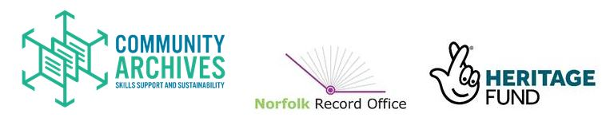
Our Groups Are: True's Yard Fisherfolk Museum, Wreningham Heritage Group, Loddon & District Local History Group, Mulbarton Heritage Group, Waveney Heritage, Acle Community Archive Group, Norfolk Wherry Trust, Surlingham History Group, The Reepham Archive, St Seraphim Icon & Railway Heritage Museum, Museum 4 Watton, Fakenham Heritage Group, Bergh Apton Local History Group, Neatishead, Irstead & Barton Turf Community Heritage Group, M&GN Circle, Wherry Yacht Charter Charitable Trust, Wisbech & Fenland Museum, Newton Flotman & Saxlingham Thorpe Heritage Group, Norfolk Polish Heritage Group, Wereham Heritage Group, Norwich Jewish Heritage Group, Brundall Local History Group, Walsingham Village Archive, Voices of Hickling, New Buckenham Society, Carleton Rode History Group, Fakenham Community Archive, Fakenham Museum of Gas & Local History, Dragon Hall Heritage Volunteers, Norwich Puppet Theatre, Martham Local History Group, Bressingham Steam & Gardens, Norfolk & Norwich Horticultural Society and The Friends of Waterloo Park.

