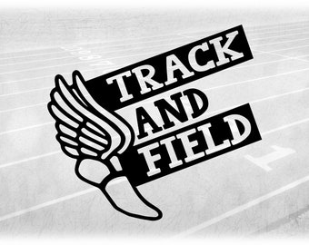
NBMS
The NBMS Track Season will officially open on Tuesday, March 1st. Track is open for all 7th & 8th grade students.
Please register your athlete through our on-line sports registration at www.familyid.com
All students will need to have a current sports physical on file.
Our sports fee is $50.00. You can make payment though our on-line program at www.schoolpay.com or stop by the front office with cash or a check. We do not have the capability to process a debit card payment.
The fee is waived for those students who qualify through our economically disadvantaged program.
All student accounts will need to be paid before approval.
BONUS: We also have a policy that a student’s sports fee is waived if they have already paid for and participated in two sports previously.
If you have any questions, please contact Sheri Gaines, NBMS Athletic Secretary at 541-751-7279 or sgaines@nbend.k12.or.us

