2015 Interconnection Data Thus Far

Since the launch of the Internet Health Test in May, more than 300,000 Internet users have performed the Internet Health Test, resulting in over 2.5 million data points. The evidence collected by the Internet Health Test points to significant degradations for users on the networks of the five largest ISPs representing 75 percent of all wireline households in the U.S. The speed, quality and reliability assurances offered to consumers by these ISPs are not being kept. While Level 3 and Cogent connections are seeing fewer degradations, GTT and Tata connections are degraded across the country (See here for rankings).

The Internet Health Test gives customers the ability to hold their Internet provider accountable through the public disclosure of this degradation.

Cast of characters:

BattlefortheNet:
- Developed the Internet Health Test using M-Lab’s open code, after recognizing the importance of this data in enforcing the Net Neutrality Rules. BftN has led outreach to hundreds of thousands of Internet users to help compile the data, and is now speaking as an arbiter of the facts in support of the Open Internet. BftN is a collaboration of Free Press Action Fund, Fight for the Future and Demand Progress. (FPAF contact: Timothy Karr tkarr@freepress.net; FftF contact: Charlie Furman furman.jr@gmail.com)
M-Lab:
- A research coalition housed at OTI, dedicated to open, reproducible Internet Measurement and data science. M-Lab does not have a role in the Internet Health Test, save for supporting the backend and data store that help power the test. M-Lab is not an advocacy organization, but can confirm the facts as presented in the data.
Collin Anderson:
- A researcher with M-Lab, who has deep experience with the data and the methodology, and has worked with BFTN to refine their analysis and confirm its methods. Collin can speak on behalf of the data. (Contact: collina@gmail.com)
Open Tech Institute:
- Home of M-Lab, the research coalition that set up the platform and tests that allowed for this data gathering. Has done extensive analysis of the data and used them to advocate in Congress and at the FCC. (Contact: Sarah Morris: sarmorris@opentechinstitute.org; Josh Stager: stager@opentechinstitute.org)

Helpful citations:

- OTI’s Beyond Frustrated report, which details why these issues matter to consumers
- Susan Crawford’s coverage of interconnection disputes as exposed by M-Lab data, includes a lot of first-person stories of what happens when e.g. your business can’t function because ISPs are fighting.
- In September, Free Press filed a “Petition to Deny” AT&T DirecTV merger stating that the nearly $70 billion transaction is a clear and undisputed violation of the antitrust guidelines.

AT&T

As the FCC prepares to approve AT&T’s DirecTV merger, a central issue raised by opponents is that AT&T will have increased incentives to control how over-the-top content reaches its users. AT&T has fiercely resisted any conditions that would reduce its ability to discriminate by not provisioning enough capacity at “interconnection points,” or the on-ramps into their network where backbone companies deliver such traffic to AT&T.

AT&T was one of several top ISPs who were heavily criticized for not provisioning enough capacity to accept the traffic its customers requested from Netflix, delivered by backbone company Cogent. Cogent and AT&T have recently struck a deal that solves that problem. But our research reveals AT&T is failing to provision enough interconnection capacity to backbone carriers GTT and Tata Communications, causing severe degredation to AT&T’s customers who attempt to visit the web sites and applications that use these transit companies to deliver traffic to AT&T and other ISPs

- As AT&T has sought to merge with DirecTV, it has assured regulators in recent weeks that “Today, private commercial negotiations already balance the interests of all participants” and that “quality of service is now a fundamental driver of agreements that meet the needs of carriers, edge providers, and consumers.”
- This is news to AT&T wireline customers across the country who have been experiencing months of Internet brownouts to particular transit ISPs. Their interests don’t appear to be part of AT&T’s glowing assessment.
- AT&T customers are seeing massive degradation in Atlanta, Chicago and Los Angeles
- In some cases, this degradation is so severe it is leaving customers with speeds less than the FCC’s lowest definition for access to the Internet, and many times below what is advertised.

Atlanta
Facts:
- Throughout May, 2015, ATT customers experienced speeds below 2Mbps between 11am and midnight when accessing content hosted on transit provider GTT.
- Performance for ATT customers across other local transit networks did not show this pattern, and on the whole presented solid and non-degraded performance, indicating that the source of the degradation is not the edge network.
- Verizon and TWC across GTT saw some degradation to the Atlanta measurement site. TWC with speeds dropping below 4Mbps between 9 and 11pm, and Verizon with speeds hovering below 5Mbps for much of the day. But the severity was nothing like that experienced by ATT customers.
  - Charter has similar degradation but we cannot guarantee that the access network directly peers with GTT, and has previously been found to use AT&T for upstream interconnection.
- Comcast customers across GTT, on the other hand, saw no such degradation. Performance remained even throughout the day, and never dropped below 15Mbps, decreasing the likelihood that the degradation is solely within the network of GTT.

Speed by hour in Atlanta on GTT, May 2015 (On Observatory):
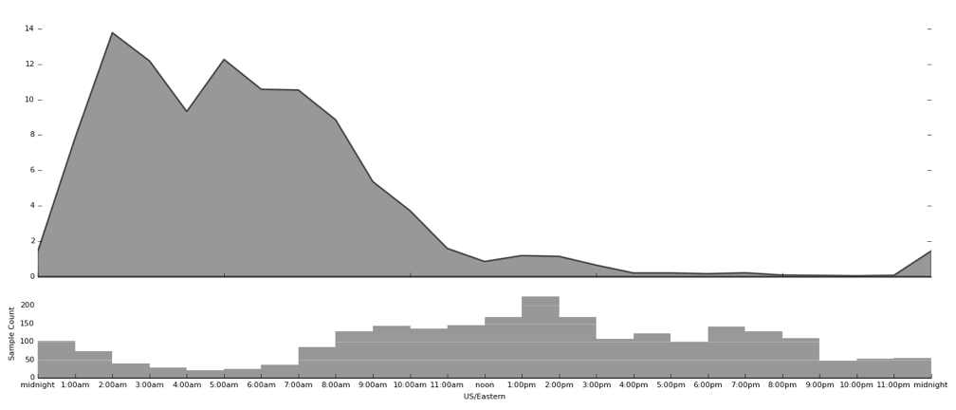

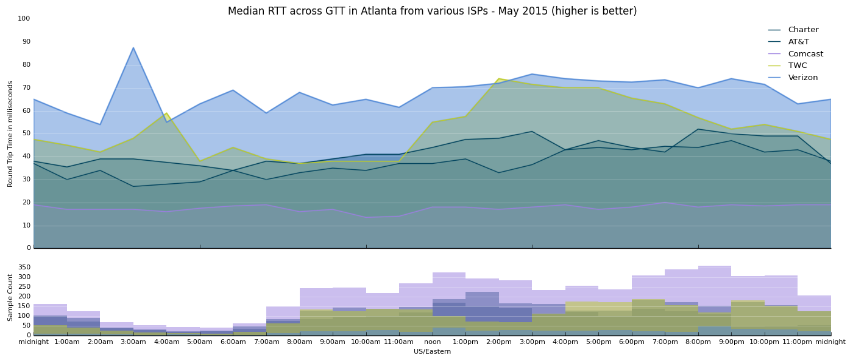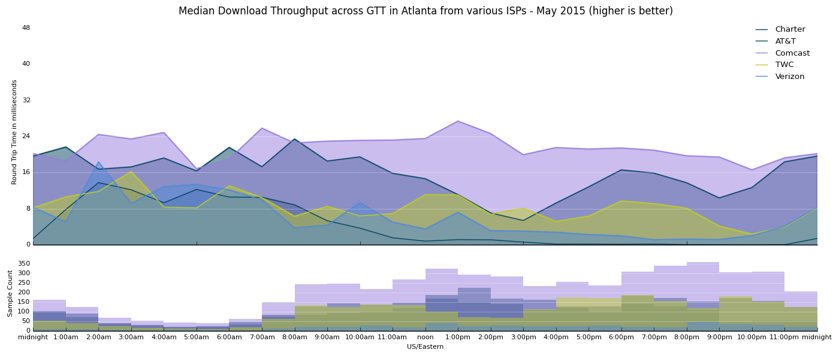

Chicago

Facts:
- Speeds for ATT customers connecting across transit provider GTT remained below 2Mbps between 8am and 2:30am (18.5 out of 24 hours) during May 2015. Between 11am and 11pm, speeds hovered around .5 Mbps, which results in an essentially unusable connection.
- ATT performance in the region, during the same time, was usable and relatively stable across other transit providers in the region (not totally an ATT problem)
- Comcast, TWC, saw some degraded performance across GTT, but nothing that compared with the scope, pattern, and severity of that experienced by ATT customers.

Speed by hour in Chicago on GTT, May 2015 (On Observatory):
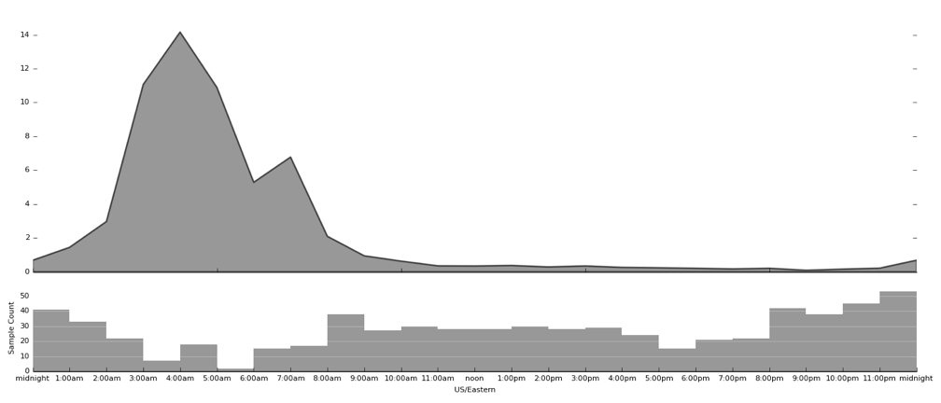

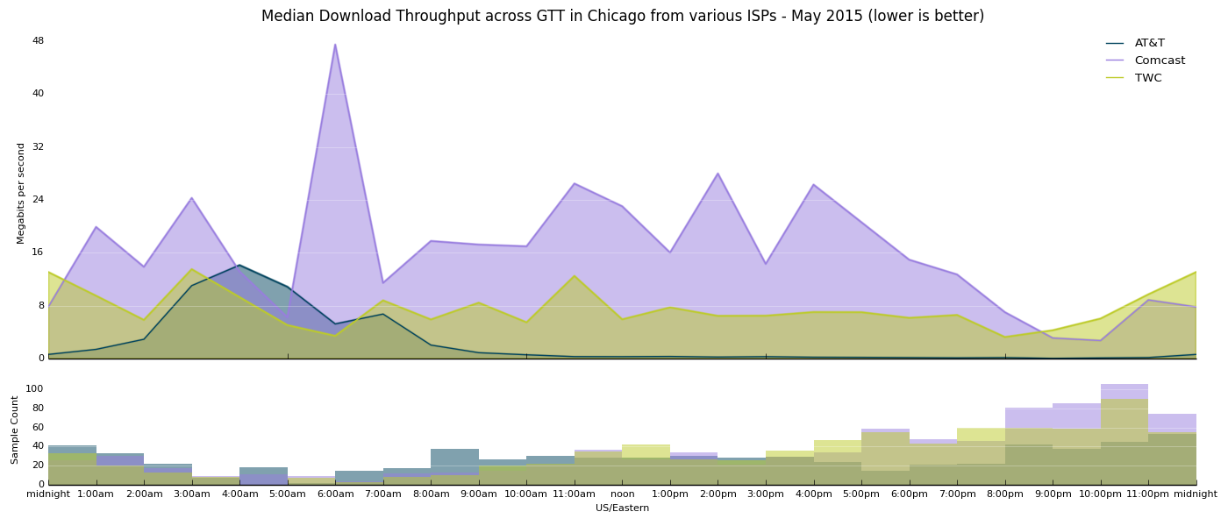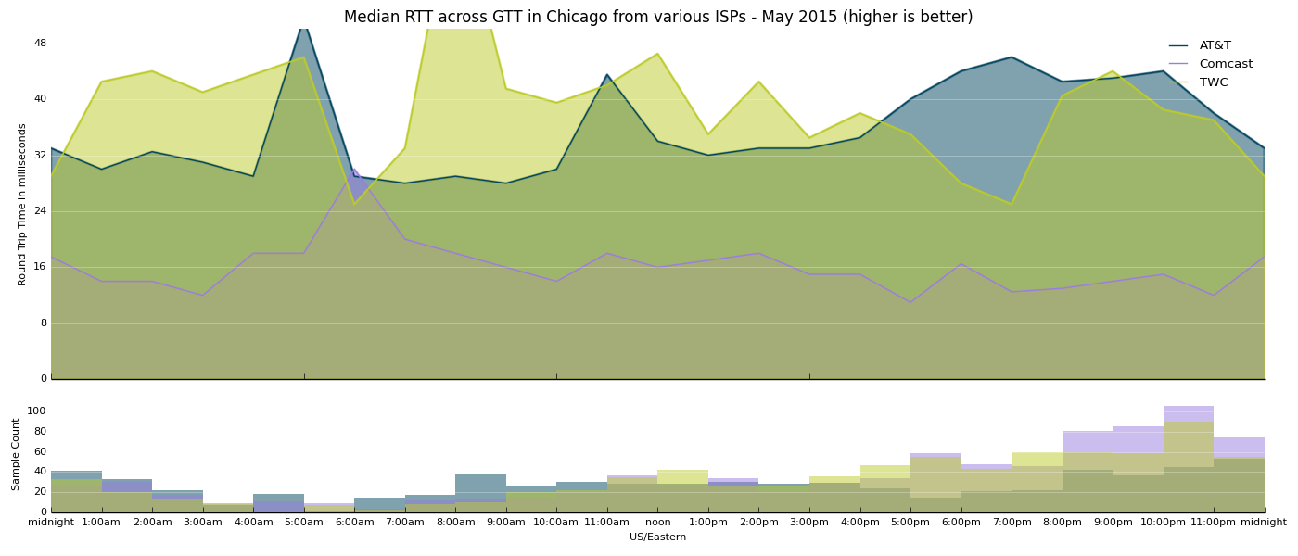

Los Angeles

Facts:
- ATT customers in the LA area saw degraded speeds when accessing content/services on transit network GTT, hovering around 2Mbps between 8pm and 10pm
- ATT customers experienced relatively consistent performance across other local transit networks. (Not just an ATT thing, interconnection related)
- Centurylink customers saw relatively stable performance across GTT, showing only mild degradation briefly around 10pm.
- TWC customers showed consistent performance across GTT (not solely a GTT problem, interconnection related).

Speed by hour in Los Angeles on GTT, May 2015:
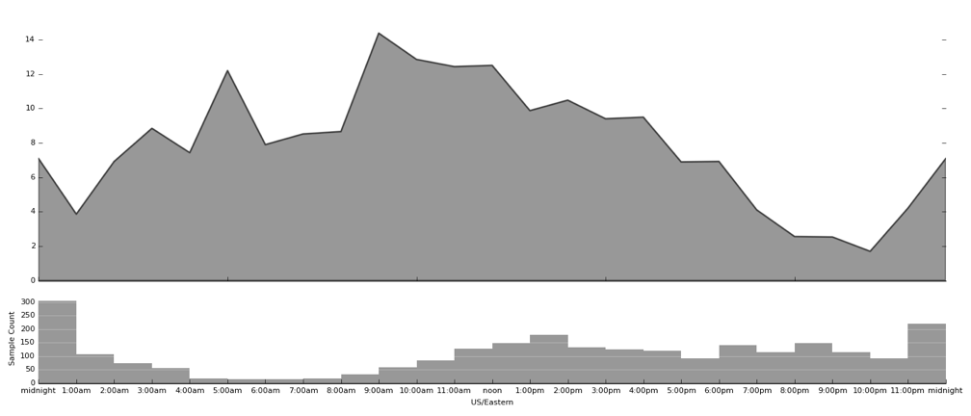
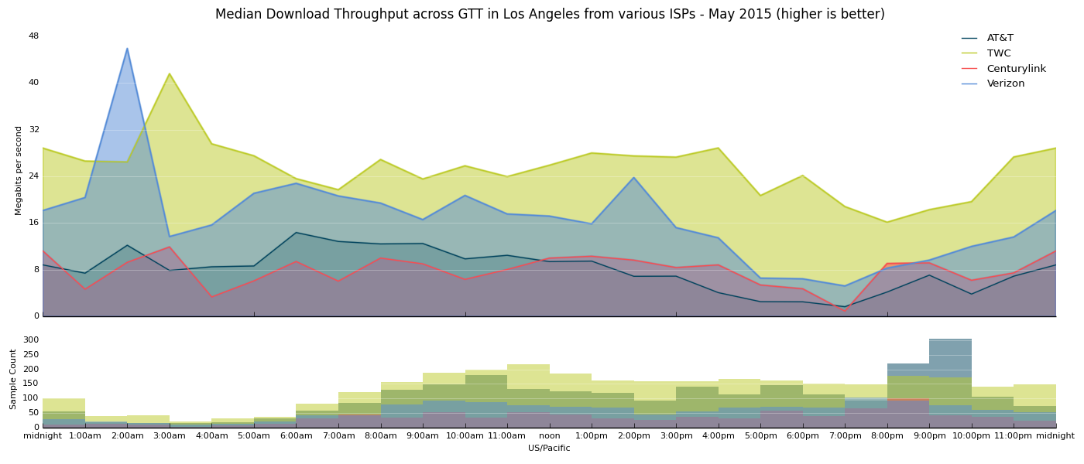
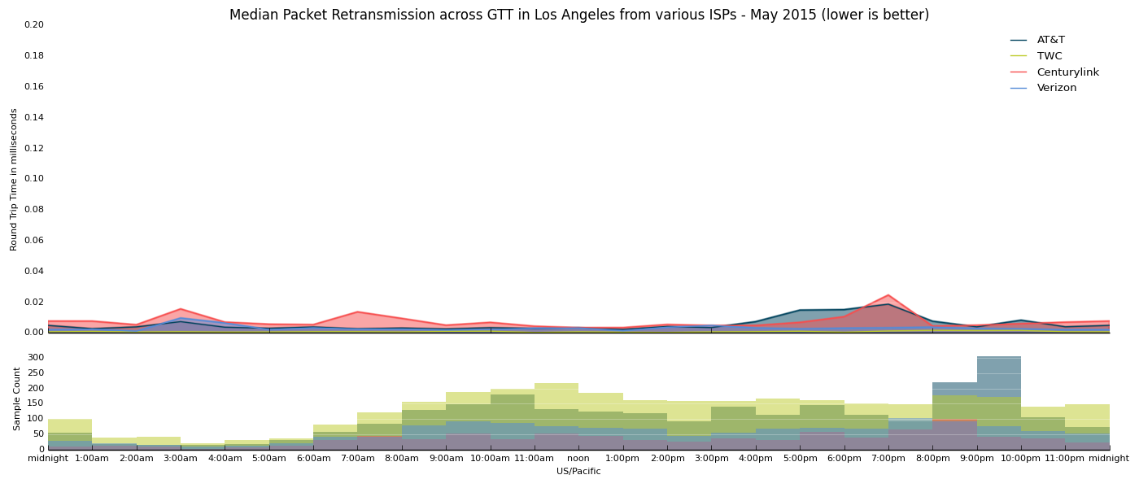

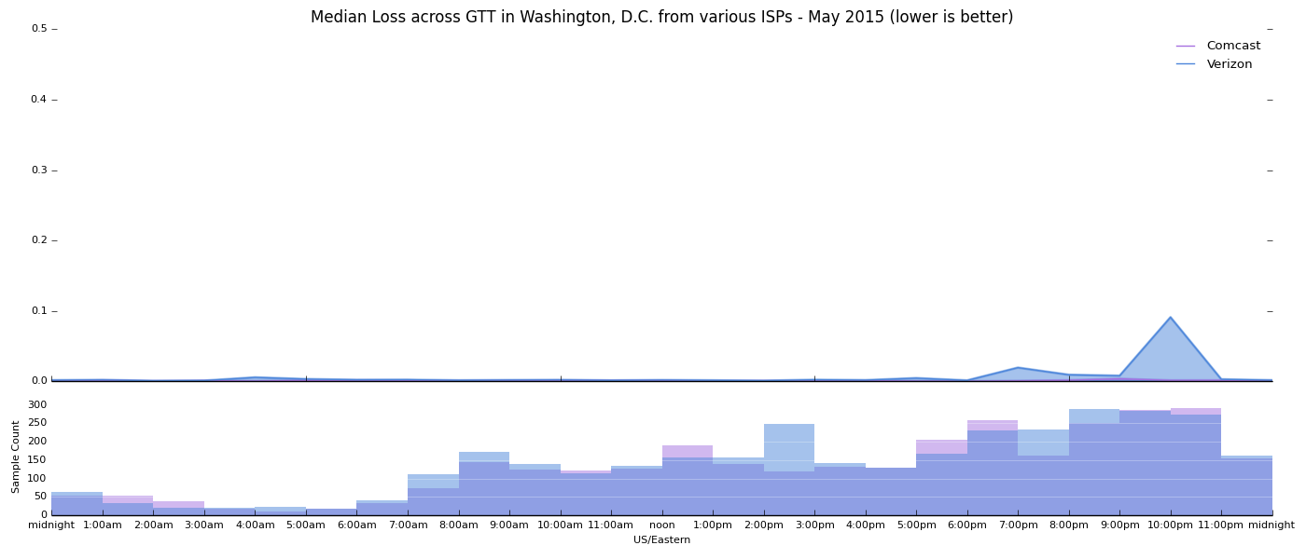

New York

- Even these inferior connections are being degraded during the hours New Yorkers are most likely to be online.
- Since 2013, New Yorkers have had to endure slow speeds across wide swaths of the Internet (refer to Cogent v. everyone M-Lab interconnection graphs)
- Major ISPs are currently performing poorly across multiple interconnections (GTT, Tata). At peak hours, performance drops well-below FCC’s standard for “broadband,” in some cases as low as 1 Mbps.
- The US will never be a broadband leader when its iconic city has to rely on speeds 1/1000th that of its global counterparts
Facts:
- Comcast, Time Warner, and Verizon all saw significant degradation during peak hours across transit provider GTT
  - Comcast: Speeds well-below 5Mbps between 3pm and midnight, dropping to as low as 1 Mbps (unusable) around 9pm
  - TWC dropped below 10Mbps around 4pm, and declined from there, getting as low as ~5Mbps around 9pm, and not going above 10 Mbps until midnight.
  - Verizon dropped below 5 Mbps around 5pm, and declined to ~1 Mbps between 8pm and 10pm. Only at 11pm does performance climb above 5Mbps
- TWC and Verizon saw degradation across Tata (speeds dropping to around 7 Mbps between 8pm and 9:30pm), as did Verizon (speeds dropping to around 3 Mbps between 6:30 and 10:00pm)
- This performance degradation was not consistent across all interconnections, pointing to business disputes as the cause.
  - Comcast, TWC, Verizon did not see the same issues when connecting with other transit providers (Voxel and Zayo)
  - TWC sees some preliminary signs of degradation on Level3, but nothing mirroring the severity of degradation on GTT. Verizon and Comcast showed consistent performance across Level3.
  - Verizon saw some degradation across Cogent, but not matching the patterns or severity of the degradation across GTT. TWC and Comcast showed no degradation across Cogent.

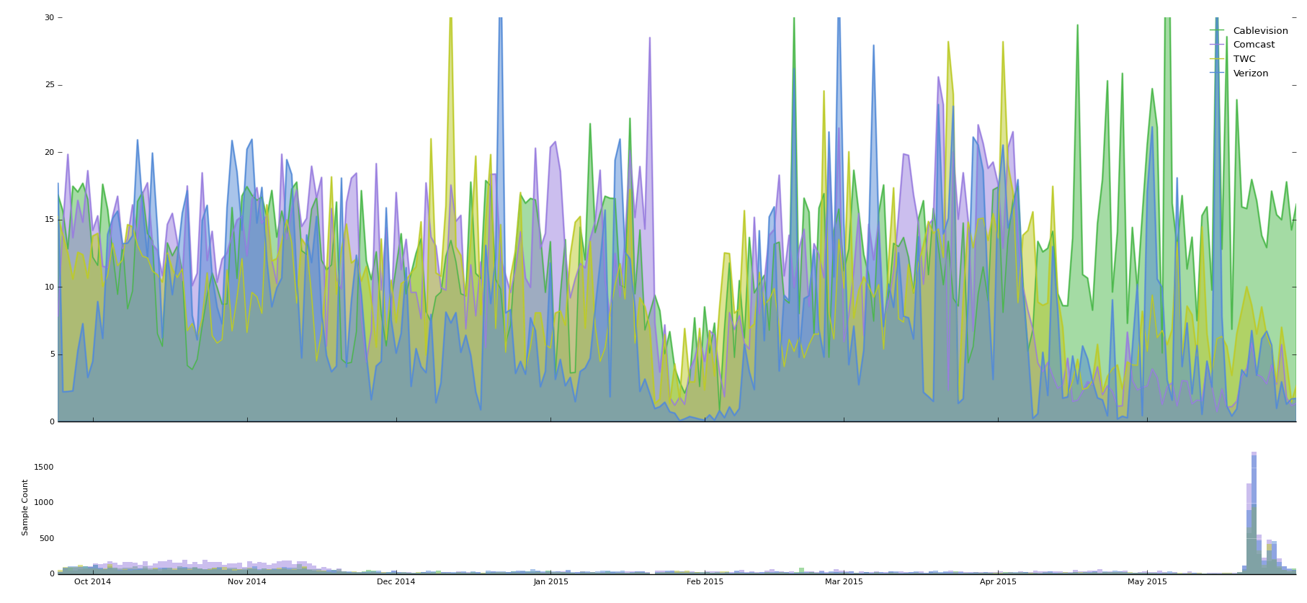
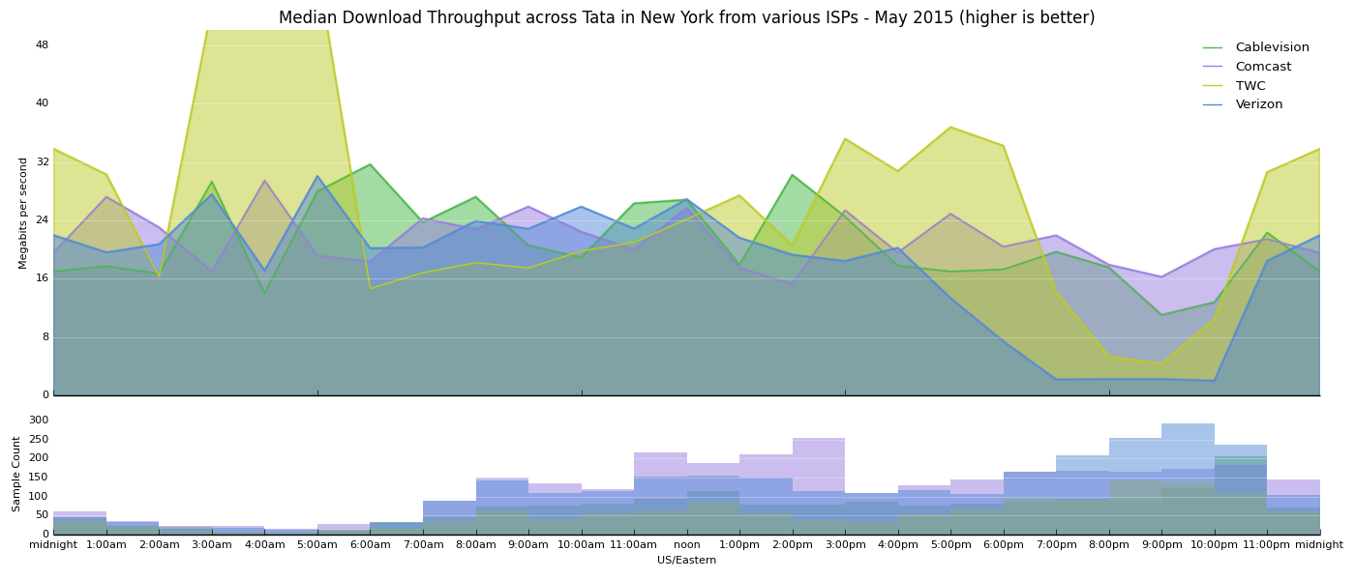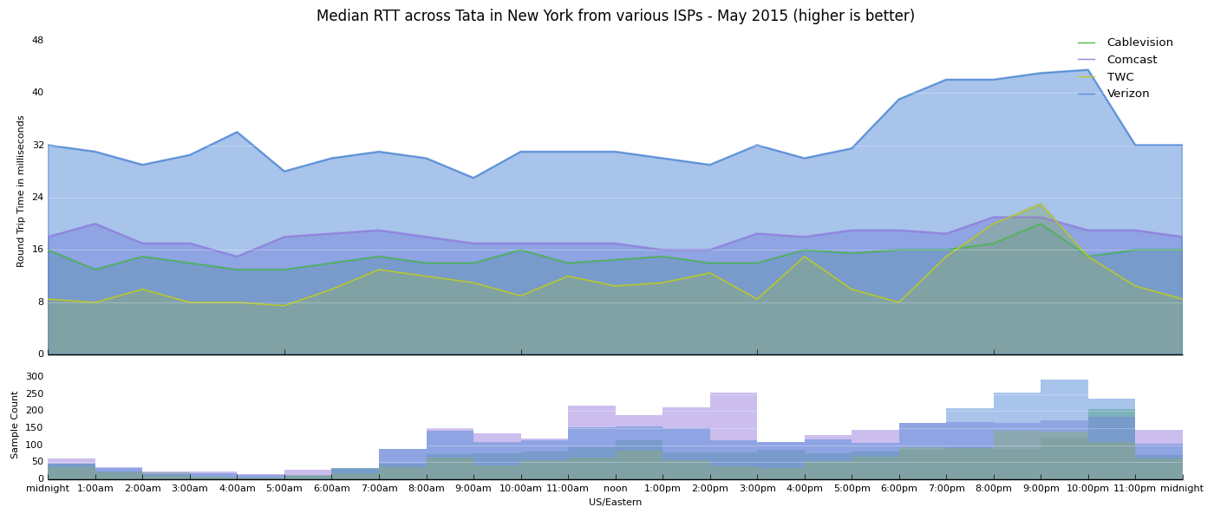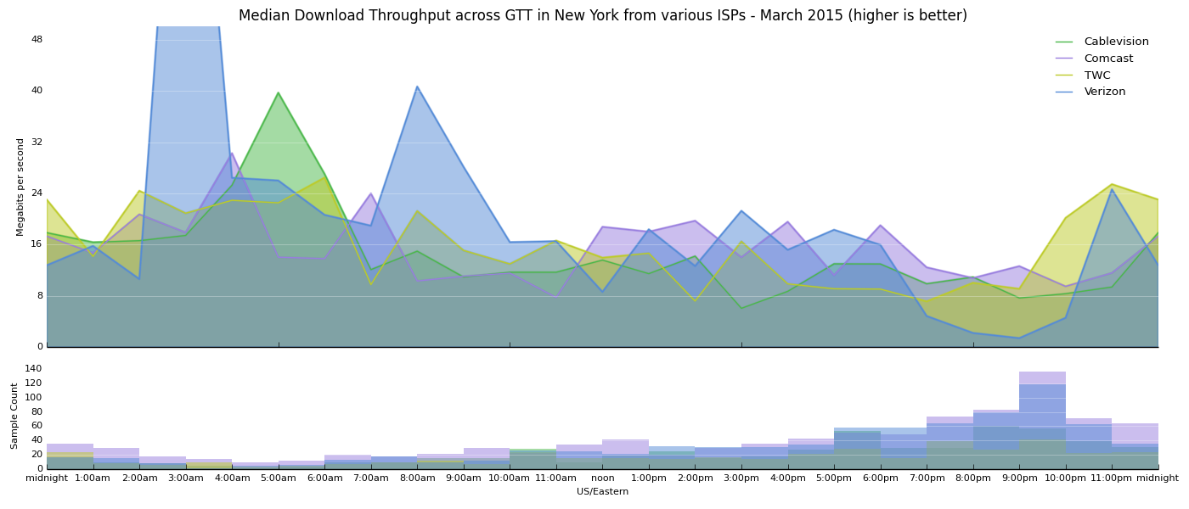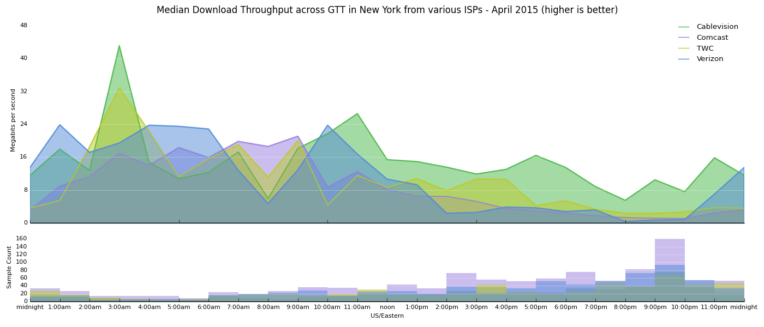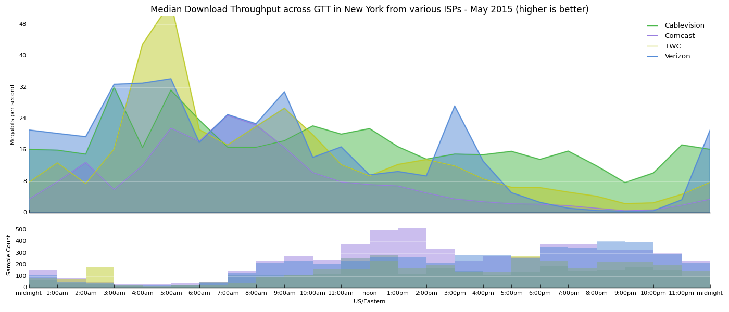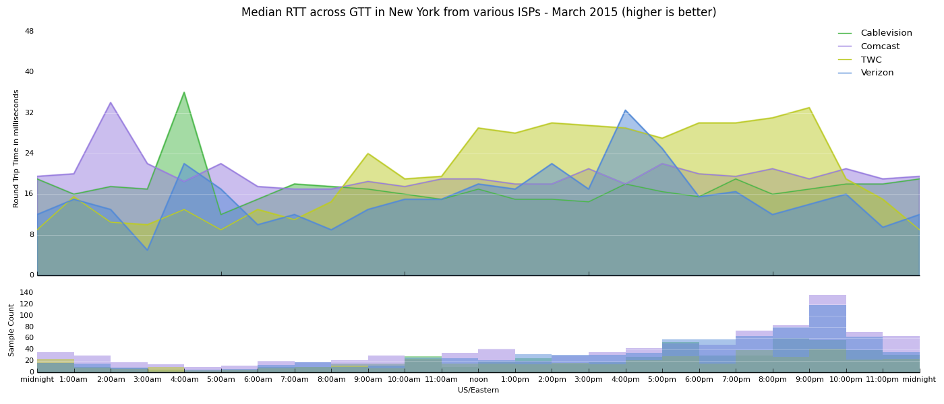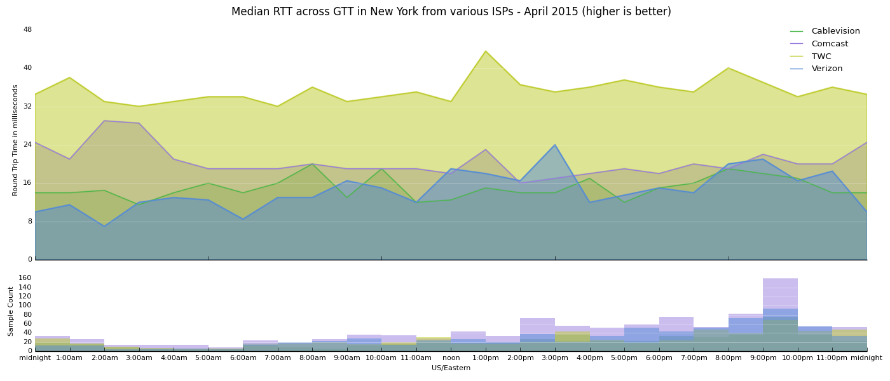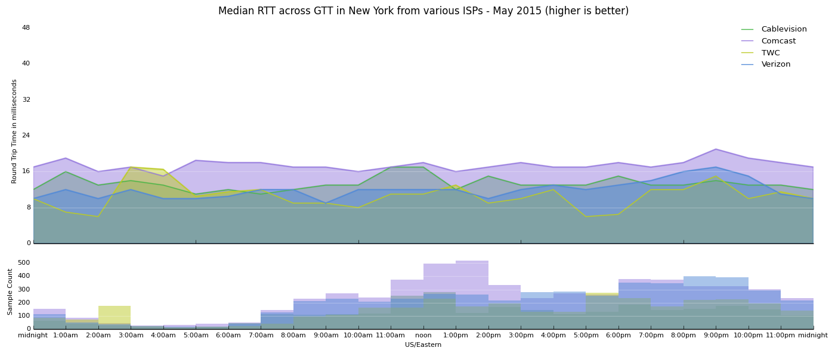

Seattle

As Seattle decides whether to build a fiber network, decisionmakers should be aware of the extent that their current Internet connectivity is being partially degraded limiting the speeds with which consumers can access many destinations across the web.
Facts:
- Seattle consumers who purchase Centurylink broadband experience severe degradation across interconnections with transit ISP tata.
  - Comcast over Tata performs 10X as well as CL during peak hours (not solely a Tata network issue).
  - CL over Level3 -- no peak degradation (so, what we’re seeing across Tata isn’t happening across CL’s network -- this *is* related to interconnection)
  - CL over GTT -- only minor peak degradation for CL, but not reaching parity or sharing a pattern with (more evidence that what we’re seeing across Tata isn’t happening across CL’s network)
  - CL over Cogent -- Bad performance across the board. Note that Comcast performs well across the board.

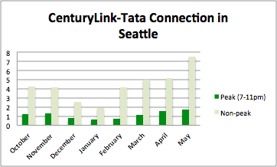

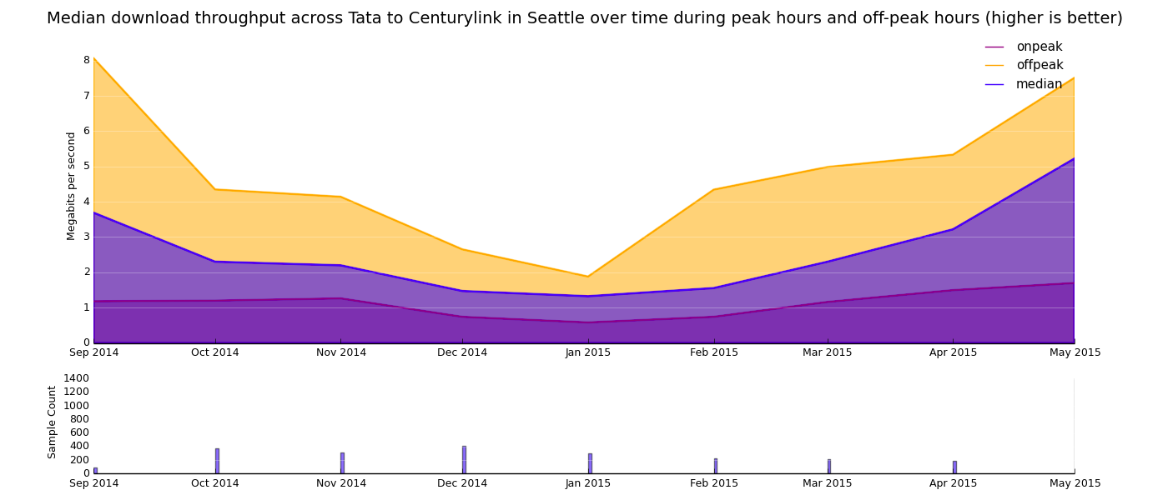
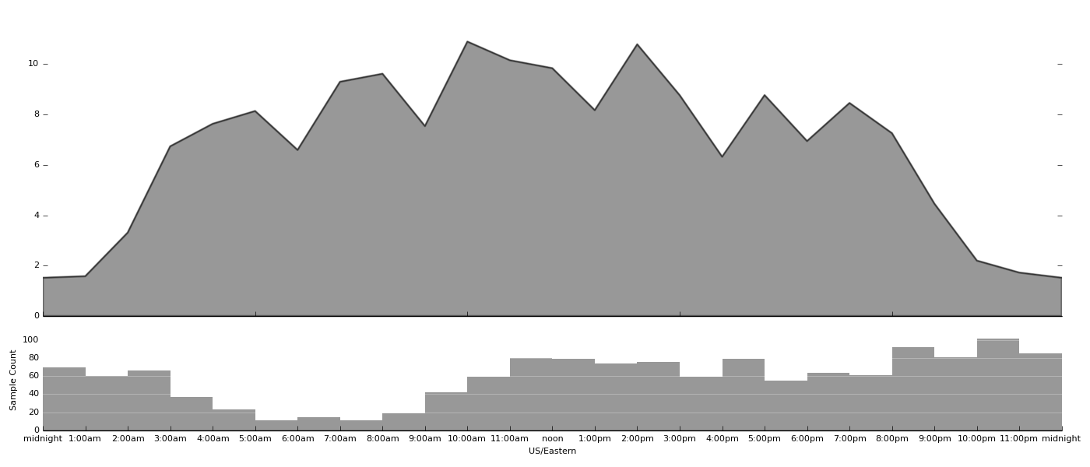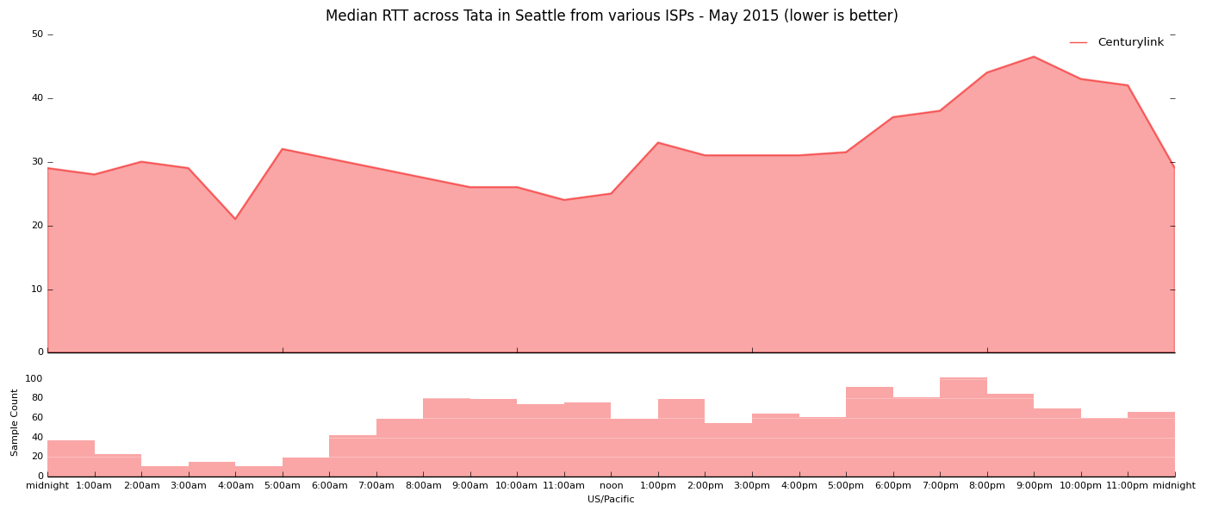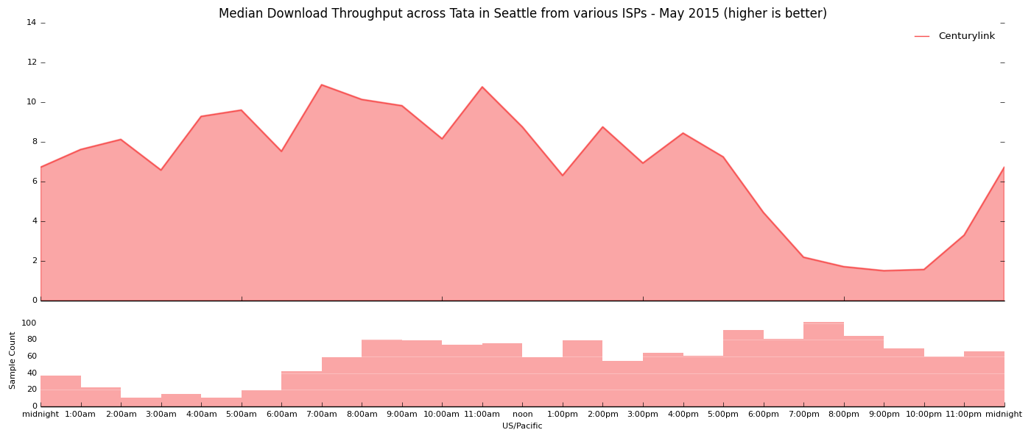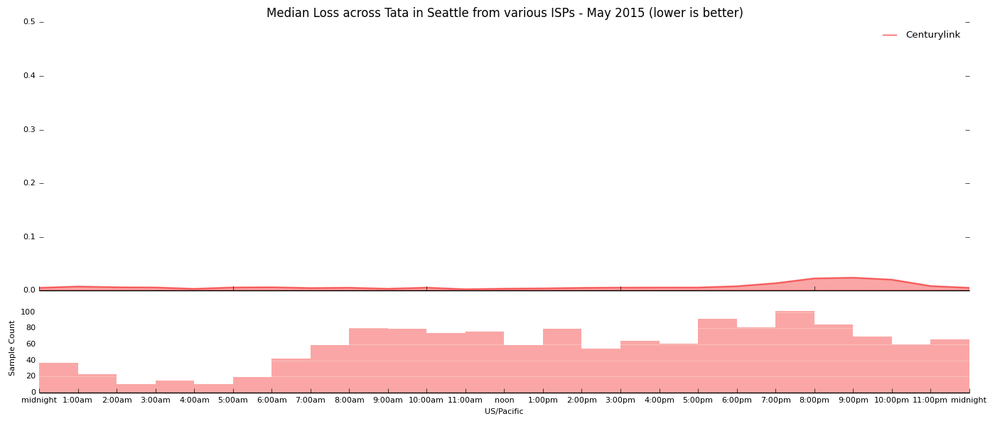

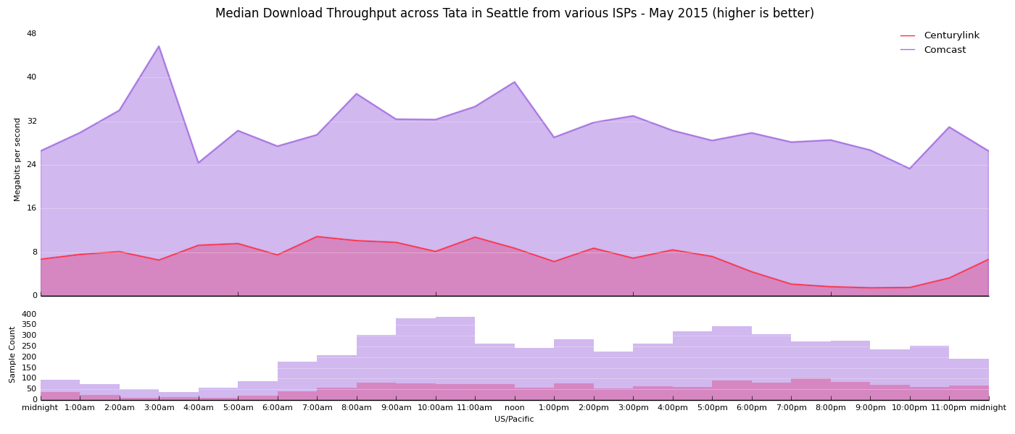

DC

Facts:
- Verizon performance showed degradation across interconnection with GTT, degrading to ~1 Mbps around 10pm.
- Comcast and TWC showed some patches of reduced performance across GTT, but nothing of the severity experienced by Verizon. (Not solely a GTT problem)
- Verizon did not show the same pattern or anywhere near the same severity of problems when interconnecting with other transit providers in the region. (Not solely a Verizon problem).

Speed by hour in Northern Virginia on GTT, May 2015 (On Observatory):

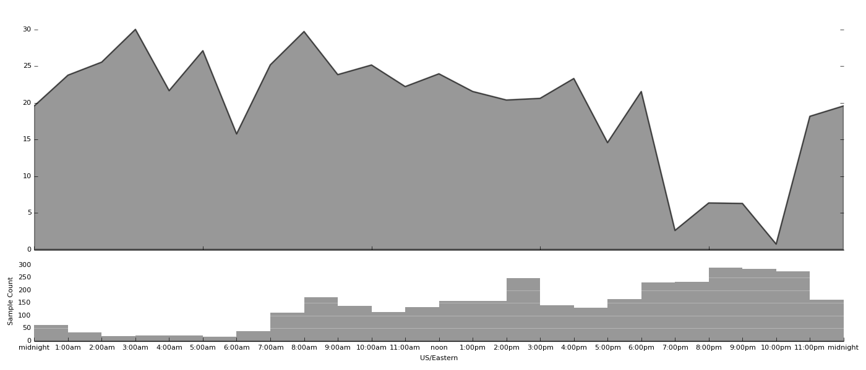
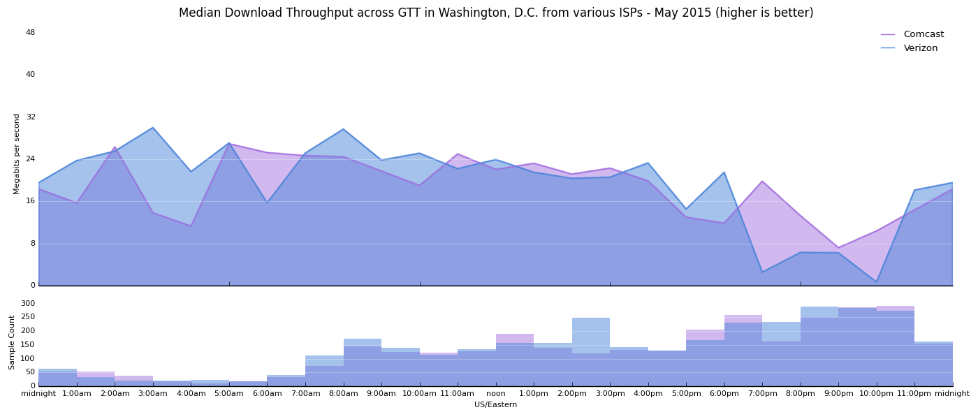

Citation: https://www.fcc.gov/reports/2015-broadband-progress-report
Citation: https://www.fcc.gov/reports/2015-broadband-progress-report
Citation: https://www.newamerica.org/oti/new-report-the-cost-of-connectivity-2014/

