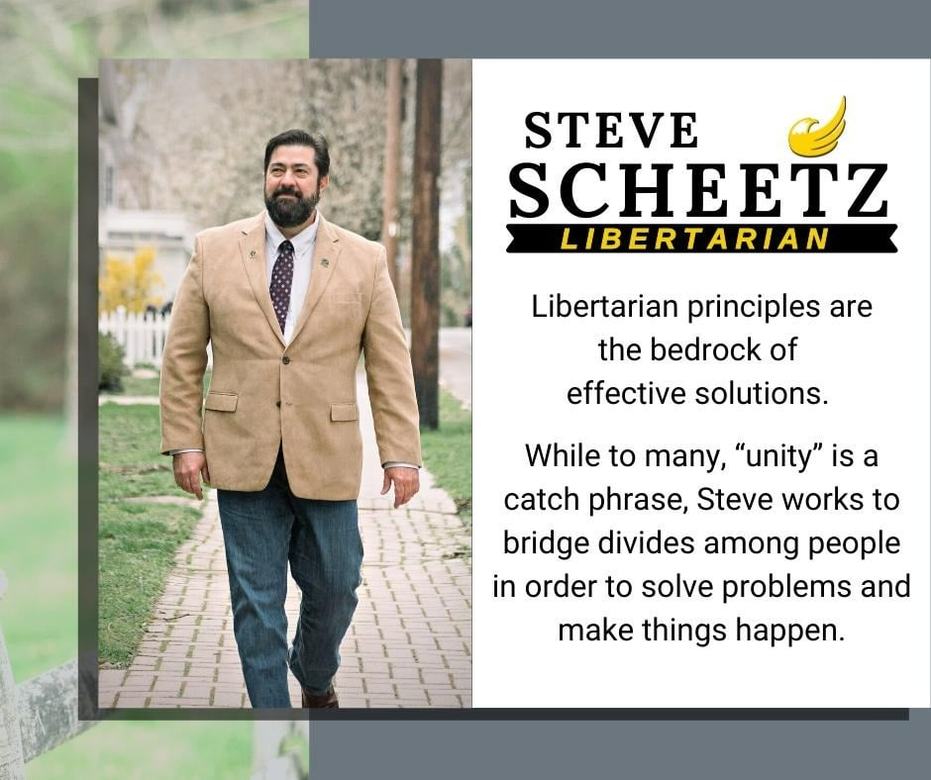

Discovering Libertarianism as a teen in the 80’s, the philosophy led him to vote Libertarian in 1992. However, he did not become very active, in the movement, until he was in his 30’s. During that decade, Steve became more involved in the party as opposed to just in the Libertarian Community.

At the local levels in Chester and Montgomery County, he became active in more leadership roles such as secretary and chair of each respective county affiliate.

In 2013, Steve was elected to serve in the role of Chair for the Libertarian Party of Pennsylvania. Having served for two years, a break was needed, and he became more of an activist for Libertarian idealism. Not straying far from the party, He served as Delegation Chair to the National Convention in 2014 and 2016. Having made the commitment to become a Lifetime member in 2014, he did so because he realized that we all are responsible for the state of our party, and when a gap opened, he chose to serve as Region 5 Alternate in 2018 filling a vacancy left by the previous alternate, in the same year he served on the Platform Committee. Working with a solid team, on elections in 2018, a plan developed, and Steve ran for Libertarian Party of Pennsylvania chair again in 2019, not just to serve, but to help enact the plan that would enable the Libertarian Party of Pennsylvania to succeed, not just as chair, but also in the role of project volunteer, and project donor.

Leaving the party with the largest number of / amount of donations, close to the largest membership in LPPA history, as well as a huge number of elected Libertarians, (all goals which have been well surpassed in the months since the LPPA's most recent convention this past May), he reflected that this particular tenure, was mostly about building successful teams within our committees, and working to support everyone working on projects.

2022 is going to be the biggest year yet, being Chair of the Bylaws Committee, and running for US Senate in PA, Steve is not interested in continuing the role past convention. Instead, he is stepping up to fill in the interim gap and support the committee as well as the people on it. Libertarian Principles are the bedrock of effective solutions, and while many politicians make “unity” a catch phrase, Steve continues his work bridging divides in order to solve problems and has a track record of making things happen. His closing thought: “Regardless of the growing pains, the Libertarian Party will continue to be a successful organization, because our people want it to succeed. Let’s work together and make that happen!”

