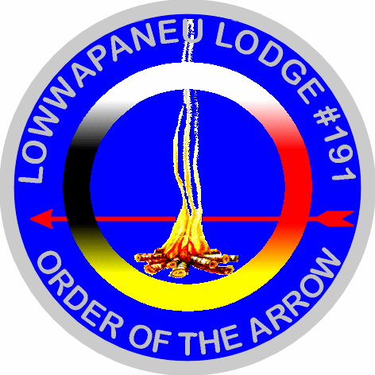
Order of the Arrow
Holiday Banquet
All Members of Lowwpaneu Lodge are invited to attend the Annually Holiday Banquet. Brothers are also encouraged to invite family members and friends to this evening of cheerful fellowship. Highlights of this year’s banquet include: recognition of the new Ordeal, Brotherhood, and Vigil members; special guests; entertainment; lodge plans for the upcoming year; fellowship; James E. West and Founders Award presentations…and more.
When: Wednesday, December 27th, 2017. Gathering at 6pm Dinner at 6:30pm
Where: Al Mia Amore Restraunt (formally The After Five)
(Located near Schiff’s & Johnson College. Take I-81 to Dickson City
exit 190. At the end of the ramp, turn right onto Main St. Go a few
hundred yards and watch for the Al Mia Amore approaching quickly
on your right. Park across the street in the Professional Plaza lot.)
Cost: $27 a person if paid by Dec. 15th
Deadline: If paid after Dec. 15th cost is $32 a person. Reservations to the Service Center close Dec. 20rd
----------------------------------------------------------------------------------------------------
Order of the Arrow Holiday Banquet Registration Form
Name(s) ___________________________________________________________
Phone: ___________________ Troop #___________
Number attending _________ @ $27.00 each
($32 after Dec. 15)
Total Enclosed ______________________
Make checks payable to: Lowwapaneu Lodge 191
Mail to: Northeastern Pennsylvania Council, Boy Scouts of America,
72 Montage Mountain Rd, Moosic, PA 18507
Reservations close on December 20

