Digital diary example.
Week 7.
Mentor feedback from last week;
Your first sprite is looking good but you haven’t included a way of resetting it when the end user wants to play it again. How can you ensure that the sprite will return to its original start position?
Also there are no instructions for the end user. Are they going to use the mouse to control the sprite or is there specific keys to use?
I have looked at my program and realised there is no way to reset the sprite.
So I included a key stroke to address this problem. Now when the left arrow key is pressed, my sprite returns to the start position. I did this by adding another algorithm to the overall program. This has the commands “When left arrow pressed, glide to position -114x -67y. “ (This is the start vector for sprite one) I will include similar coding for sprite two so they both reset at the same time.

I have also added some text to explain how to move the sprites too. This allows the end user to interact with the program.

This week I am adding another sprite to interact with the first one. The reason for this is to add more user appeal. This way they are not just moving one character but creating an interaction between characters.
I have decided on a bat. Bats have been associated with Halloween for a long time due to the fact they are nocturnal and scary looking. There are also species of bat that are vampire in nature.
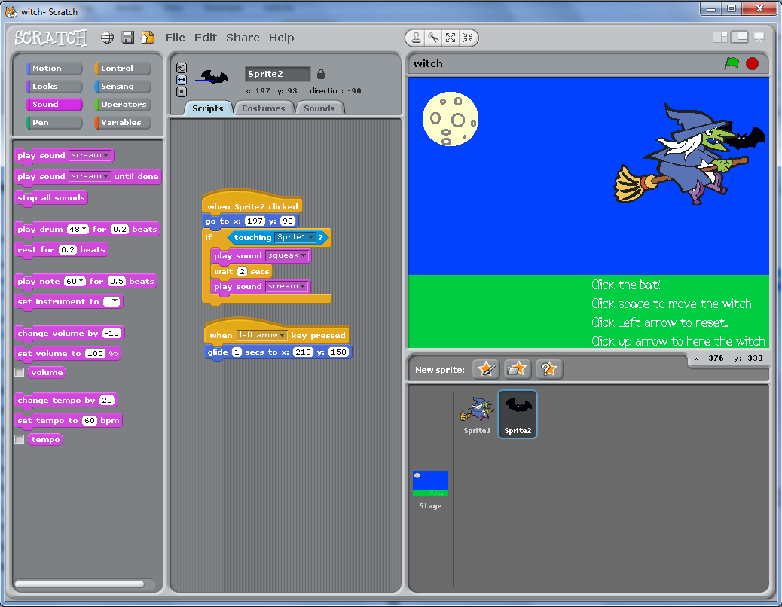
I am going to allow the witch to fly into the bat. At that point I will have the witch scream as she is startled by the bat. However if the bat flies into a witch I will have the bat squeak then the witch scream. I need to record the sound effects for this as well.

Above is my finished program for sprite 2.
The movement is triggered by clicking on the bat. If this is done after the space bar is pressed, the bat squeaks before the witch screams.
I had a problem with the scream and squeak happening at the same time. I then added a delay between them and this solved that problem.
I added a reset that uses the same code I duplicated from sprite one to reset but I forgot to change the vectors to where the bat started off.
I realised this after I tested the card, so I then repositioned the bat to its start position and made a note of the vectors. I then added these to the ‘glide too’ command to reset the bat.
Following on from the feedback from last week, I also made a note in the instructions to allow end users to operate the bat.
I found this week challenging as I needed to think about the way the sprites sensed each other and then have to remember to include resets, sounds and movements too. I didn’t need to contact my mentor but may do next week to clarify a few points.
I was using ideas from the discussion board this week too. I used the record a sound feature as I wasn’t happy about the sounds available to me. This was explained by Ann Other whilst discussing this weeks work.

