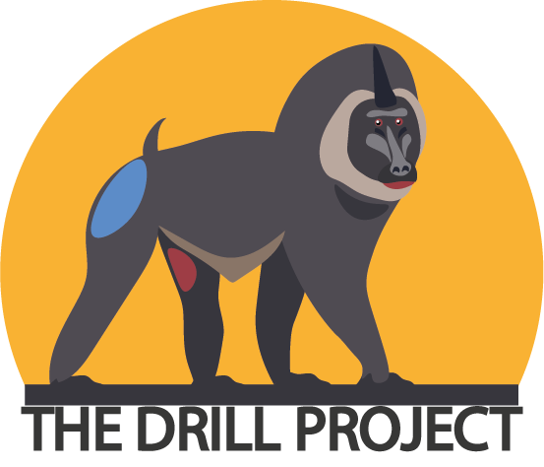
VOLUNTEERING ONLINE
THE DRILL PROJECT
As you all know, due to the pandemic situation that we are experiencing, many organizations that work in conservation are facing difficult times due to the lack of tourism, increased strain on logistics and financial scarcity.
As a result, our vital conservation and research efforts are currently being limited. Currently, our organization is reduced to a small team to ensure that our essential conservation and research work continues.
As of right now you may not be able to join us here in person… But we happy for you to join us digitally, through our new "Volunteering from home" program!
Would you like to get involved in drill conservation?
Drills are one of the most threatened and least known primate species on the planet.
You can learn more about them at:
www.thedrillproject.org/es/el-mono-dril
We need your help! We are a small NGO working in Equatorial Guinea. Our work is primarily focused on collecting data, raising awareness for environmental issues, and providing protection for drills.
Our current projects involve a lot of work, both in the field and on the web, to achieve our goals. We would love to find compassionate and dedicated people to aid us in our work. Together we can provide protection to the biodiversity of Bioko Island, as well as opportunities and resources to the people who live in and near regions where drills live.
One of our most ambitious projects is the construction of the FIRST PRIMATE RESCUE CENTER IN EQUATORIAL GUINEA, would you like to join us in this adventure?

What profile are we looking for?
You do not need specific training, but if you have knowledge about biology, primatology, community development or education, this is your perfect opportunity to, with your experience and knowledge, help us grow and achieve our goals.
At the moment we are looking for 3 specific profiles:
- Volunteer for the fundraising campaign
- Volunteer for content creation
- Volunteer for camera trap video analysis
- Volunteer for project writing

And what do we give you in return?
- Be part of an expanding project in which there is the possibility of working in the future
- Training on camera traps (operation, analysis ...)
- Possibility of traveling to Equatorial Guinea to get involved in the project on-site
- Put your knowledge into practice to support our campaigns

How much time do I have to invest in volunteering?
The time you invest in volunteering is completely up to you. For us, the longer we can count on you the better, but we understand that other obligations and responsibilities will take time in your life so we adapt to your availability (even so, an approximate amount of time of a minimum of 4 hours a week is proposed).
In order to get the most out of your experience with us, we would like to ask you for a commitment with us for a minimum of 2 months. We believe that we will get much more out of the experience if we can get to know each other and thus be able to establish a plan according to your objectives and needs, in company with ours.
If you are interested in collaborating with us, do not hesitate to send us an email with your CV and a small cover letter to
thedrillproject@gmail.es
We are waiting for you! Become a member of our team and help us to #savethedrills!

We would like to know a little more about you through a short questionnaire so that we can know your needs, skills and objectives at a professional level in order to offer you the best volunteering experience within our organization. Please answer these short questions and forward the document to us at thedrillproject@gmail.com

Name:
Age:
Occupation:
Place of residence:

1. Why are you applying for the volunteer position and what would you like to get out of it?

2. What skills and experience do you have that could be beneficial to our organization? This may include paid work, volunteer work, study, training or personal experience.

3. Is there a specific research project, area or job that you would like to focus on during your time with us?

4. How long could you commit to working with us and how many hours per week?

6. Would you be willing to travel to Equatorial Guinea in the future to work with us on in-situ conservation projects?

7. Are you currently studying (career, master ...)?

¡Thank you again for your interest in our organization!
