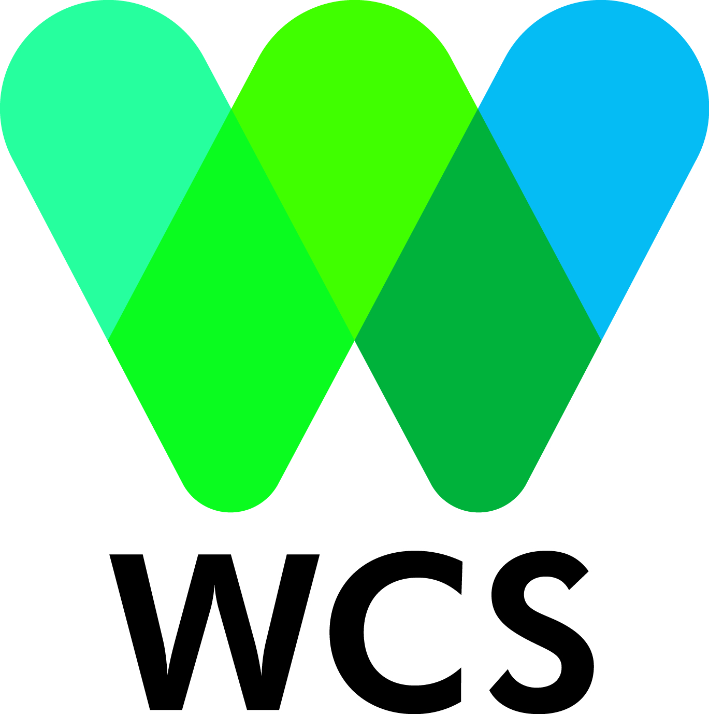
Vacancy Announcement

Position: WCS Behavior Change Communication Campaign Management Consultant
Division: Wildlife Conservation Society – Africa Program
Reports to: The WCS Congo Program Manager
Location: Pointe Noire, Republic of Congo

Objective

The campaign manager will manage the development and roll-out of the behavior change communications campaign for the Urban Bushmeat Project in Pointe Noire, to reduce the luxury consumption of bushmeat. The campaign is a first-of-its-kind multi-media behavior change campaign aiming to reduce the level of bushmeat consumption in urban centers.

Project Description
WCS has been developing a bushmeat program to address threats to wildlife from rural zones, provincial towns, and large urban cities. As part of these efforts, WCS has instituted an urban bushmeat project in Kinshasa, Brazzaville, and Pointe Noire to reduce the luxury consumption of bushmeat. The goal of this project is to reduce the hunting threat to wildlife populations around nearby protected areas by developing an approach that raises societal awareness, builds constituencies and support, and uses a first-of-its-kind multi-media behavior change campaign to reduce the level of bushmeat consumption.

Principal Responsibilities
- Development of the Campaign Implementation Plan for the project
- Production of Campaign Multi-Media Materials
- Serve as the communications focal point in Pointe Noire for campaign external relationships
- Implementation of the multi-media campaign
- Monitoring and evaluation to assess the success of the campaign

Key deliverables

      - Campaign materials and services commissioning (e.g. TdRs, review of bids, budgets contracts, etc)
      - Weekly Campaign Update reports (1-2 pages max, including monitoring the distribution of campaign materials)
      - Publicity launching
      - Final report after implementation, incorporating audience and KAP research findings from the research team (concept testing, pretesting and baseline/follow up study results of the campaign).

Period and place of performance

The position is opened for 10 months from March, 1st to December 31th 2018, with possibility of extending dependent on performance and funding. The position is based in Pointe-Noire, Republic of Congo. This is a locally-hired position, so the consultant is expected to cover all their personal expenses in Pointe Noire. Business-related travel to Brazzaville or and Kinshasa may be required and all related expenses will be covered by WCS. The consultant will be provided with access to WCS office resources and utilities in Pointe-Noire during this time. Congolese and women are encouraged to apply.

Qualifications
This position requires a minimum of the following:
- First or master’s degree in communication, marketing or other related field.
- Strong experience in campaigning and behavior change/social marketing methods
- At least 3-5 years in campaign management.
- Excellent writing and speaking skills in French and desired in English
- Understanding of media production and experience working with media teams with private or NGOs sectors are strongly preferred
- Knowledge of conservation approaches is a bonus

Payment
Pay will be commensurate with experience.

Application deadline
Please address your CV and Motivation Letter to Robert Mwinyihali (rmwinyihali@wcs.org), copying Emilie Fairet (efairet@wcs.org, and kibra.bushmeat@gmail.com) before February, 15th 2018.
Only shortlisted candidates will be contacted. Further information; please contact Mr. Mwinyihali, at the email address above.

