1. expected_success final markup:

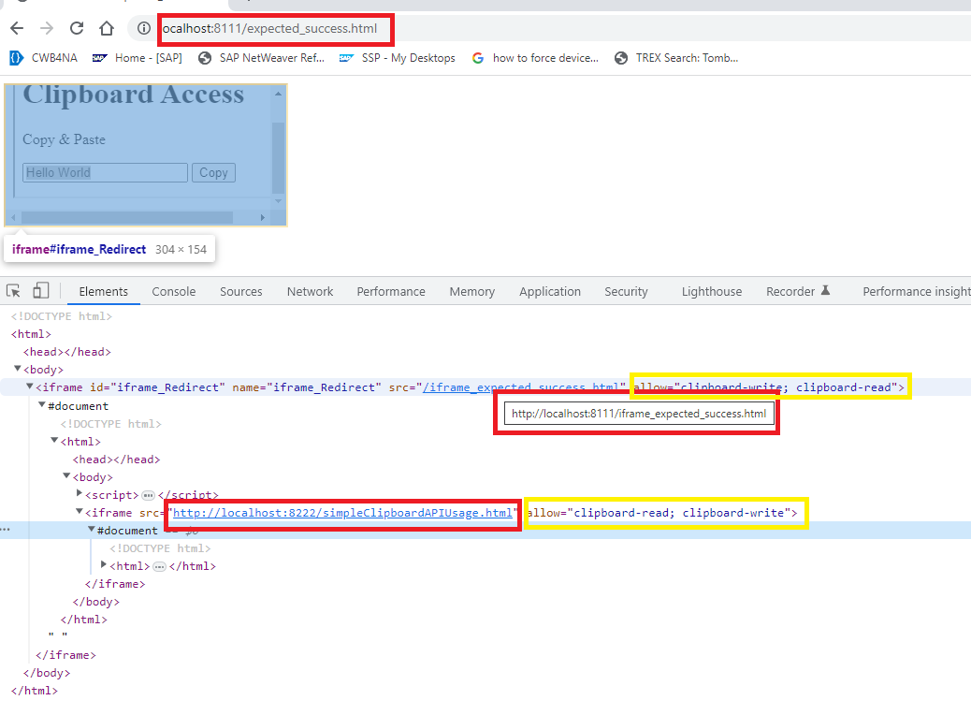

No error in console:

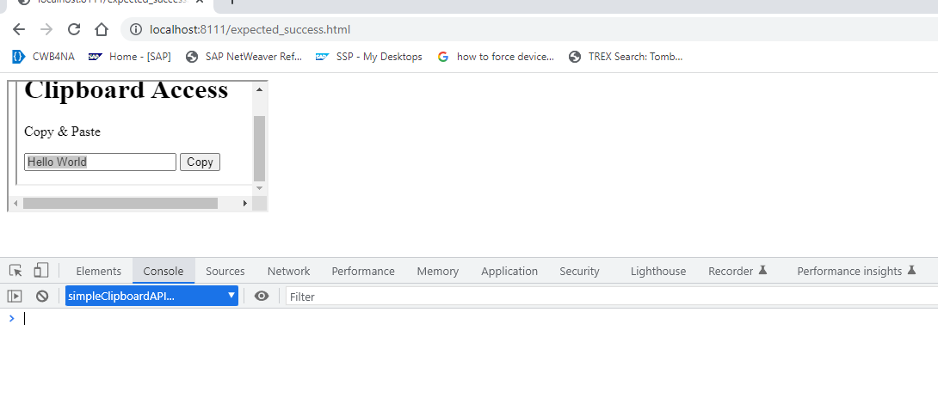

1. expected_failure final markup:

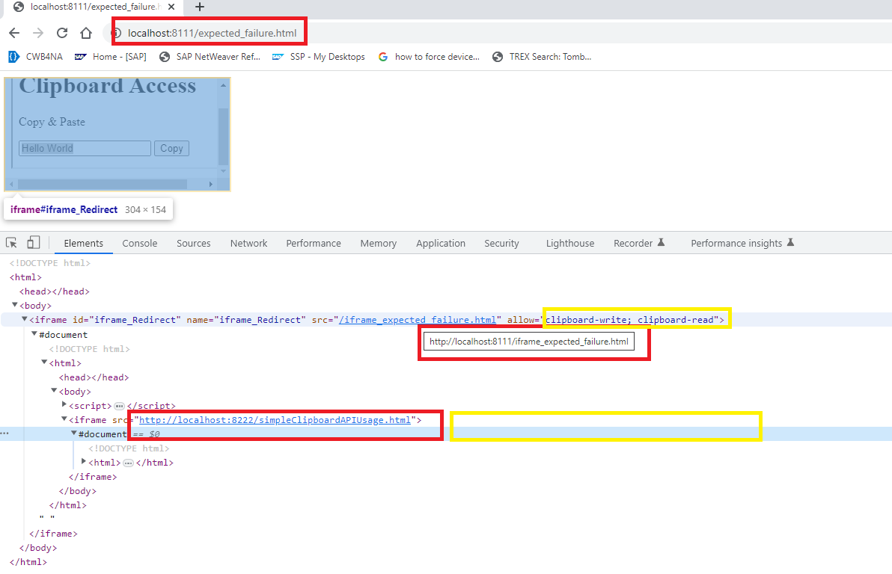

Expected error in console:

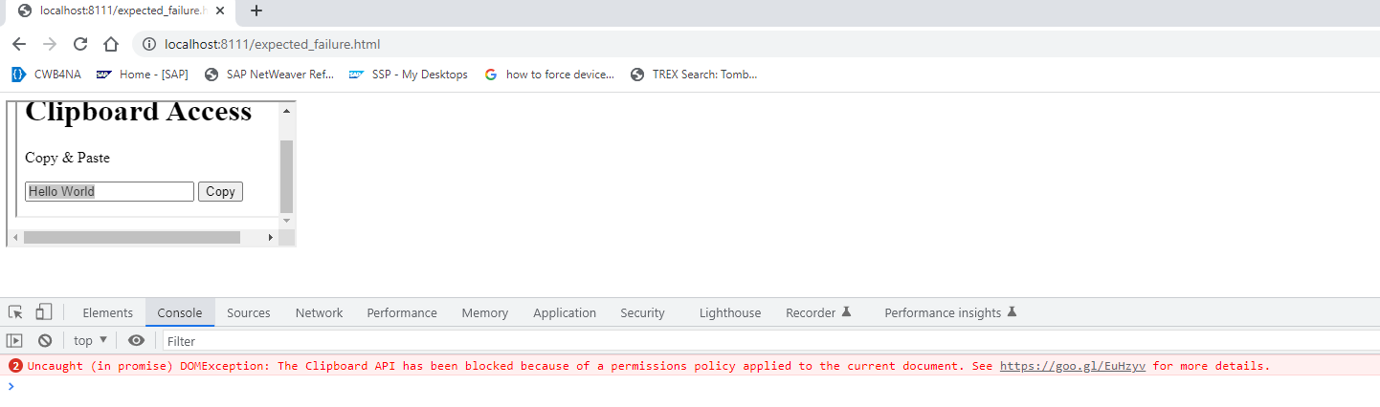

1. unexpected_failure final markup:

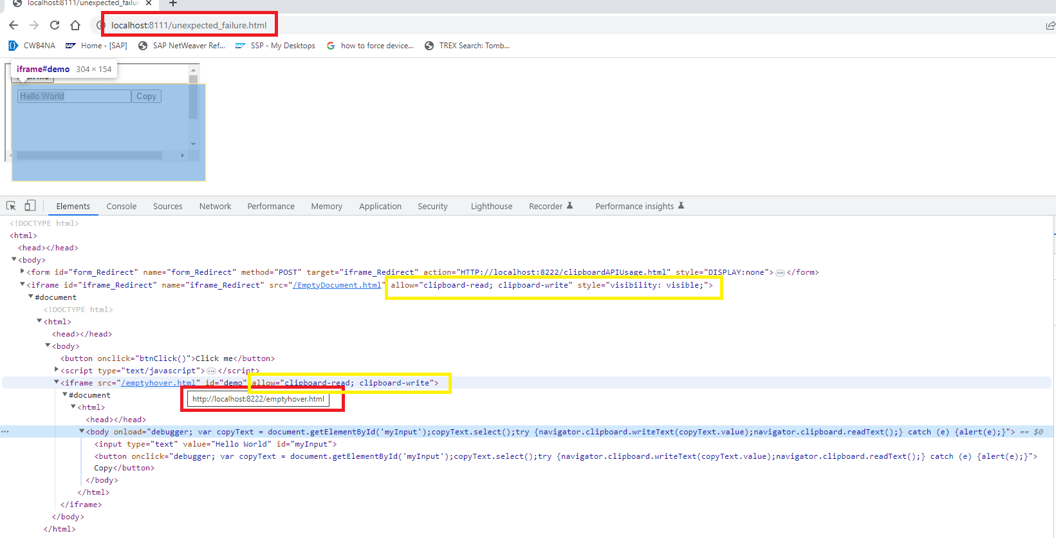

Unexpected error in console:

