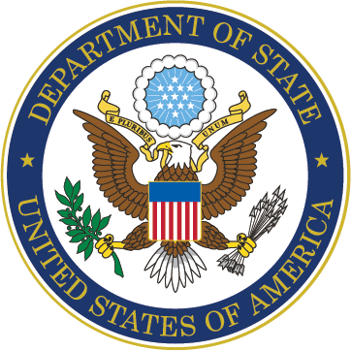
Employer: U.S. Department of State
Website: careers.state.gov
POC: Diplomat in Residence for the Northwest: DIRNorthwest@state.gov

As the lead federal agency responsible for U.S. foreign affairs, the U.S. Department of State contributes to foreign policy formulation and to advancing U.S. interests around the world. Our employees contribute different perspectives, life experiences, and innovative thinking to our mission of serving the people of the United States and managing our international diplomatic presence. Foreign Service Officers and Specialists represent the U.S. abroad at over 270 diplomatic missions. Our Civil Service employees provide continuity and expertise in all aspects of our work at our HQ in Washington, D.C. We recruit from every field, including IT, engineering, healthcare, federal law enforcement, international affairs, legal, business, management, and public relations. The U.S. Department of State is firmly committed to building a workforce that reflects our nation’s diversity and leverages the creativity of diverse, talented groups to advance America’s foreign policy priorities. To reap the benefits of a diverse workforce, we have built an inclusive workplace in which every employee is treated with dignity and respect and feels empowered to serve the American people. The U.S. Department of State also offers of wealth of student programs, including paid and unpaid internships, study abroad, and paid fellowships. Visit careers.state.gov to learn more. U.S. citizenship is required. An equal opportunity employer.

Learn who We Are:
https://www.youtube.com/watch?v=5ZcHWQYrYrk&feature=youtu.be

Learn how to join our Team:
https://www.youtube.com/watch?v=_BwkiMVu3I8

